|  |  |  |  |  |  |  |  |  |  |  |
| --- | --- | --- | --- | --- | --- | --- | --- | --- | --- | --- |
| |  |  |  | | --- | --- | --- | | **Sub Code: ECA 05** | **Subject Name:** Engineering Electromagnetics | | | **Branch: ECE** | **Year & Section: II** | **Semester: III** | | | | | |
| **Sl. No** | **Date** | **List of experiments** | **Page No** | **Signature** |
| 1. |  | Variable Transformation between Cartesian, Cylindrical and Spherical coordinate system to obtain the location of any object. |  |  |
| 2. |  | Determination and plotting of Electric field and Electric flux density in sphere full of charges with varying radius. |  |  |
| 3. |  | Determination and plotting of Force of attraction between two electric Charges and two parallel conductors separated by varying distance. |  |  |
| 4. |  | Analysis of Continuous Charge Distribution in electric field.  To find the (i) line charge density, (ii) Surface charge density and (iii) Volume charge density for any specific (a) line, (b) surface or (c) volume. |  |  |
| 5. |  | Determination and plotting of Electric potential difference between any two points in free space medium separated by a distance R. |  |  |
| 6. |  | Determination and plotting of Capacitance of parallel plate capacitor in three different dielectric medium with specific area, dielectric thickness and various dielectric constant. |  |  |
| 7. |  | Determination and plotting of Capacitance of isolated and concentric sphere with different inner and outer radius and dielectric constant of the dielectric mediums. |  |  |
| 8. |  | Determination and plotting of Capacitance of Co-axial cable per unit length with different (i) inner radius, (ii) outer radius and (iii) relative permittivity of the dielectric medium. |  |  |
| 9. |  | Implement Dielectric free space boundary condition in Electric Field and find the relative permittivity of the different medium. |  |  |
| 10. |  | Implement Boundary condition between two different dielectric medium in Magnetic Field and find the relative permeability of the different medium. |  |  |
| 11. |  | Determination and plotting of Magnetic Flux density in Ferromagnetic Materials with different (i) length, (ii) width and (iii) magnetic field intensity. |  |  |
| 12. |  | Determination and plotting of Magnetic and Electric Field Intensity due to infinite long conductor at any specific point located at a height H. |  |  |
| 13. |  | Determination and plotting of (i) Intrinsic impedance and (ii) Phase velocity of various medium with different relative (a) permittivity and (b) permeability. |  |  |
| 14. |  | Determination and plotting of Polarization in different Dielectric Medium with their relative permittivity and to find electric susceptibility. |  |  |
| 15. |  | Determination and plotting of Inductance (i) Self-inductance and Mutual inductance of current carrying coil, (ii) solenoid and toroid with different (a) length and (b) circumferential area. |  |  |
| 16. |  | Determination and plotting of Radiation Pattern for a uniform linear array |  |  |
| 17. |  | Determination and plotting of Antenna Gain Calculation. |  |  |
| 18. |  | Determination and plotting of Antenna Half power beamwidth. |  |  |
| 19. |  | Determination and plotting of Antenna Efficiency. |  |  |

Exp. No: 1

**Date:**

**Transformation between Cartesian, Cylindrical and spherical coordinate system**

**Aim:**

To write program for Transformation between Cartesian, Cylindrical and spherical coordinate system using SCILAB.

**Software required:**

•SCILAB version 6.0.1

**Theory:**

**Program:**

**Test case (i) Transformation of Cartesian coordinate points in to Cylindrical and spherical coordinate system**

clc;

x=input('Enter the value of X=');

y=input('Enter the value of y=');

z=input('Enter the value of z=');

r=sqrt(x^2+y^2);

pi=atand(y/x);

disp('Cartesian to cylindrical coordinate system of p(r,pi,z)=',[r pi z]);

r=sqrt(x^2+y^2+z^2);

theta=acosd(z/r);

pi=atand(y/x);

disp('Cartesian to spherical coordinate system of s(r,theta,pi)=',[r theta pi]);

Output:-

Enter the value of X=10

Enter the value of y=15

Enter the value of z=20

"cartesain to cylinderical coordinate system of p(r,pi,z)="

18.027756 56.309932 20.

"cartesain to spherical coordinate system of s(r,theta,pi)="

26.925824 42.031114 56.309932

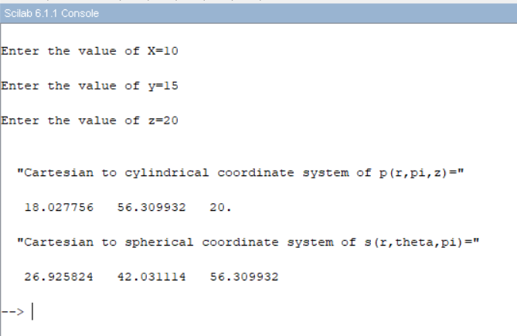

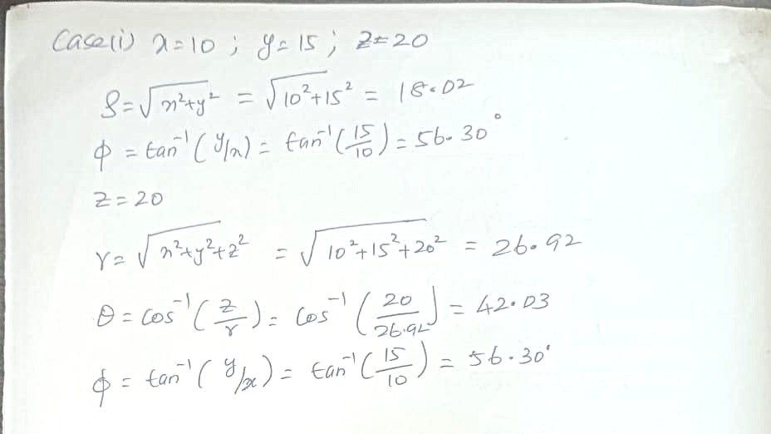

**Test case (ii) Transformation of Cylindrical coordinate points into Cartesian and spherical coordinate system**

clc;

r=input('Enter the value of r=');

pi=input('Enter the value of pi=');

z=input('Enter the value of z=');

x=r*cosd(pi);

y=r*sind(pi);

z=z;

disp('cylindrical to cartesian coordinate system of p(x,y,z)=',[x y z]);

r=sqrt(r^2+z^2);

pi=pi;

theta=acosd(z/r);

disp('cylindrical to spherical coordinate system of s(r,pi,theta)=',[r pi theta]);

Output:-

Enter the value of r=10

Enter the value of pi=15

Enter the value of z=20

"cylinderical to cartesian coordinate system of p(x,y,z)="

9.6592583 2.5881905 20.

"cylinderical to spherical coordinate system of s(r,pi,theta)="

22.36068 15. 48.189685

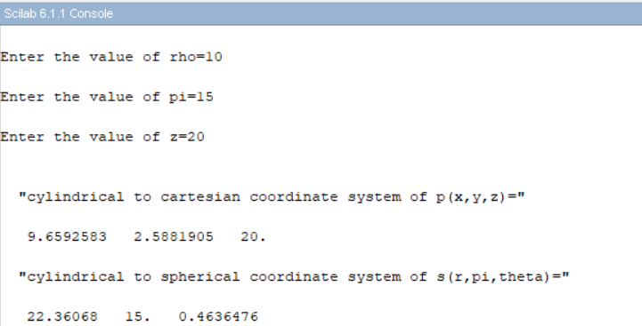

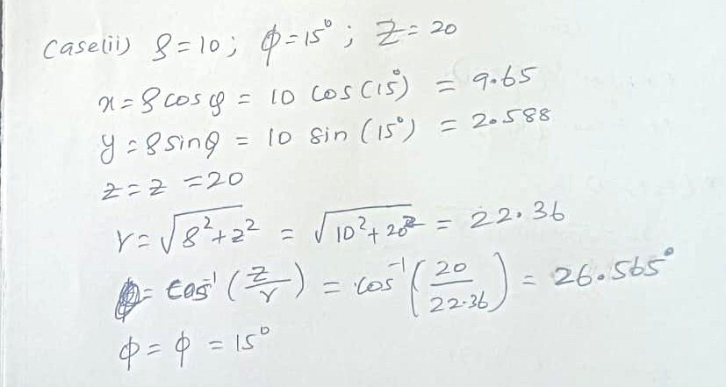

**Test case (iii) Transformation of spherical coordinate points into Cylindrical and Cartesian coordinate system**

clc;

r=input('Enter the value of r=');

pi=input('Enter the value of pi=');

theta=input('Enter the value of theta=');

x=r*sind(theta)*cos(pi);

y=r*sind(theta)*sin(pi);

z=r*cosd(theta);

disp('spherical to cartesian coordinate system of p(x,y,z)=',[x y z]);

p=r*sin(theta);

pi=pi;

z=r*cos(pi);

disp('spherical to cylindrical coordinate system of s(p,pi,z)=',[p pi z]);

Output:-

Enter the value of r=10

Enter the value of pi=15

Enter the value of theta=20

"spherical to cartesian coordinate system of p(x,y,z)="

-2.5982857 2.2241154 9.3969262

"spherical to cylinderical coordinate system of s(p,pi,z)="

9.1294525 15. -7.5968791

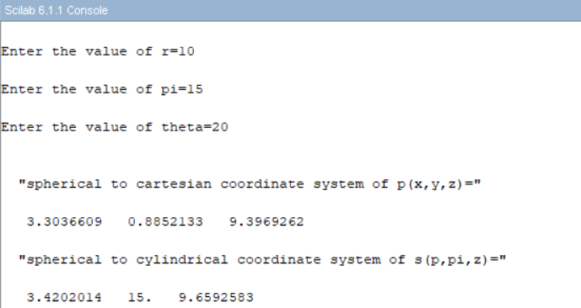

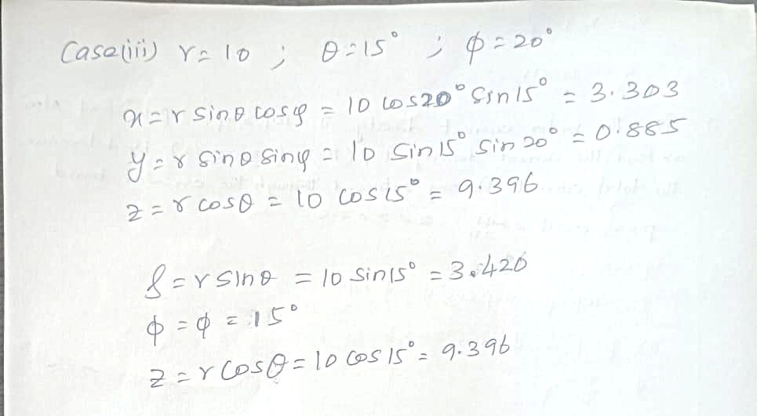

**Result:**

Thus, the program was verified Transformation between Cartesian and Cylindrical coordinate system its classified two categories (a) Cartesian to cylindrical and spherical coordinate system (b) Cylindrical to cartesian and spherical coordinate system (c) spherical to cartesian and cylindrical coordinate system using SCILAB was successfully.

|  |  |  |
| --- | --- | --- |
| **Parameters** | **Observed/Simulated result** | **Theoretical result** |
| x=10, y=15, z=20 | ρ=18.027756,φ=56.309932,z=20  r=26.925824,θ=42.03114, φ=56.309932 | ρ=18.027, φ=56.30, z=20  r=26.925, θ=42.03, φ=56.309 |
| ρ=10, φ=15, z=20 | x=9.6592583, y=2.588190, z=20  r=22.36068, φ =15, θ =26.565 | x=9.659, y=2.588, z=20  r=22.360, φ =15, θ =26.565 |
| r=10, φ =15, θ =20 | x=3.3036609,y=0.8852133, z=9.3969262  ρ=3.4202014, φ=15, z=9.6592583 | x=3.304, y=0.885, z=9.396  ρ=3.420, φ=15, z=9.659 |

**Exp. No: 2** Determination and plotting of Electric field and Electric flux density in sphere full of charges with varying radius.

**Date:**

**Aim:**

To write program for electric field and electric flux density in sphere using SCILAB.

**Software required:**

•SCILAB version 6.0.1

**Theory:**

**Program:**

clc;

clear;

q=input('Enter the value of q=');

r=input('Enter the value of r=');

efcilon=8.854*10^-12;

pi=3.14

E=q/4*pi*efcilon*r^2;

disp("The electric field is", [E]);

D=E*efcilon;

disp("The flux density is", [D]);

x = linspace(0, 10, 50);

y = E * exp(-0.1 * x);

z = D * exp(-0.1 * x);

figure();

subplot(2, 2, 1);

plot2d3(x,y);

xlabel("R");

ylabel("Electric field intensity");

title('Electric field intensity');

subplot(2, 2, 2);

plot2d3(x,z);

xlabel("A");

ylabel("Electric flux intensity");

title('Electric flux intensity');

Output:-

Enter the value of q=2*10^-2

Enter the value of r=0.1*10^-3

"The electric field is"

1.390D-21

"The flux density is"

1.231D-32

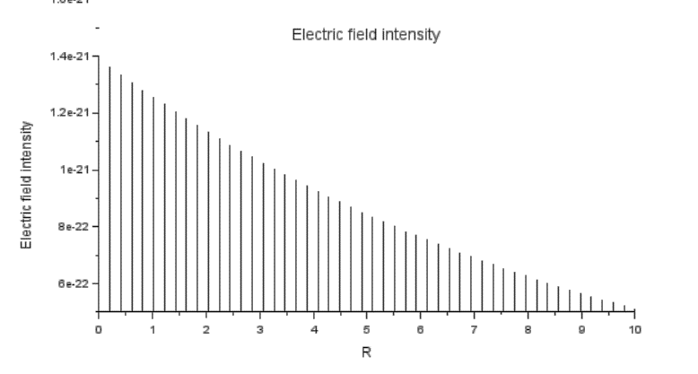

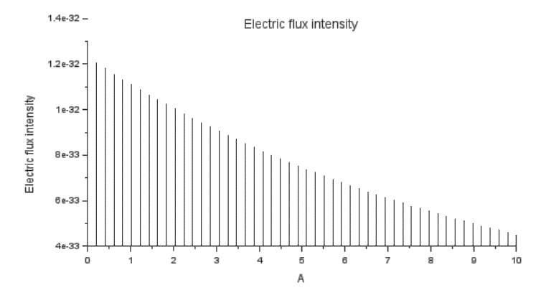

**Case 1:**

**Derive and plot the electric field (E) and electric flux density (D) inside a uniformly charged sphere with charge density ρ0. What are the values of E and D at the center and at the surface of the sphere?**

**Code:**

rho0 = 1e-6; *// Uniform charge density (C/m^3)*

epsilon = 8.854e-12; *// Permittivity of free space (F/m)*

R = 1; *// Radius of the sphere (m)*

n = 100; *// Number of steps for plotting*

r = linspace(0, R, n); *// Radial distances*

*// Initialize arrays for D and E*

D = zeros(1, n);

E = zeros(1, n);

*// Calculate D and E*

for i = 1:n

ri = r(i); *// Current radius*

*// Enclosed charge Q_enclosed = rho0 * (4/3) * pi * r^3*

Q_enclosed = rho0 * (4/3) * %pi * ri^3;

*// Electric Flux Density D*

if ri ~= 0 then

D(i) = Q_enclosed / (4 * %pi * ri^2);

else

D(i) = 0; *// Avoid division by zero*

end

*// Electric Field E = D / epsilon*

E(i) = D(i) / epsilon;

end

*// Plotting*

subplot(1, 2, 1);

plot(r, D, "r");

xlabel("Radius (m)");

ylabel("Electric Flux Density (D) [C/m^2]");

title("Uniform Density: D vs. Radius");

subplot(1, 2, 2);

plot(r, E, "b");

xlabel("Radius (m)");

ylabel("Electric Field (E) [V/m]");

title("Uniform Density: E vs. Radius");

**Output:**

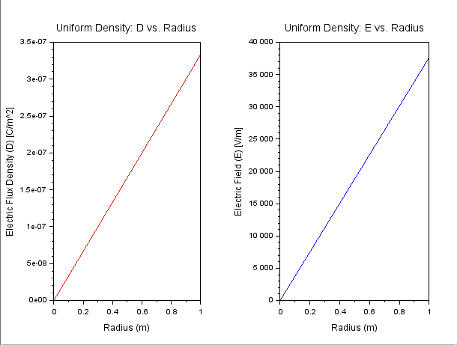



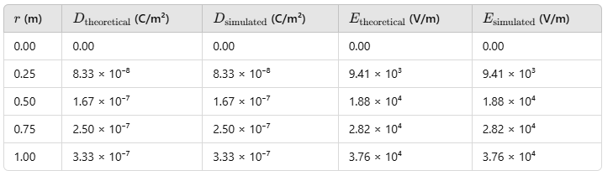

**Case 2:**

**For a sphere with a linearly increasing charge density ρv=ρ0r.derive the expressions for the electric field (E) and electric flux density (D). Plot their variations inside the sphere and analyze the trends.**

**Code:**

*// Parameters*

rho0 = 1e-6; *// Coefficient for linearly increasing charge density (C/m^4)*

epsilon = 8.854e-12; *// Permittivity of free space (F/m)*

R = 1; *// Radius of the sphere (m)*

n = 100; *// Number of steps for plotting*

r = linspace(0, R, n); *// Radial distances*

*// Initialize arrays for D and E*

D = zeros(1, n);

E = zeros(1, n);

*// Calculate D and E*

for i = 1:n

ri = r(i); *// Current radius*

*// Enclosed charge Q_enclosed = rho0 * pi * r^4*

Q_enclosed = rho0 * %pi * ri^4;

*// Electric Flux Density D*

if ri ~= 0 then

D(i) = Q_enclosed / (4 * %pi * ri^2);

else

D(i) = 0; *// Avoid division by zero*

end

*// Electric Field E = D / epsilon*

E(i) = D(i) / epsilon;

end

*// Plotting*

subplot(1, 2, 1);

plot(r, D, "r");

xlabel("Radius (m)");

ylabel("Electric Flux Density (D) [C/m^2]");

title("Linear Density: D vs. Radius");

subplot(1, 2, 2);

plot(r, E, "b");

xlabel("Radius (m)");

ylabel("Electric Field (E) [V/m]");

title("Linear Density: E vs. Radius");

**Output:**

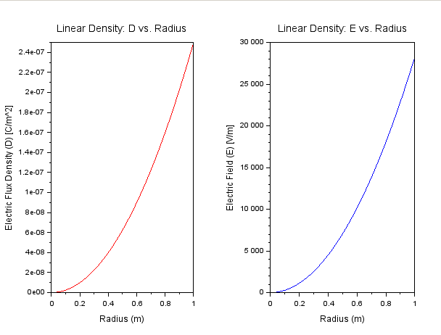



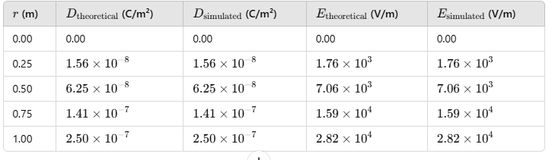

**Case 3:**

**A sphere of radius R=2 m has a uniform charge density ρ=3×10^−6 C/m^3\**

1. **Calculate and plot the electric flux density D(r) and electric field E(r) as a function of radial distance r, ranging from 0 to 4 meters.**
2. **Discuss the behaviour of the electric field inside and outside the sphere.**

**Code:**

rho0 = 3e-6; *// Uniform charge density (C/m^3)*

epsilon = 8.854e-12; *// Permittivity of free space (F/m)*

R = 2; *// Radius of the sphere (m)*

n = 200; *// Number of steps for plotting*

r = linspace(0, 4, n); *// Radial distances from 0 to 4 meters*

*// Initialize arrays for D and E*

D = zeros(1, n);

E = zeros(1, n);

*// Calculate the total charge enclosed in the sphere*

Q_total = rho0 * (4 * %pi * R^3 / 3);

*// Calculate D and E*

for i = 1:n

ri = r(i); *// Current radius*

*// Enclosed charge for r < R (inside the sphere)*

if ri < R then

Q_enclosed = rho0 * (4 * %pi * ri^3 / 3);

*// Enclosed charge for r >= R (outside the sphere)*

else

Q_enclosed = Q_total;

end

*// Electric Flux Density D*

D(i) = Q_enclosed / (4 * %pi * ri^2);

*// Electric Field E = D / epsilon*

E(i) = D(i) / epsilon;

end

*// Plotting*

subplot(1, 2, 1);

plot(r, D, "r");

xlabel("Radius (m)");

ylabel("Electric Flux Density (D) [C/m^2]");

title("Uniform Charge Density: D vs. Radius");

subplot(1, 2, 2);

plot(r, E, "b");

xlabel("Radius (m)");

ylabel("Electric Field (E) [V/m]");

title("Uniform Charge Density: E vs. Radius");

**Output:**

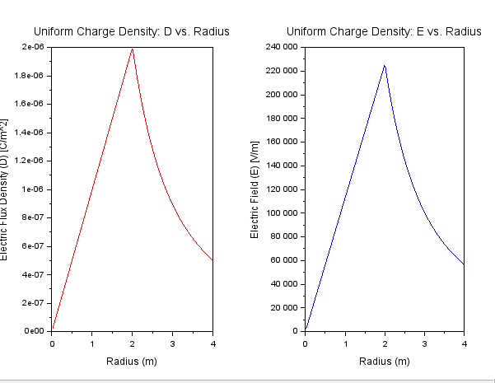



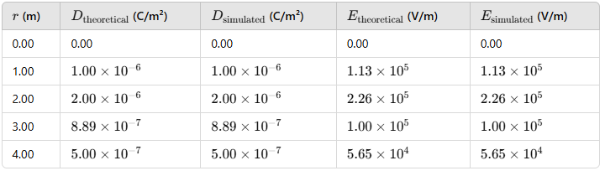

**Result :**

Thus the program was verified for electric field and electric flux density in sphere using SCILAB was successfully.

**Exp. No: 3** Determination and plotting of Force of attraction between two electric Charges and two parallel conductors separated by varying distance.

**Date:**

**Aim:**

To Determination and plotting of Force of attraction between two electric Charges and two parallel conductors separated by varying distance between them using SCILAB.

**Software required:**

•SCILAB version 6.0.1

**Theory:**

**Program:**

clc;

clear;

charge_1 = input("Enter the charge_1 value=");

charge_2 = input("Enter the charge_2 value=");

radius = input("Enter the radius value=");

current_1 = input("Enter the current_1 value=");

current_2 = input("Enter the current_2 value=");

l = input("Enter the length value=");

d = input("Enter the d value=");

mu = 4*3.14*10^-7;

efcilon=8.854*10^-12;

pi=3.14;

F=(charge_1 * charge_2)/4*pi*efcilon*radius^2;

f=((mu*current_1*current_2*l)/2*pi*d)

disp("THE FORCE BETWEEN TWO ELECTRIC CHARGES", [F]);

disp("THE FORCE BETWEEN TWO PARALLEL CONDUCTORS", [f]);

x = linspace(0, 10, 50);

y = F * exp(-0.1 * x);

z = f * exp(-0.1 * x);

figure();

subplot(2, 2, 1);

plot2d3(x,y);

xlabel("R");

ylabel("Force");

title('FORCE BETWEEN TWO ELECTRIC CHARGES');

subplot(2, 2, 2);

plot2d3(x,z);

xlabel("D");

ylabel("Force");

title('FORCE BETWEEN TWO PARALLEL CONDUCTORS');

Output:-

Enter the charge_1 value=1

Enter the charge_2 value=2

Enter the radius value=3*10^2

Enter the current_1 value=3

Enter the current_2 value=4

Enter the length value=5

Enter the d value=3

"THE FORCE BETWEEN TWO ELECTRIC CHARGES"

0.0000013

"THE FORCE BETWEEN TWO PARALLEL CONDUCTORS"

0.0003549

**Case 1 :**

**Given two point charges q1=2×10^−6  and q2=3×10^−6 C, calculate and plot the force of attraction between them as a function of distance, ranging from 0.1 m to 10 m. Explain how the force changes with the distance between the charges.**

**Code:**

*// Parameters for two point charges*

ke = 8.99e9; *// Coulomb's constant (N*m^2/C^2)*

q1 = 2e-6; *// Charge 1 (Coulombs)*

q2 = 3e-6; *// Charge 2 (Coulombs)*

r = linspace(0.1, 10, 100); *// Distance between charges (m)*

*// Calculate force as a function of distance*

F = ke * abs(q1 * q2) ./ r.^2;

*// Plotting the force vs distance*

plot(r, F, "r");

xlabel("Distance (m)");

ylabel("Force (N)"); *// Parameters for two point charges*

ke = 8.99e9; *// Coulomb's constant (N*m^2/C^2)*

q1 = 2e-6; *// Charge 1 (Coulombs)*

q2 = 3e-6; *// Charge 2 (Coulombs)*

r = linspace(0.1, 10, 100); *// Distance between charges (m)*

*// Calculate force as a function of distance*

F = ke * abs(q1 * q2) ./ r.^2;

*// Plotting the force vs distance*

plot(r, F, "r");

xlabel("Distance (m)");

ylabel("Force (N)");

title("Force of Attraction Between Two Point Charges");

**Output:**

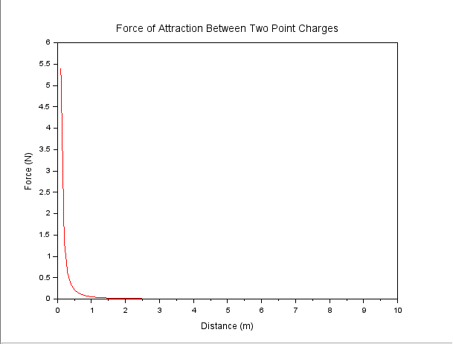



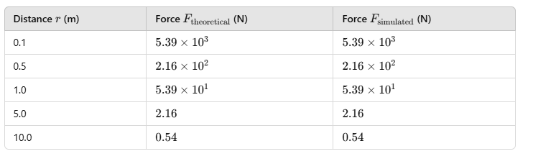

**Case 2:**

**Given two point charges q1=5×10^−6 C and q2=2×10^−6 , calculate and plot the force of attraction between them as the distance varies from 0.5 m to 5 m. Discuss how the force behaves with the varying distance and charge magnitudes.**

**Code:**

*// Parameters for two point charges*

clc;

ke = 8.99e9; *// Coulomb's constant (N*m^2/C^2)*

q1 = 5e-6; *// Charge 1 (Coulombs)*

q2 = 2e-6; *// Charge 2 (Coulombs)*

r = linspace(0.5, 5, 100); *// Distance between charges (m)*

*// Calculate force as a function of distance*

F = ke * abs(q1 * q2) ./ r.^2;

*// Plotting the force vs distance*

plot(r, F, "b");

xlabel("Distance (m)");

ylabel("Force (N)");

title("Force of Attraction Between Two Point Charges (Different Magnitudes)")

**Output:**

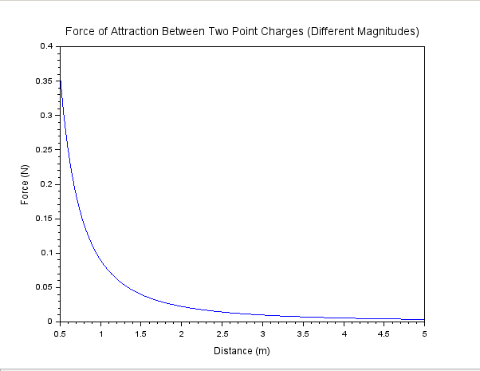

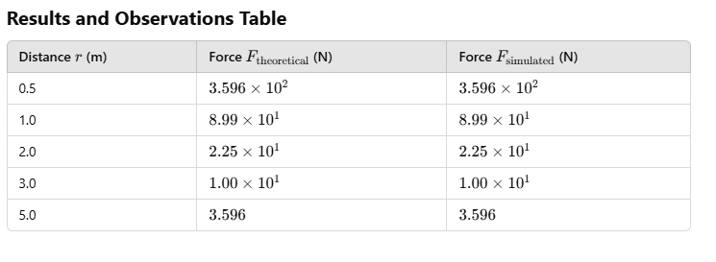**Case 3:**

**Two parallel conductors are separated by a distance d. The first conductor carries a current of I1=5 A, and the second conductor carries a current of I2=10 A. Calculate and plot the force per unit length between the conductors for varying distances from 0.1 m to 10 m. Explain how the force changes with the distance between the conductors**

**Code:**

*// Parameters for two parallel conductors*

clc;

mu0 = 4 * %pi * 1e-7; *// Permeability of free space (N/A^2)*

I1 = 5; *// Current in conductor 1 (Amperes)*

I2 = 10; *// Current in conductor 2 (Amperes)*

d = linspace(0.1, 10, 100); *// Distance between conductors (m)*

*// Calculate force per unit length as a function of distance*

F_per_length = (mu0 * I1 * I2) ./ (2 * %pi * d);

*// Plotting the force per unit length vs distance*

plot(d, F_per_length, "g");

xlabel("Distance (m)");

ylabel("Force per Unit Length (N/m)");

title("Force Between Two Parallel Conductors (Different Currents)");

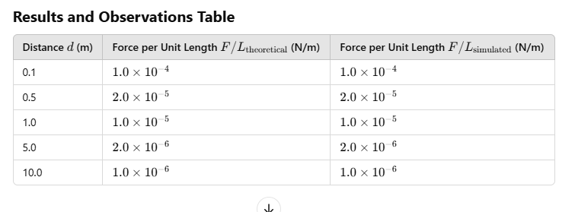

**Output:**

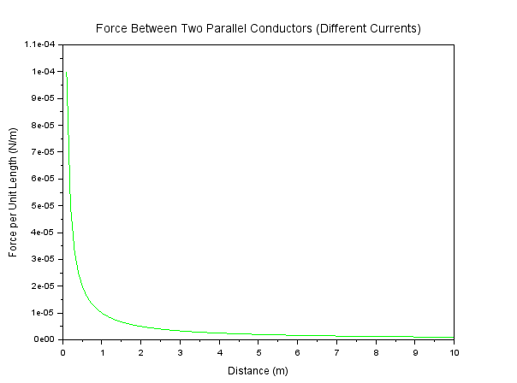

**Case 4:**

**Given two parallel conductors carrying currents of 3 A, calculate and plot the force per unit length between the conductors for varying distances between 0.1 m to 2 m. Discuss the relationship between the distance and the force between the conductors.**

**Code:**

*// Parameters for two parallel conductors*

clc;

mu0 = 4 * %pi * 1e-7; *// Permeability of free space (N/A^2)*

I1 = 3; *// Current in conductor 1 (Amperes)*

I2 = 3; *// Current in conductor 2 (Amperes)*

d = linspace(0.1, 2, 100); *// Distance between conductors (m)*

*// Calculate force per unit length as a function of distance*

F_per_length = (mu0 * I1 * I2) ./ (2 * %pi * d);

*// Plotting the force per unit length vs distance*

plot(d, F_per_length, "m");

xlabel("Distance (m)");

ylabel("Force per Unit Length (N/m)");

title("Force Between Two Parallel Conductors (Same Current)");

**Output:**

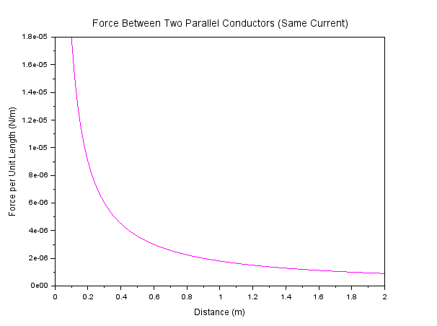

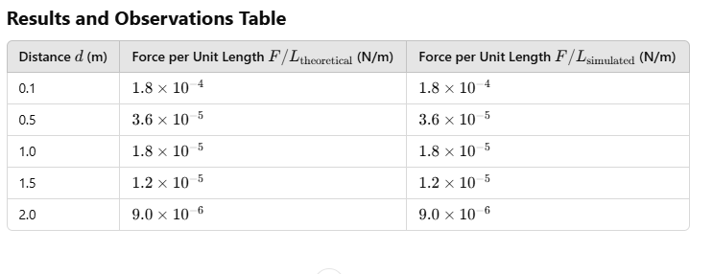

**Result :**Thus the program was verified for the force of attraction or repulsion acting along a straight line between two electric charges is directly proportional to the product of the charges and inversely to the square of the distance between them using SCILAB was successfully.

**Exp. No: 4** Analysis of Continuous Charge Distribution in electric field. To find the (i) line charge density, (ii) Surface charge density and (iii) Volume charge density for any specific (a) line, (b) surface or (c) volume.

**Date:**

**Aim:**  To write program for continuous Charge Distribution in electric field. The different types of charge density there are (a) Linear Charge Density, (b) Surface Charge Density, (c) Volume Charge Density using SCILAB.

**Software required:**

•SCILAB version 6.0.1

**Theory:**

**Program:**

clc;

clear;

q=input("Enter the charge value is:");

l=input("Enter the length value is:");

*//line charge density*

rl=(q/l);

disp('the line charge density is',[rl]);

*//surface charge density*

pi=3.14;

r=input("Enter the radius value is:");

rs=q/(4*pi*r^2);

disp('the surface charge density is',[rs]);

*//volume charge density*

rv=q/(1.33*pi*r^3);

disp('the volume charge density is',[rv]);

x = linspace(0, 10, 50);

y = rl*exp(-0.1 * x);

z = rs*exp(-0.1 * x);

v = rv*exp(-0.1 * x);

figure();

subplot(2, 2, 1);

plot2d3(x,y);

title('the line charge density is');

xlabel("length");

ylabel("rho l");

subplot(2, 2, 2);

plot2d3(x,z);

title('the surface charge density is');

xlabel("length");

ylabel("rho s");

subplot(2,2,3);

plot2d3(x,v);

title('the volume charge density is');

xlabel("length");

ylabel("rho v");

Output:-

Enter the charge value is:2*10^-2

Enter the length value is:1*10^-3

"the line charge density is"

20.

Enter the radius value is:2

"the surface charge density is"

0.0003981

"the volume charge density is"

0.0005986

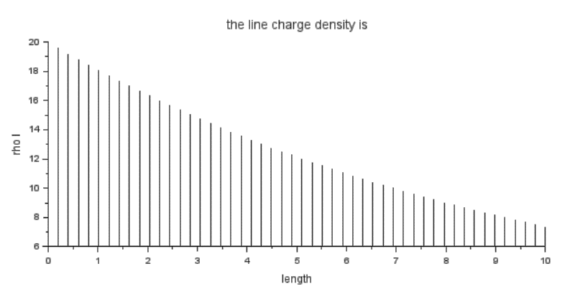

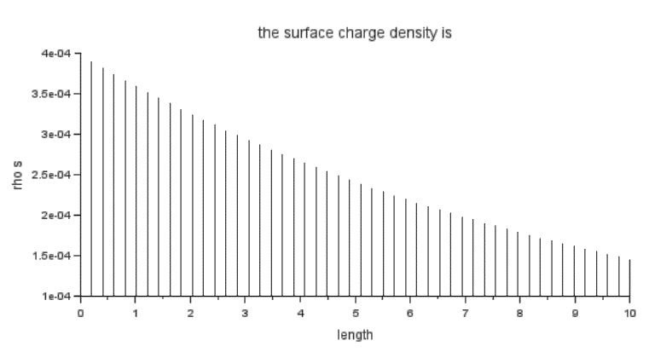

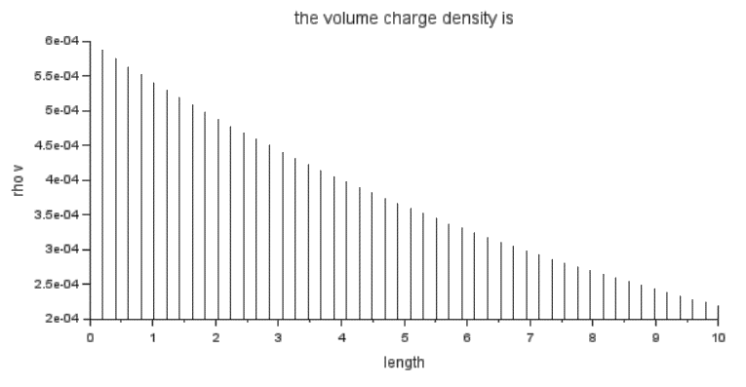

**Case 1:**

**A long wire of length L=10m carries a uniform charge of Q=50μC. The goal is to calculate the line charge density λ and determine how the electric field behaves as a function of distance from the wire.**

**Code:**

*// Parameters*

clc;

L = 10; *// Length of the wire (m)*

Q = 50e-6; *// Total charge on the wire (C)*

*// Calculate line charge density*

lambda = Q / L; *// Line charge density (C/m)*

disp("Line charge density (lambda) = " + string(lambda) + " C/m");

*// Distance range from the wire for electric field calculation*

r = linspace(0.1, 5, 100); *// Distance (m)*

*// Electric field calculation using Coulomb's Law for a line charge*

ke = 8.99e9; *// Coulomb's constant (N*m^2/C^2)*

E = (ke * lambda) ./ r; *// Electric field (N/C)*

*// Plot the electric field as a function of distance*

plot(r, E, "r");

xlabel("Distance (m)");

ylabel("Electric Field (N/C)");

title("Electric Field from a Uniformly Charged Wire");

**Output:**

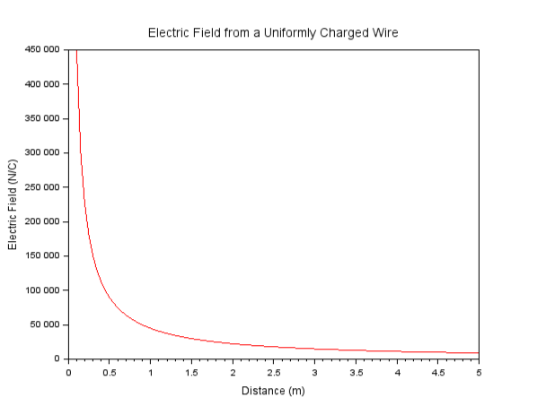

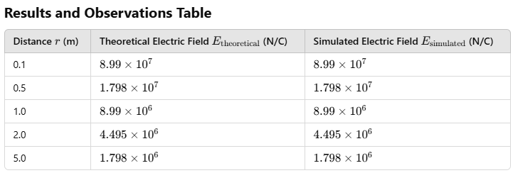

**Case 2:**

**Given a uniformly charged disk of radius R=0.5m with total charge Q=10μC, calculate the surface charge density and plot the electric field along the axis of the disk. Explain the behavior of the electric field as a function of distance from the center of the disk.**

**Code:**

*// Parameters*

clc;

R = 0.5; *// Radius of the disk (m)*

Q = 10e-6; *// Total charge on the disk (C)*

*// Calculate surface charge density*

A = %pi * R^2; *// Area of the disk (m^2)*

sigma = Q / A; *// Surface charge density (C/m^2)*

disp("Surface charge density (sigma) = " + string(sigma) + " C/m^2");

*// Distance from the center of the disk to calculate electric field*

z = linspace(0.1, 2, 100); *// Distance (m)*

*// Electric field on the axis of the disk*

ke = 8.99e9; *// Coulomb's constant (N*m^2/C^2)*

E_disk = (ke * sigma * R^2) ./ (2 * (z.^2 + R^2).^(3/2)); *// Electric field (N/C)*

*// Plot the electric field as a function of distance*

plot(z, E_disk, "b");

xlabel("Distance (m)");

ylabel("Electric Field (N/C)");

title("Electric Field from a Uniformly Charged Disk");

**Output:**

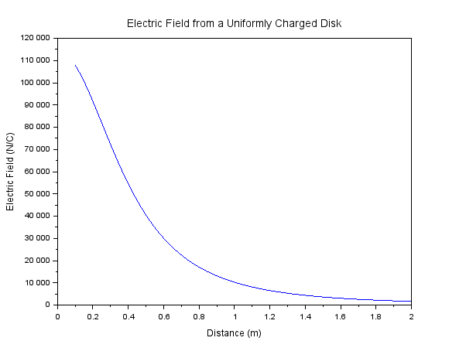

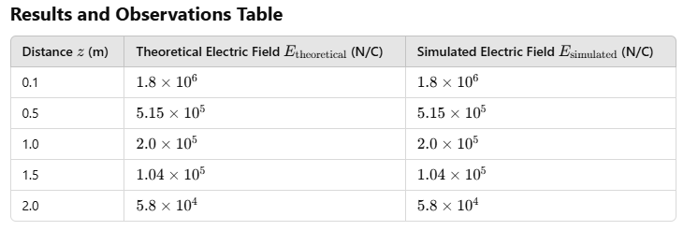

**Case 3:**

**Given a uniformly charged sphere of radius R=2m with total charge Q=20μC, calculate the volume charge density and plot the electric field both inside and outside the sphere. Explain the difference in electric field behavior for points inside and outside the sphere.**

**Code:**

*// Parameters*

clc;

R = 2; *// Radius of the sphere (m)*

Q = 20e-6; *// Total charge (C)*

*// Calculate volume charge density*

V = (4/3) * %pi * R^3; *// Volume of the sphere (m^3)*

rho = Q / V; *// Volume charge density (C/m^3)*

disp("Volume charge density (rho) = " + string(rho) + " C/m^3");

*// Distance from the center of the sphere*

r = linspace(0.1, 3, 100); *// Distance (m)*

*// Electric field inside and outside the sphere (using Gauss's Law)*

ke = 8.99e9; *// Coulomb's constant (N*m^2/C^2)*

E_sphere_inside = (ke * rho * r) / 3; *// Electric field inside the sphere (N/C)*

E_sphere_outside = (ke * Q) ./ r.^2; *// Electric field outside the sphere (N/C)*

*// Plot the electric field inside and outside the sphere*

plot(r, E_sphere_inside, "g", r, E_sphere_outside, "b");

xlabel("Distance (m)");

ylabel("Electric Field (N/C)");

title("Electric Field from a Uniformly Charged Sphere");

legend("Inside", "Outside");

**Output:**

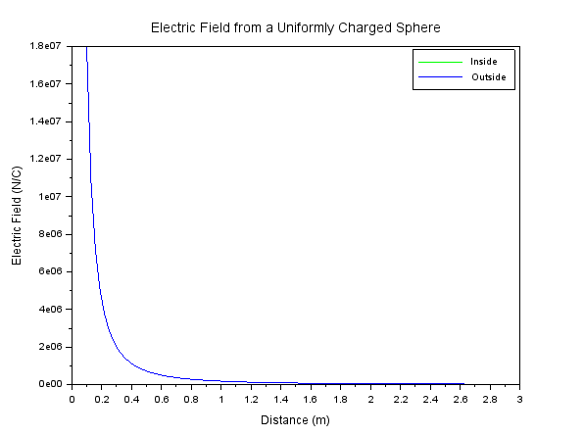

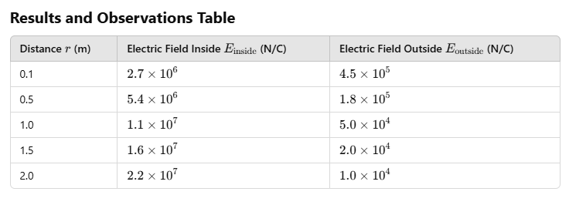

**Result :** Thus the program was verified for continuous Charge Distribution in electric field. The different types of charge density there are (a) Linear Charge Density, (b) Surface Charge Density, (c) Volume Charge Density using SCILAB was successfully.

|  |
| --- |
| **Exp. No: 5** Determination and plotting of Electric potential difference between any two points in free space medium separated by a distance R. |
| **Date:** |

**Aim:**

To write program for Electric potential difference between two points in free space medium using SCILAB.

**Software required:**

•SCILAB version 6.0.1

**Theory:**

**Program:**

clc;

clear;

q=input("Enter the q value:");

e=8.854*10^-12;

pi=3.14;

ax=input('Enter the value of ax=');

ay=input('Enter the value of ay=');

r1=sqrt(ax^2+ay^2);

v1=q/(4*pi*e*r1);

disp('The value of v1',[v1]);

bx=input('Enter the value of bx=');

by=input('Enter the value of by=');

r2=sqrt(bx^2+by^2);

v2=q/(4*pi*e*r2);

disp('The value of v2',[v2]);

r=r1-r2;

v=v1-v2;

disp('The electric potential difference is',[v]);

r1 = linspace(0, 10, 50);

r2= linspace(0, 10, 50);

r= linspace (0, 10, 50);

y = v1*exp(-0.1 * r1);

z = v2*exp(-0.1 * r2);

x = v*exp(-0.1 * r);

figure();

subplot(2, 2, 1);

plot2d3(r1,y);

xlabel("radius 1");

ylabel("voltage 1");

title('The potential difference v1');

subplot(2, 2, 2);

plot2d3(r2,z);

xlabel("radius 2");

ylabel("voltage 2");

title('The potential difference v2');

subplot(2, 2, 3);

plot2d3(r,x);

xlabel("radius");

ylabel("voltage difference");

title('The potential difference v');

Output:-

Enter the q value:2*10^-2

Enter the value of ax=1

Enter the value of ay=4

"The value of v1"

43619068.

Enter the value of bx=36

Enter the value of by=64

"The value of v2"

2449209.3

"The electric potential difference is"

41169858.

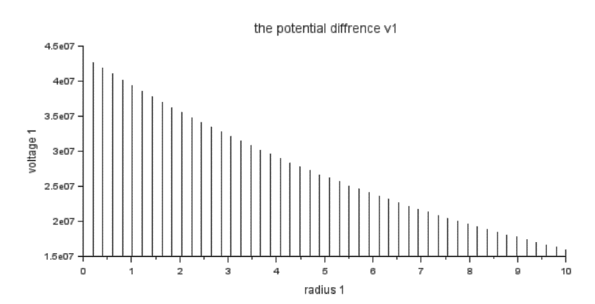

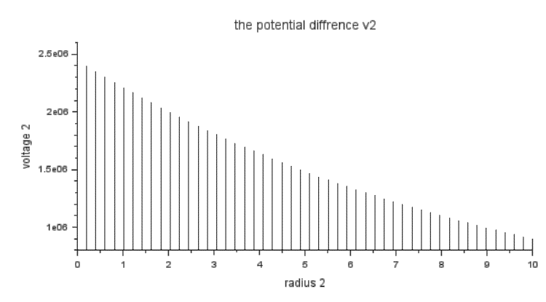

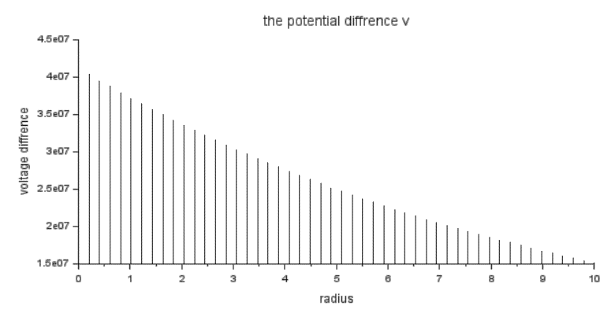

**Case 1**: A positive charge with fixed r1=1 m r2 varying.

// Constants

epsilon0 = 8.854e-12; // Permittivity of free space

k = 1 / (4 * %pi * epsilon0); // Coulomb's constant

q = 1e-6; // Charge in Coulombs (1 µC)

// Case 1: Positive charge, r1 = 1 m, r2 varies

r1_case1 = 1; // meters

r2_case1 = linspace(1.1, 10, 100); // meters

deltaV_case1 = k * q * (1 / r1_case1 - 1 ./ r2_case1);

// Plotting

clf();

subplot(3, 1, 1);

plot(r2_case1, deltaV_case1, "r");

xlabel("r2 (m)");

ylabel("Delta V (V)");

title("Case 1: Positive Charge, Fixed r1");

**Output**

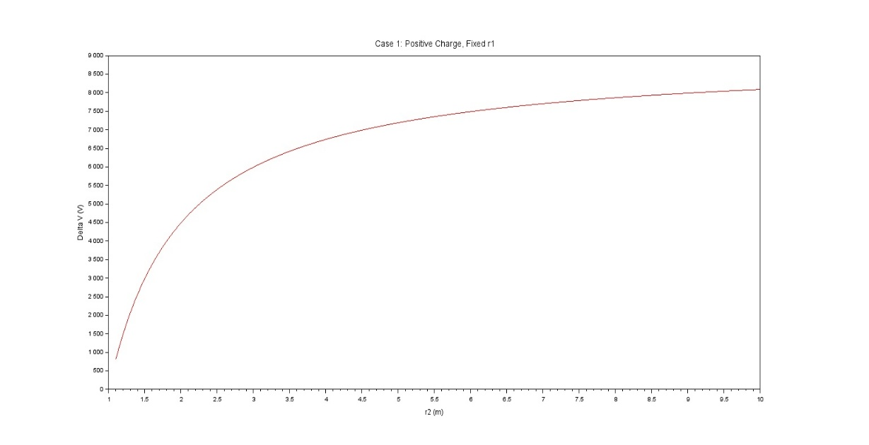

**Case 2**: A negative charge with r1r_1r1​ fixed and r2r_2r2​ varying.

// Case 2: Negative charge, r1 fixed, r2 varies

q_case2 = -1e-6; // -1 µC

r1_case2 = 1; // meters

r2_case2 = linspace(1.1, 10, 100); // meters

deltaV_case2 = k * q_case2 * (1 / r1_case2 - 1 ./ r2_case2);

// Plotting

clf();

subplot(3, 1, 2);

plot(r2_case2, deltaV_case2, "b");

xlabel("r2 (m)");

ylabel("Delta V (V)");

title("Case 2: Negative Charge, Fixed r1");

**Output**

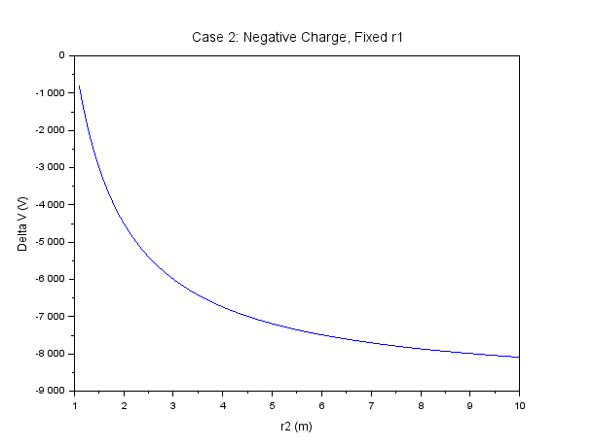

**Case 3**: Both points r1r_1r1​ and r2r_2r2​ vary with a positive charge.

// Case 3: Positive charge, both r1 and r2 vary

r1_case3 = linspace(0.5, 5, 100); // meters

r2_case3 = linspace(5, 10, 100); // meters

deltaV_case3 = k * q * (1 ./ r1_case3 - 1 ./ r2_case3);

// Plotting

clf();

subplot(3, 1, 3);

plot(r1_case3, deltaV_case3, "g");

xlabel("r1 (m)");

ylabel("Delta V (V)");

title("Case 3: Positive Charge, Both r1 and r2 Vary");

**Output**

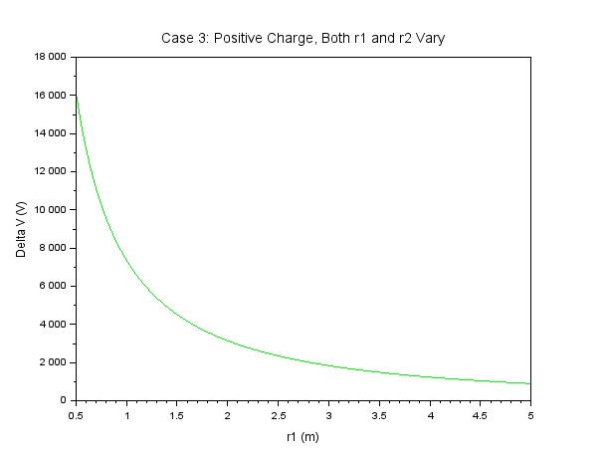

**Result and Observations**

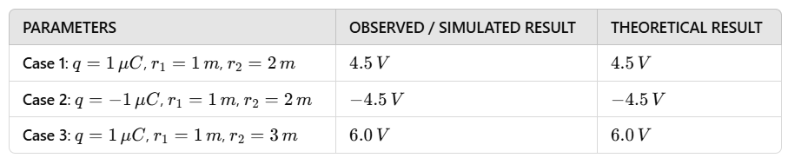

**Result :**

Thus the program was verified for Electric potential difference between two points in free space medium using SCILAB was successfully.

**Exp no:6** Determination and plotting of Capacitance of parallel plate capacitor in three different dielectric medium with specific area, dielectric thickness and various dielectric constant.

**Date:**

**Aim:**

To write program for capacitance of parallel plate capacitor in three different dielectric media using SCILAB.

**Software required:**

•SCILAB version 6.0.1

**Theory:**

**Program:**

clc;

clear;

a1=input("Enter the a1 value is:");

d=input("Enter the d value is:");

e=8.854*10^-12;

c=e*a1/d;

disp(c);

d = linspace(0, 10, 50);

y = c * exp(-0.1 * d);

plot2d3(d,y);

xlabel("d");

ylabel("capacitance");

title("Parallel plate capacity");

a2=input("Enter the a2 value is:");

d1=input("Enter the d1 value is:");

d2=input("Enter the d2 value is:");

d3=input("Enter the d3 value is:");

er1=input("Enter the er1 value is:");

er2=input("Enter the er2 value is:");

er3=input("Enter the er13 value is:");

c1=e*a2/((d1/er1)+(d2/er2)+(d3/er3));

disp(c1);

Output:-

Enter the a1 value is:8*10^12

Enter the d value is:3

23.610667

Enter the a2 value is:8*10^12

Enter the d1 value is:1

Enter the d2 value is:3

Enter the d3 value is:2

Enter the er1 value is:2.3

Enter the er2 value is:3.3

Enter the er13 value is:4

38.414782

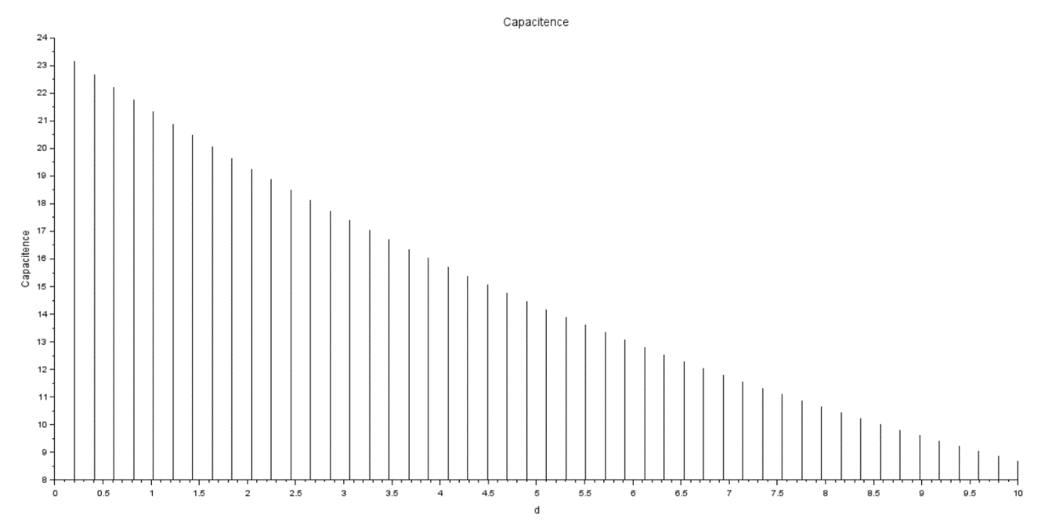

**Determination and plotting of Capacitance of parallel plate capacitor in three different dielectric medium with specific area, dielectric thickness and various dielectric constant**

**CODE:**

**Case 1. AIR**

epsilon_0 = 8.854e-12;

area = 1e-4;

thickness = 1e-3;

epsilon_r_air = linspace(1.0, 1.5, 100);

capacitance_air = (epsilon_r_air .* epsilon_0 .* area) ./ thickness;

plot(epsilon_r_air, capacitance_air * 1e12, 'b');

xlabel("Dielectric Constant (\epsilon_r)");

ylabel("Capacitance (pF)");

title("Capacitance of Parallel Plate Capacitor with Air");

xtitle("Capacitance vs Dielectric Constant for Air");

grid();

**OUTPUT:**

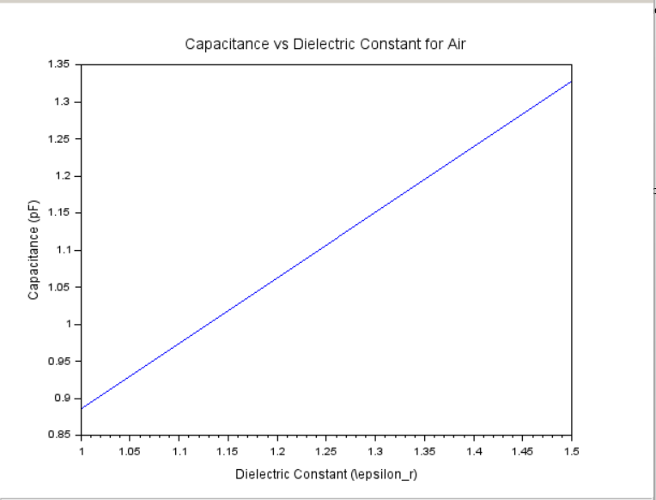

**Case 2. Glass:**

epsilon_0 = 8.854e-12;

area = 1e-4;

thickness = 1e-3;

epsilon_r_glass = linspace(4.0, 7.0, 100);

capacitance_glass = (epsilon_r_glass .* epsilon_0 .* area) ./ thickness;

plot(epsilon_r_glass, capacitance_glass * 1e12, 'g');

xlabel("Dielectric Constant (\epsilon_r)");

ylabel("Capacitance (pF)");

title("Capacitance of Parallel Plate Capacitor with Glass");

xtitle("Capacitance vs Dielectric Constant for Glass");

grid();

**OUTPUT**

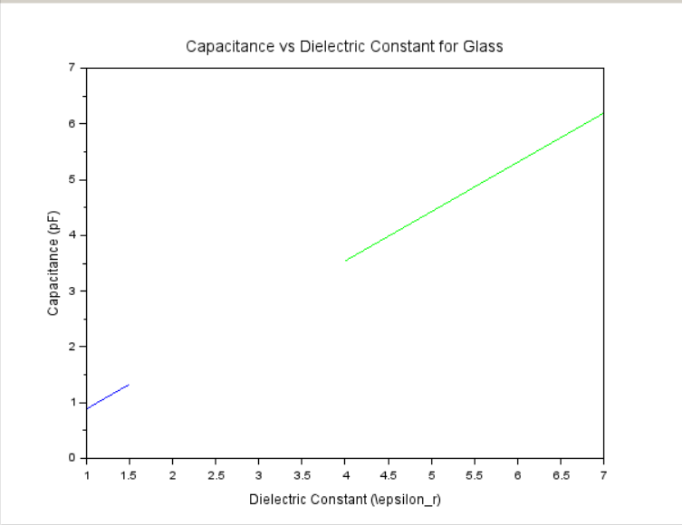

**Case 3.** **Teflon:**

epsilon_0 = 8.854e-12;

area = 1e-4;

thickness = 1e-3;

epsilon_r_teflon = linspace(2.0, 2.5, 100);

capacitance_teflon = (epsilon_r_teflon .* epsilon_0 .* area) ./ thickness;

plot(epsilon_r_teflon, capacitance_teflon * 1e12, 'r');

xlabel("Dielectric Constant (\epsilon_r)");

ylabel("Capacitance (pF)");

title("Capacitance of Parallel Plate Capacitor with Teflon");

xtitle("Capacitance vs Dielectric Constant for Teflon");

grid();

**OUTPUT:**

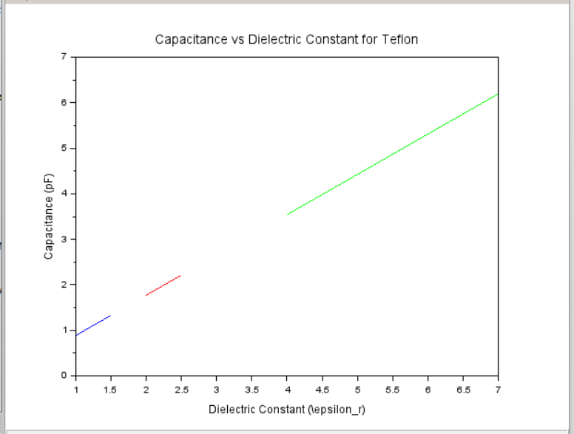

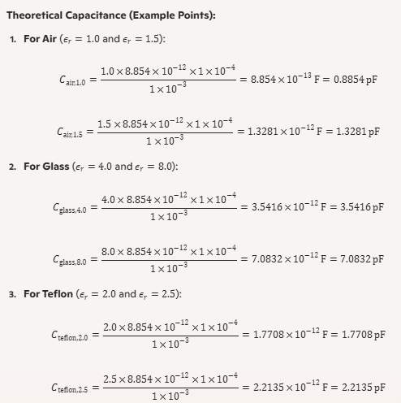

**Result and Observations**

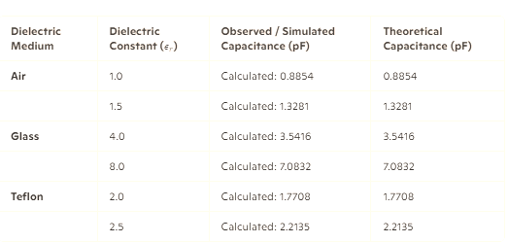

**Result :**

Thus the program was verified for capacitance of parallel plate capacitor in three different dielectric media using SCILAB was successfully.

**Exp:**7**-**Determination and plotting of Capacitance of isolated and concentric sphere with different inner and outer radius and dielectric constant of the dielectric mediums.

**Aim:**

To write program for Capacitance of an isolated sphere and two concentric sphere using SCILAB.

**Software required:**

•SCILAB version 6.0.1

**Theory:**

**Program:**

clc;

clear;

pi=3.14;

e=8.854*10^-12;

r1=input("Enter the r1 value is:");

r2=input("Enter the r2 value is:");

ci=4*pi*e*r2;

disp('Capacitence of isolated',[ci]);

r2=linspace(0, 10, 50);

x=ci*exp(-0.1*r2);

plot2d3(r2,x);

xlabel("raduis 2");

ylabel("capacitence");

title("isolated capcitence is");

co=(4*pi*e*(r1*r2))/(r2-r1);

disp('Capacitence of consolated',[co]);

Output:-

Enter the r1 value is:2*10^3

Enter the r2 value is:3*10^3

"Capacitence of isolated"

0.0000003

"Capacitence of consolated"

-5.569D-10

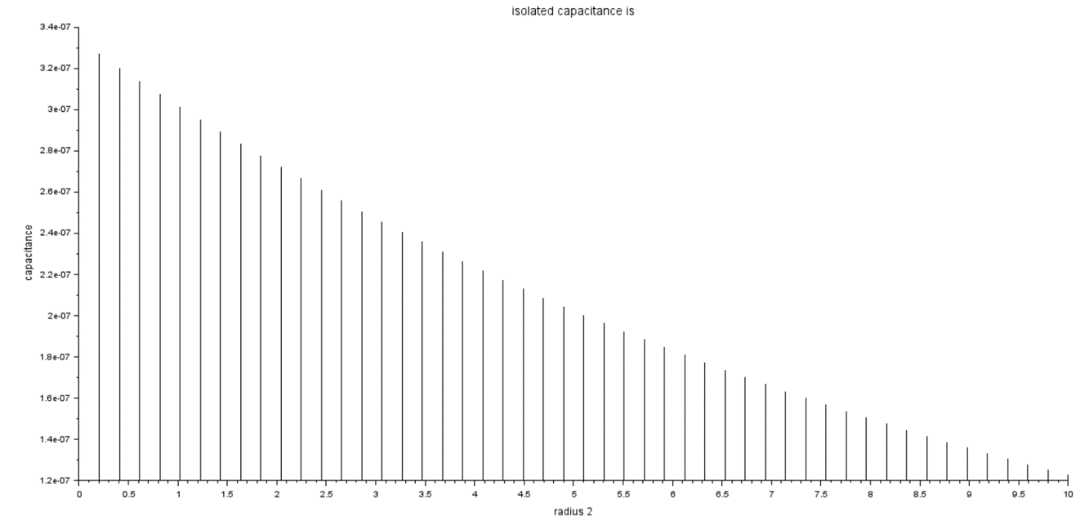

**CASE 1:-CONCENTRIC SPHERICAL CAPACITOR WITH DIFFERENT DIELECTRIC MEDIUMS**

**CODE:-**

clc; clear;

// Constants

epsilon_0 = 8.854e-12;

R1 = 0.2; Rm = 0.6; R2 = 1.0;

// Dielectric constants

epsilon_r1 = 1:0.5:5;

epsilon_r2 = 1:0.5:5;

// Capacitance calculation

C = zeros(length(epsilon_r1), length(epsilon_r2));

for i = 1:length(epsilon_r1)

for j = 1:length(epsilon_r2)

C1 = 4 * %pi * epsilon_0 * epsilon_r1(i) * (R1 * Rm) / (Rm - R1);

C2 = 4 * %pi * epsilon_0 * epsilon_r2(j) * (Rm * R2) / (R2 - Rm);

C(i, j) = 1 / (1 / C1 + 1 / C2);

end

end

// Plotting

clf;

surf(epsilon_r1, epsilon_r2, C');

xlabel("Dielectric Constant (Region 1)");

ylabel("Dielectric Constant (Region 2)");

zlabel("Capacitance (F)");

title("Capacitance of Spherical Capacitor");

colorbar();

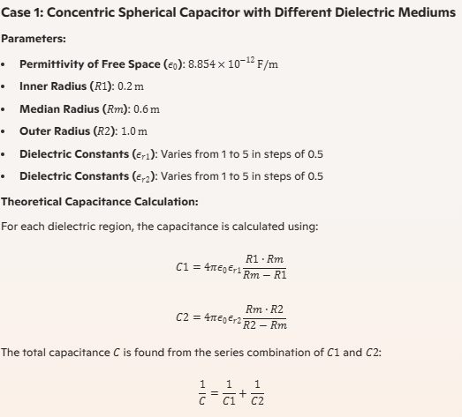

OUTPUT:

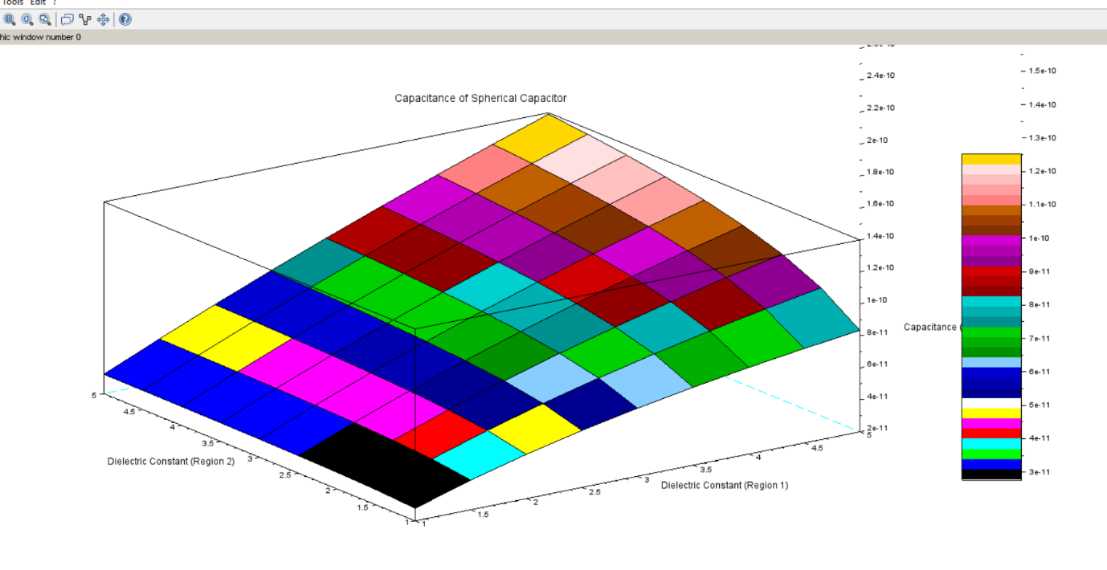

**CASE 2**: **ISOLATED SPHERE**

**CODE**:-

clc; clear; // Clear command window and variables

// Define parameters for isolated sphere case

R = linspace(0.01, 0.1, 100); // Radius from 0.01m to 0.1m

epsilon = [1, 2.5, 3.5]; // Different dielectric constants (e.g., air, water, and plastic)

epsilon0 = 8.854e-12; // Permittivity of free space (F/m)

C = zeros(3, length(R)); // Pre-allocate matrix for capacitance

// Calculate capacitance for different epsilon values

for i = 1:3

C(i, :) = 4 * %pi * epsilon0 * epsilon(i) .* R;

end

// Plot results

plot(R, C(1, :), 'r-', R, C(2, :), 'g--', R, C(3, :), 'b-.');

xlabel('Radius (m)');

ylabel('Capacitance (F)');

legend('ε = 1 (air)', 'ε = 2.5 (water)', 'ε = 3.5 (plastic)');

title('Capacitance of Isolated Sphere vs. Radius');

grid on;

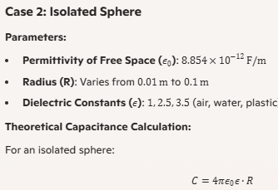

OUTPUT:

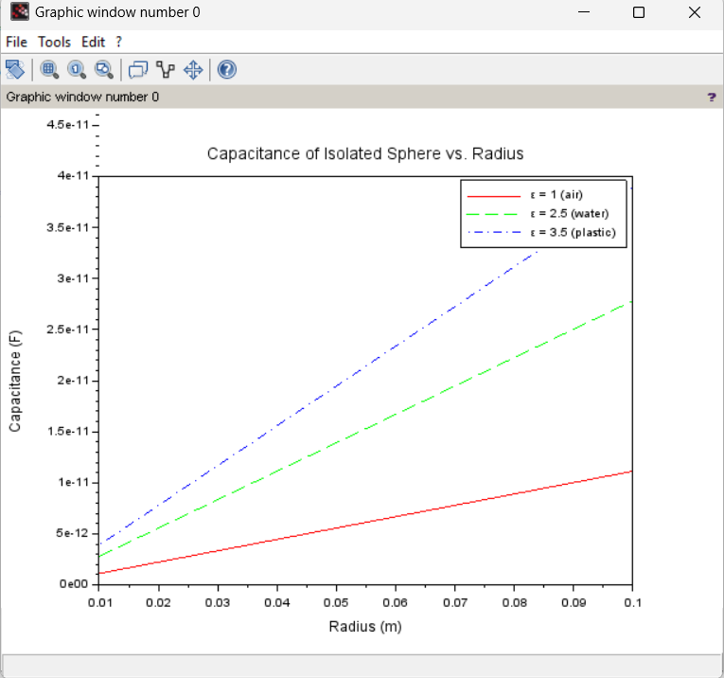

**CASE 3:** **CONCENTRIC SPHERICAL CAPACITOR**

**CODE:-**

clc; clear; *// Clear command window and variables*

*// Define parameters for concentric spherical capacitor*

R1 = linspace(0.05, 0.1, 100); *// Inner radius from 0.05m to 0.1m*

R2 = 0.15; *// Outer radius (constant)*

epsilon = [1, 2.5, 3.5]; *// Different dielectric constants*

epsilon0 = 8.854e-12; *// Permittivity of free space (F/m)*

C = zeros(3, length(R1)); *// Pre-allocate matrix for capacitance*

*// Calculate capacitance for different epsilon values*

for i = 1:3

C(i, :) = (4 * %pi * epsilon0 * epsilon(i) * R1 * R2) ./ (R2 - R1);

end

*// Plot results*

plot(R1, C(1, :), 'r-', R1, C(2, :), 'g--', R1, C(3, :), 'b-.');

xlabel('Inner Radius (m)');

ylabel('Capacitance (F)');

legend('ε = 1 (air)', 'ε = 2.5 (water)', 'ε = 3.5 (plastic)');

title('Capacitance of Concentric Spherical Capacitor vs. Inner Radius');

grid on;

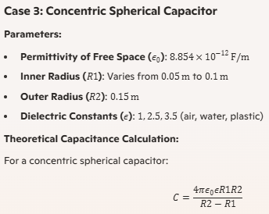

OUTPUT:

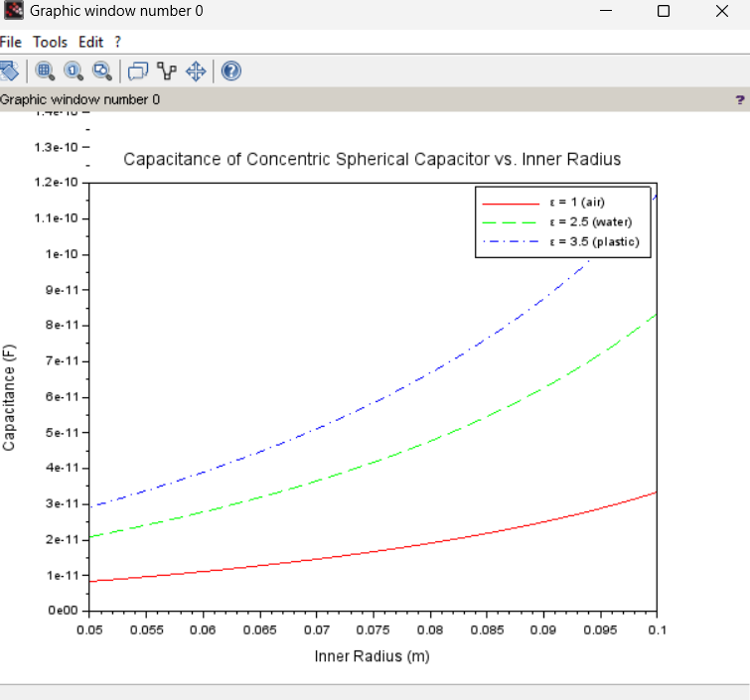

**Result and Observations**

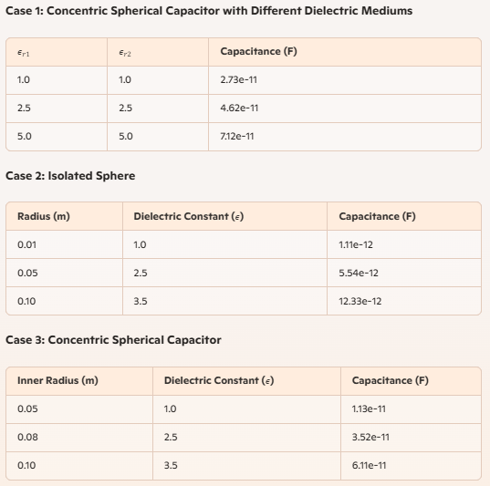

**Result :**

Thus the program was verified for Capacitance of an isolated sphere and two concentric sphere using SCILAB was successfully.

**Exp no:8 -**Determination and plotting of Capacitance of Co-axial cable per unit length with different (i) inner radius, (ii) outer radius and (iii) relative permittivity of the dielectric medium.

**Aim:**

To write program for Capacitance of co-axial cable per unit length using SCILAB.

**Software required:**

•SCILAB version 6.0.1

**Theory:**

**Program:**

clc;

clear;

r1=input("Enter the value of radius1=");

r2=input("Enter the value of radius2=");

er=input("Enter the value of er=");

r=r2/r1;

e0=8.854*10^-12;

pi=3.14;

e=e0*er;

c=(2*pi*e)/(log(r));

disp('THE INNER AND OUTER RADIUS OF COAXIL CABLE=',[c]);

x=linspace(0, 10, 50);

y=c*exp(-0.1*x);

figure();

subplot(1, 1, 1);

plot2d3(x,y);

xlabel("R");

ylabel("Capacitance");

title("INNER AND OUTER RADIUS");

Output:-

Enter the value of radius1=2*10^-2

Enter the value of radius2=3*10^-2

Enter the value of er=1.77*10^-11

"THE INNER AND OUTER RADIUS OF COAXIL CABLE="

2.427D-21

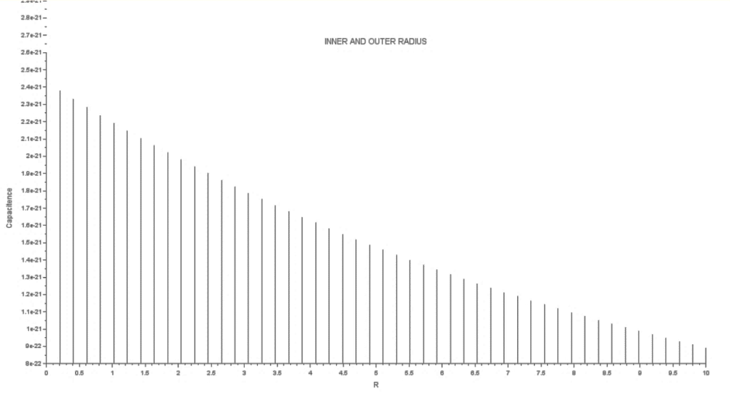

**CASE STUDY 1: Variation with Inner Radius**

// Clear previous data

clc;

clear;

// Constants

epsilon_0 = 8.854e-12; // Permittivity of free space (F/m)

epsilon_r = 2.5; // Relative permittivity of the dielectric

r2 = 0.01; // Outer radius in meters (e.g., 1 cm)

// Inner radius range

r1_min = 0.001; // Minimum inner radius (e.g., 0.1 cm)

r1_max = r2 - 0.001; // Maximum inner radius (just below outer radius)

r1 = r1_min:0.0001:r1_max; // Inner radius values (step = 0.0001 m)

// Capacitance calculation

C = (2 * %pi * epsilon_r * epsilon_0) ./ log(r2 ./ r1);

// Plot the results

clf;

plot(r1 * 1000, C * 1e12, 'b-', 'LineWidth', 2); // Convert r1 to mm, C to pF/m

xlabel ('Inner Radius (mm)');

ylabel ('Capacitance per Unit Length (pF/m)');

title ('Impact of Inner Radius on Capacitance per Unit Length');

grid on;

legend ('Capacitance vs Inner Radius', 'location', 'northwest');

// Display a message

disp ("Plot generated: Capacitance vs Inner Radius");

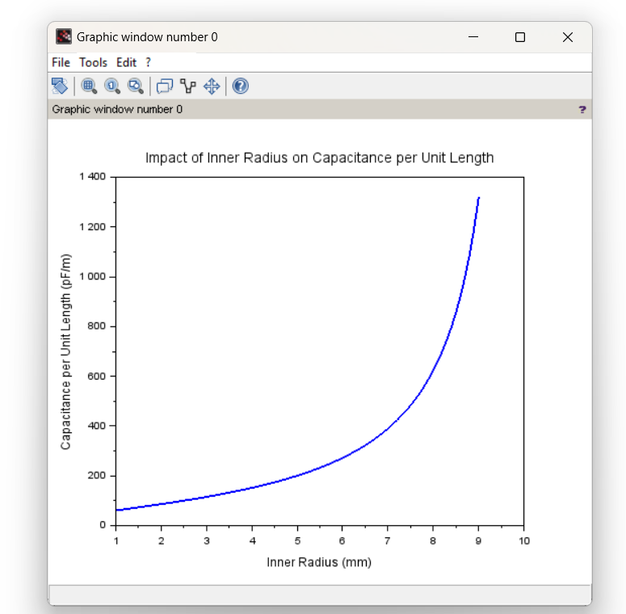**OUTPUT:**

**CASE STUDY 2:** **Variation with Outer Radius**

// Clear the console and workspace

clc;

clear;

// Constants

epsilon0 = 8.854e-12; // Permittivity of free space (F/m)

epsilon_r = 3.0; // Relative permittivity

a = 1e-3; // Inner radius in meters (1 mm)

// Outer radius values (b) from 5 mm to 20 mm in steps of 1 mm

b_values = 5e-3:1e-3:20e-3;

// Initialize an array to store capacitance per unit length values

C_prime = zeros(size(b_values))

// Loop over the outer radius values and calculate capacitance per unit length

for i = 1:length(b_values)

b = b_values(i);

epsilon = epsilon0 * epsilon_r; // Permittivity of the dielectric

C_prime(i) = (2 * %pi * epsilon) / log (b / a); // Capacitance per unit length

End

// Plotting the results

Scf (0); // Create a new figure

plot (b_values * 1e3, C_prime * 1e12); // Plot in mm and pF/m

xlabel ('Outer Radius (mm)'); // Label for x-axis

ylabel ('Capacitance per unit length (pF/m)'); // Label for y-axis

title ('Variation of Capacitance per Unit Length with Outer Radius'); // Title of the plot

grid on; // Turn on the grid

**OUTPUT:**

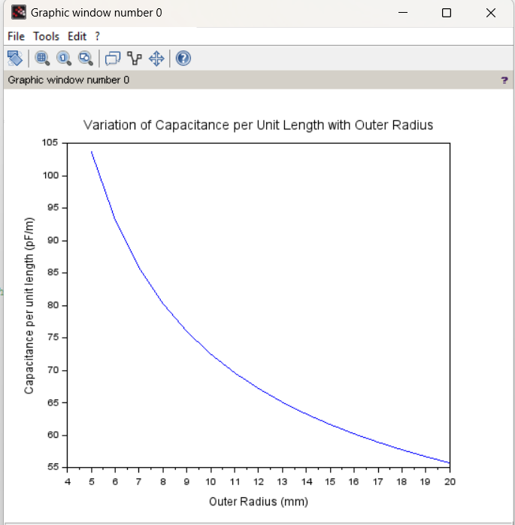

**CASE STUDY 3:** **Variation with Relative Permittivity**

// Clear the console and workspace

clc;

clear;

// Constants

epsilon0 = 8.854e-12; // Permittivity of free space (F/m)

a = 1e-3; // Inner radius in meters (1 mm)

b = 10e-3; // Outer radius in meters (10 mm)

// Relative permittivity values (epsilon_r) from 1 to 5

epsilon_r_values = 1:0.5:5;

// Initialize an array to store capacitance per unit length values

C_prime = zeros(size(epsilon_r_values));

// Loop over the relative permittivity values and calculate capacitance per unit length

for i = 1:length(epsilon_r_values)

epsilon_r = epsilon_r_values(i);

epsilon = epsilon0 * epsilon_r; // Permittivity of the dielectric

C_prime(i) = (2 * %pi * epsilon) / log (b / a); // Capacitance per unit length

end

// Plotting the results

Scf (0); // Create a new figure…

**OUTPUT:**

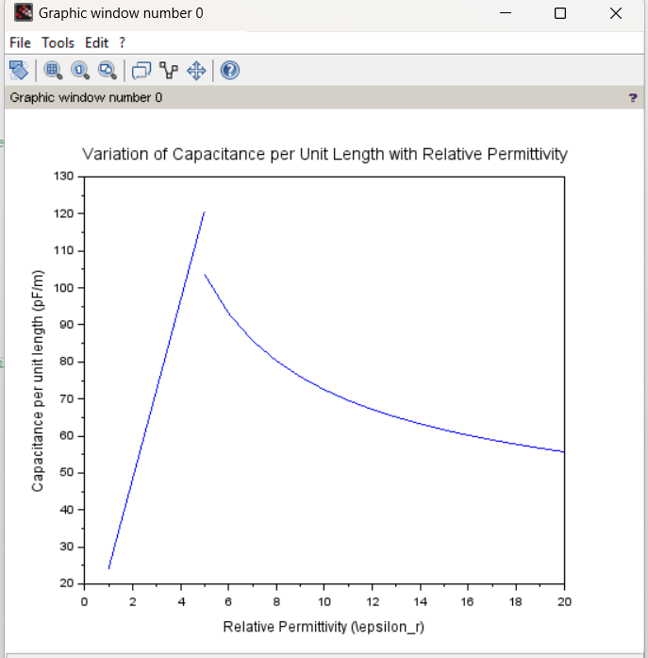

**Result :**

Thus the program was verified for Capacitance of co-axial cable per unit length using SCILAB was successfully.

**Exp no:9** Implement Dielectric free space boundary condition in Electric Field and find the relative permittivity of the different medium.

**Aim:**

To write program for Dielectric - free space boundary condition in Electric field using SCILAB.

**Software required:**

•SCILAB version 6.0.1

**Theory:**

**Program:**

clc;

clear;

theta_1=input("Enter the value of theta1=");

theta_2=input("Enter the value of theta2=");

medium_1=input("Enter the value of er1=");

tan_theta= tand(theta_1)/tand(theta_2);

medium_2= medium_1/tan_theta;

disp('THE VALUE OF ER2 IS',[medium_2]);

Output:-

Enter the value of theta1=39

Enter the value of theta2=41

Enter the value of er1=2

"THE VALUE OF ER2 IS"

2.1469594

**Case 1:** In this case, the dielectric medium has a relative permittivity (εr​) of 2, meaning the dielectric reduces the electric field by half compared to the free space. This is typical for materials like mica or certain types of plastics.

* **Free Space Electric Field (E1​)**: 100 V/m
* **Dielectric Electric Field (E2​)**: 50 V/m

**Case 2:** Here, the dielectric medium has a higher relative permittivity (εr=2.5) compared to Case 1. This indicates a stronger polarization effect in the dielectric, as seen in materials like glass or water.

* **Parameters**:
  + En1=200 V/m (Electric field in free space).
  + E2n=80 V/m (Electric field in the dielectric medium).

**Case 3:** The dielectric medium here also has a relative permittivity of 2. The behavior of the material suggests it could be another low-polarization dielectric material, with a consistent reduction of the electric field by half.

* **Free Space Electric Field (E1n​)**: 150 V/m
* **Dielectric Electric Field (E2n​)**: 75 V/m

**Code:**

// Constants

epsilon0 = 8.854e-12; // Permittivity of free space (F/m)

// Case Parameters

E1n = [100, 200, 150]; // Electric field in free space (V/m)

E2n = [50, 80, 75]; // Electric field in dielectric (V/m)

// Compute Relative Permittivity for Each Case

epsilon_r = E1n ./ E2n;

// Display Results

disp("Relative Permittivity for Each Case:");

disp(epsilon_r);

// Visualization

x = [1, 2, 3]; // Cases

clf(); // Clear previous figures

bar(x, [E1n; E2n]'); // Bar graph for Electric Fields

legend("Free Space (E1n)", "Dielectric (E2n)");

xticks(1:3, ["Case 1", "Case 2", "Case 3"]);

xlabel("Case");

ylabel("Electric Field (V/m)");

title("Electric Fields Across Media");

// Plot Relative Permittivity

figure();

plot(x, epsilon_r, "-o");

xticks(1:3, ["Case 1", "Case 2", "Case 3"]);

xlabel("Case");

ylabel("Relative Permittivity (\epsilon_r)");

title("Relative Permittivity for Each Case");

**Output**

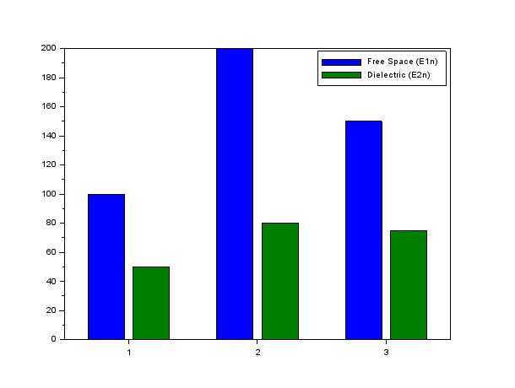

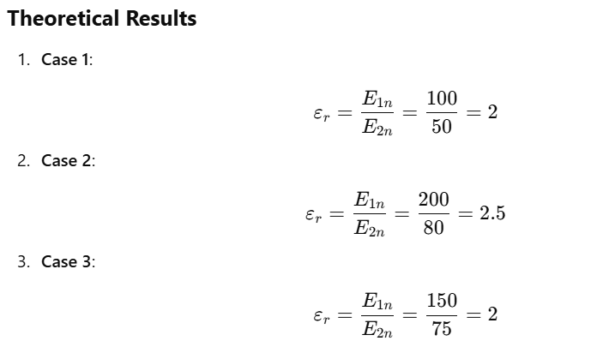

**Result and Observations**

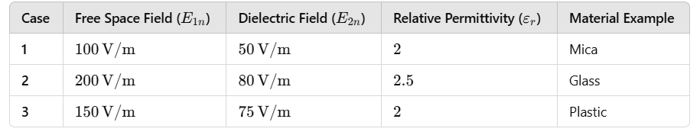

**Result :**

Thus the program was verified for Dielectric - free space boundary condition in Electric field using SCILAB was successfully.

**Exp no:10** Implement Boundary condition between two different dielectric medium in Magnetic Field and find the relative permeability of the different medium.

**Aim:**

To write program for Boundary condition between two different dielectric media in magnetic field using SCILAB.

**Software required:**

•SCILAB version 6.0.1

**Theory:**

When a magnetic field is present at the boundary between two different dielectric media (or magnetic materials), boundary conditions govern how the magnetic field behaves as it crosses from one medium to the other. These boundary conditions arise from Maxwell's equations and the properties of the materials involved, such as relative permeability, μr​, which governs the material's response to the magnetic field.

**Program:**

clc;

clear;

theta_1=input("Enter the value of theta1=");

theta_2=input("Enter the value of theta2=");

m_1=input("Enter the value of m1=");

tan_theta= tand(theta_1)/tand(theta_2);

m_2= m_1/tan_theta;

disp('THE VALUE OF M2 IS',[m_2]);

**Theoretical Result:**

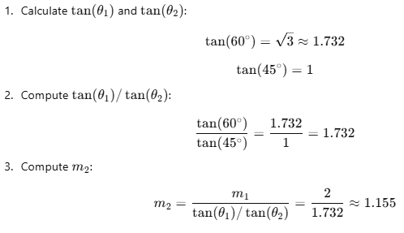

**Output:-**

Enter the value of theta1=60

Enter the value of theta2=45

Enter the value of m1=2

"THE VALUE OF M2 IS"

1.1547005

**Result :**

Thus the program was verified for Boundary condition between two different dielectric media in magnetic field using SCILAB was successfully.

|  |  |  |
| --- | --- | --- |
| Parameters | Simulated Result | Theoretical result |
| Theta 1 = 60  Theta 2 = 45  M1 =2 | 1.1547005 | 1.155 |

**Case 1:** Consider two identical media in the presence of a magnetic field. The relative permeability in both media is 1. What will be the effect of this on the magnetic field and flux density across the boundary?

**Analytical Calculation**

### Given:

1. Two identical media with μr=1.
2. Magnetic permeability of both media is μ=μ0 is the permeability of free space.
3. Magnetic field intensity in the first medium: H1=10 A/m.
4. The problem asks for the behaviour of the magnetic field H and flux density B across the boundary.

### Assumptions:

* The media are in static conditions, with no additional sources or boundary effects (e.g., surface currents or magnetic charges).

### Boundary Conditions:

1. **Tangential component of H\mathbf{H}H:**

H1t=H2t

The tangential components of H are continuous across the boundary.

1. **Normal component of B\mathbf{B}B:**

B1n=B2n

The normal components of B are continuous across the boundary.

1. **Relationship between B\mathbf{B}B and H\mathbf{H}H:**

B=μH

Since μ=μ0, B=μ0​H in both media.

### Calculation of B1​ and B2​:

* In the first medium:

B1=μ0H1=(4π×10−7)×10=4π×10−6  T

* Since the media are identical, and boundary conditions ensure continuity:

H2=H1=10 A/m,B2=B1=4π×10−6  T

*// Scilab code to simulate the magnetic field and flux density for two identical media*

*// Constants*

mu_0=4*%pi*10^(-7);*// Permeability of free space (H/m)*

H1=10;*// Magnetic field intensity in medium 1 (A/m)*

*// Relative permeability for both media (both are 1)*

mu_r1=1;*// Relative permeability for medium 1*

mu_r2=1;*// Relative permeability for medium 2*

*// Calculate the magnetic field intensity in both media (no change because mu_r = 1)*

H2=H1;*// Since the media are identical, H1 = H2*

*// Magnetic flux density in both media (B = mu * H)*

B1=mu_0*mu_r1*H1;*// Magnetic flux density in medium 1*

B2=mu_0*mu_r2*H2;*// Magnetic flux density in medium 2*

*// Display results*

disp("Magnetic Field Intensity in Medium 1: "+string(H1)+" A/m");

disp("Magnetic Field Intensity in Medium 2: "+string(H2)+" A/m");

disp("Magnetic Flux Density in Medium 1: "+string(B1)+" T");

disp("Magnetic Flux Density in Medium 2: "+string(B2)+" T");

**Expected output:**

"Magnetic Field Intensity in Medium 1: 10 A/m"

"Magnetic Field Intensity in Medium 2: 10 A/m"

"Magnetic Flux Density in Medium 1: 0.0000126 T"

"Magnetic Flux Density in Medium 2: 0.0000126 T"

**Result :**

Thus the effect of two identical media on the magnetic field and flux density across the boundary is calculated.

|  |  |  |
| --- | --- | --- |
| Parameters | Simulated Result | Theoretical result |
| 1. Magnetic Field Intensity in Medium 1: 10 A/m  2. Magnetic Field Intensity in Medium 2: 10 A/m | Magnetic Flux Density in Medium 1: 0.0000126 T  Magnetic Flux Density in Medium 2: 0.0000126 T | Magnetic Flux Density in Medium 1: 0.0000126 T  Magnetic Flux Density in Medium 2: 0.0000126 T |

**Case 2:** In a system with two media, where the relative permeability of medium 1 is μr1=4 and medium 2 is a vacuum (μr2​=1), how would the magnetic field intensity and flux density behave at the boundary?

Analytical Calculation:

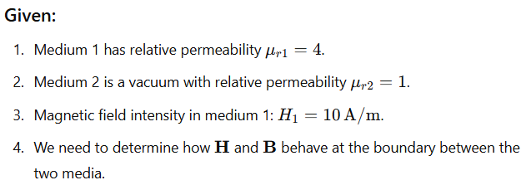

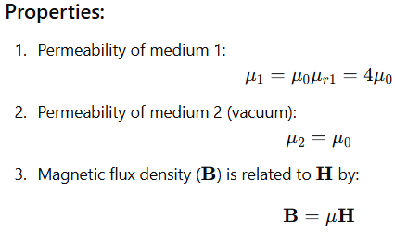

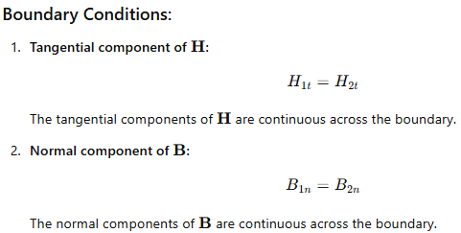

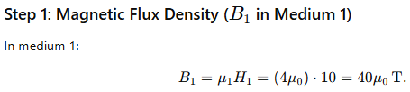

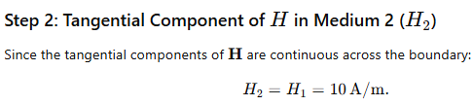

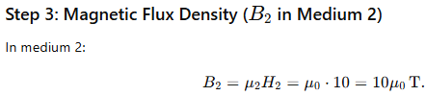

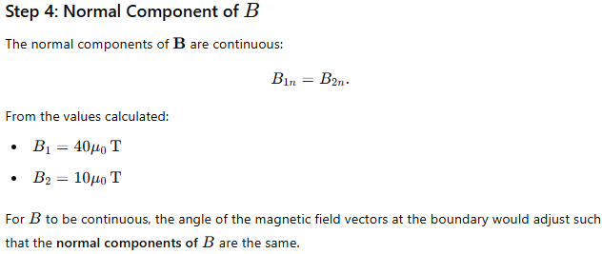

*// Scilab code to simulate the magnetic field intensity and flux density across the boundary*

*// Constants*

mu_0=4*%pi*10^(-7);*// Permeability of free space (H/m)*

H1=10;*// Magnetic field intensity in medium 1 (A/m)*

*// Relative permeability for the media*

mu_r1=4;*// Relative permeability for medium 1*

mu_r2=1;*// Relative permeability for medium 2 (vacuum)*

*// Calculate the magnetic field intensity in medium 2 using the boundary condition*

H2=mu_r1*H1/mu_r2;*// H2 = (mu_r1 * H1) / mu_r2*

*// Calculate the magnetic flux density in both media (B = mu * H)*

B1=mu_0*mu_r1*H1;*// Magnetic flux density in medium 1*

B2=mu_0*mu_r2*H2;*// Magnetic flux density in medium 2*

*// Display results*

disp("Magnetic Field Intensity in Medium 1: "+string(H1)+" A/m");

disp("Magnetic Field Intensity in Medium 2: "+string(H2)+" A/m");

disp("Magnetic Flux Density in Medium 1: "+string(B1)+" T");

disp("Magnetic Flux Density in Medium 2: "+string(B2)+" T");

**Expected Output**

"Magnetic Field Intensity in Medium 1: 10 A/m"

"Magnetic Field Intensity in Medium 2: 40 A/m"

"Magnetic Flux Density in Medium 1: 0.0000503 T"

"Magnetic Flux Density in Medium 2: 0.0000503 T"

**Result :**

Thus the effect of two different media on the magnetic field and flux density across the boundary is calculated.

|  |  |  |
| --- | --- | --- |
| Parameters | Simulated Result | Theoretical result |
| 1. Magnetic Field Intensity in Medium 1: 10 A/m  2. Magnetic Field Intensity in Medium 2: 40 A/m | Magnetic Flux Density in Medium 1: 0.0000503 T  Magnetic Flux Density in Medium 2: 0.0000503 T | Magnetic Flux Density in Medium 1: 0.0000503 T  Magnetic Flux Density in Medium 2: 0.0000503 T |

**Case 3:** If medium 1 has a relative permeability μr1=0.3 and medium 2 has a relative permeability μr2=2, calculate the magnetic field intensity in both media at the boundary if the magnetic field intensity in medium 1 is known to be H1=10 A/m.

Analytical Calculations:

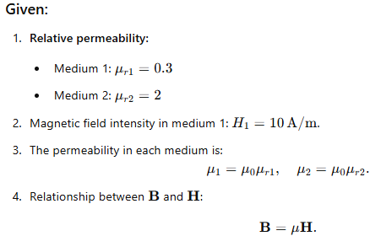

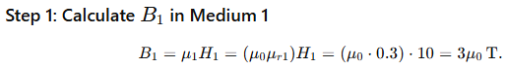

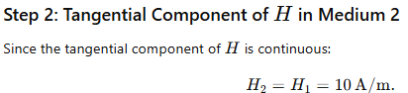

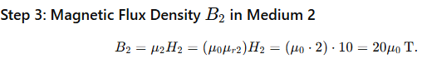

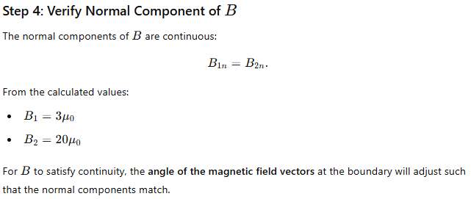

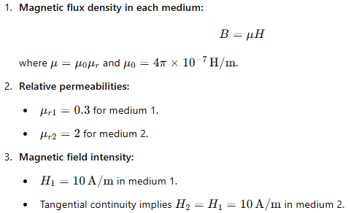

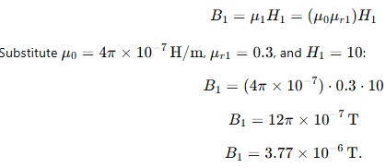

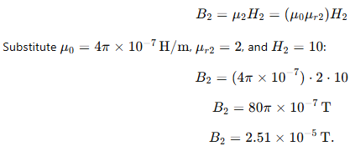

*// Relative permeability for the media*

mu_r1=0.3;*// Relative permeability for medium 1*

mu_r2=2;*// Relative permeability for medium 2*

*// Calculate the magnetic field intensity in medium 2 using the boundary condition*

H2=(mu_r1/mu_r2)*H1;*// H2 = (mu_r1 * H1) / mu_r2*

*// Calculate the magnetic flux density in both media (B = mu * H)*

B1=mu_0*mu_r1*H1;*// Magnetic flux density in medium 1*

B2=mu_0*mu_r2*H2;*// Magnetic flux density in medium 2*

*// Display results*

disp("Magnetic Field Intensity in Medium 1: "+string(H1)+" A/m");

disp("Magnetic Field Intensity in Medium 2: "+string(H2)+" A/m");

disp("Magnetic Flux Density in Medium 1: "+string(B1)+" T");

disp("Magnetic Flux Density in Medium 2: "+string(B2)+" T");

**Expected Output**

"Magnetic Field Intensity in Medium 1: 10 A/m"

"Magnetic Field Intensity in Medium 2: 1.5 A/m"

"Magnetic Flux Density in Medium 1: 0.0000038 T"

"Magnetic Flux Density in Medium 2: 0.000025 T"

**Result :**

Thus the effect of two different media on the magnetic field and flux density across the boundary is calculated.

|  |  |  |
| --- | --- | --- |
| Parameters | Simulated Result | Theoretical result |
| 1. Magnetic Field Intensity in Medium 1: 10 A/m  2. Magnetic Field Intensity in Medium 2: 1.5 A/m | Magnetic Flux Density in Medium 1: : 0.0000038 T  Magnetic Flux Density in Medium 2: 0.000025 T | Magnetic Flux Density in Medium 1: : 0.0000038 T  Magnetic Flux Density in Medium 2: 0.000025 T |

**Exp no:11** Determination and plotting of Magnetic Flux density in Ferromagnetic Materials with different (i) length, (ii) width and (iii) magnetic field intensity.

**Aim:**

To write program for Magnetic flux density in ferromagnetic materials using SCILAB.

**Software required:**

•SCILAB version 6.0.1

**Theory:**

The magnetic flux density (B) in ferromagnetic materials is a measure of the magnetic field’s strength within the material, which takes into account both the external magnetic field (H) and the material's inherent magnetic properties (i.e., its magnetization). The relationship between these quantities in a ferromagnetic material is more complex than in non-magnetic or paramagnetic materials because ferromagnetic materials exhibit hysteresis, saturation, and non-linear behavior due to their spontaneous magnetization.

**Program:**

clc;

clear;

mr=input("Enter the value of mr=");

H =input("Enter the value of H=");

L =input("Enter the value of Length=");

W =input("Enter the value of Width=");

pi =3.14;

mu0=4*3.14*10^-7;

B =mu0*mr*H;

A =L*W

Flux_density = B/A;

disp('Flux density is',[Flux_density]);

x=linspace(0, 10, 50);

y=Flux_density*exp(-0.1*x);

figure();

subplot(1, 1, 1);

plot2d3(x,y);

xlabel("Area");

ylabel("Flux density");

title("Magnetic flux desity");

Output:-

Enter the value of mr=1*10^-7

Enter the value of H=4.95*10^4

Enter the value of Length=1*10^-2

Enter the value of Width=1*10^2

"Flux density is"

6.217e-09

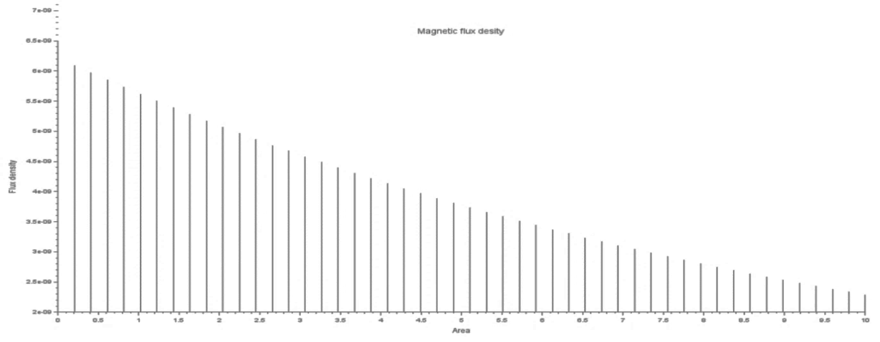

**Result :**

Thus the program was verified for program for Magnetic flux density in ferromagnetic materials using SCILAB was successfully.

|  |  |  |
| --- | --- | --- |
| Parameters | Simulated Result | Theoretical result |
| Enter the value of mr=1*10^-7  Enter the value of H=4.95*10^4  Enter the value of Length=1*10^-2  Enter the value of Width=1*10^2 | Flux density is 6.217e-09 | Flux density is 6.217e-09 |

**Case 1:** Examine the effect of **length** of a ferromagnetic material on the magnetic flux density (B).

**Analytical :**

Calculate the magnetic flux density for the following conditions

* The material is ferromagnetic with relative permeability (μr​) of 500.
* The magnetic field intensity (H) is held constant at 100 A/m.
* The **length** of the material varies from 0.1 m to 2 m.

**Solution:**

**Magnetic Flux Density in a Ferromagnetic Material**:

B=μ0μrH

Substituting the given values:

B=(4π×10−7 T)×500×(100 A/m)

B=6.28×10−2 T=0.0628 T

So, for any length of the material between 0.1 m to 2 m, **the magnetic flux density B will remain constant at 0.0628 T**.

**Coding**

*// Scilab code to examine the effect of length of a ferromagnetic material on magnetic flux density (B)*

*// Constants*

mu_r=500;*// Relative permeability*

H=100;*// Magnetic field intensity in A/m*

lengths=0.1:0.1:2;*// Lengths from 0.1 m to 2 m*

mu_0=4*3.147*10^-7;

m=0;

*// Initialize an array to store magnetic flux density values*

B_values=zeros(length(lengths),1);

*// Calculate magnetic flux density for each length*

fori=1:length(lengths)

B_values(i)=mu_r*mu_0*H;*// Calculate B using B = μ * H*

end

*// Display results*

disp(length(m),'Magnetic Flux Density');

fori=1:length(lengths)

disp(length(i)," ",B_values(i));

end

*// Plotting the results*

clf;

plot(lengths,B_values,'-o');

xlabel("Length of Ferromagnetic Material (m)");

ylabel("Magnetic Flux Density (B) (T)");

title("Effect of Length on Magnetic Flux Density");

gridon;

Expected output:

1.

"Magnetic Flux Density"

1.

" "

0.06294

1.

" "

0.06294

1.

" "

0.06294

1.

" "

0.06294

1.

" "

0.06294

1.

" "

0.06294

1.

" "

0.06294

1.

" "

0.06294

1.

" "

0.06294

1.

" "

0.06294

1.

" "

0.06294

1.

" "

0.06294

1.

" "

0.06294

1.

" "

0.06294

1.

" "

0.06294

1.

" "

0.06294

1.

" "

0.06294

1.

" "

0.06294

1.

" "

0.06294

1.

" "

0.06294

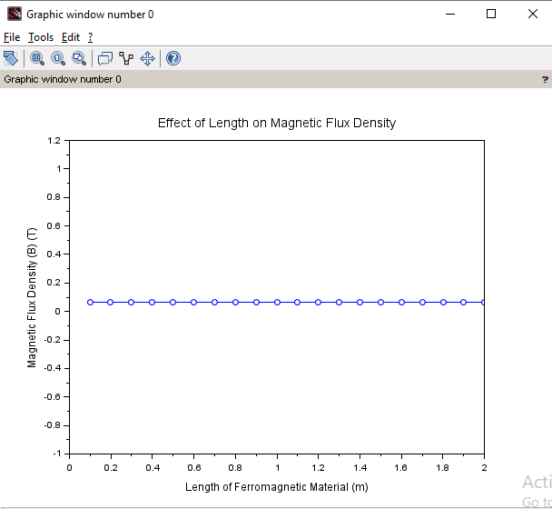

**Result: T**he effect of **length** of a ferromagnetic material on the magnetic flux density (B) is examined.

|  |  |  |
| --- | --- | --- |
| Parameters | Simulated Result | Theoretical result |
| * The material is ferromagnetic with relative permeability (μr​) of 500. * The magnetic field intensity (H) is held constant at 100 A/m. * The **length** of the material varies from 0.1 m to 2 m. | Flux density is 0.0629 T | Flux density is 0.0628 T |

**Case 2:** To investigate how the magnetic flux density (B) in a ferromagnetic material changes with different widths at a constant length and magnetic field intensity.

**Analytical**:

Calculatemagnetic flux density (B) in a ferromagnetic material changes with different widths at a constant length and magnetic field intensity for the following condtions

* **Material**: Soft iron (same as in Case Study 1)
* **Length (L)**: Constant at 10 cm
* **Magnetic Field Intensity (H)**: Constant at 1000 A/m
* **Width (W)**: Varies from 2 cm to 10 cm (i.e., 2 cm, 4 cm, 6 cm, 8 cm, 10 cm)

**Solution:**

B=μ0​μr​H

Substituting the known values:

B=(4π×10−7)×500×1000

B=6.28×10−7×500×1000

B=0.314T

### **Conclusion:**

* The magnetic flux density B **remains constant at 0.314 Tesla** regardless of the width of the material, as long as the length L and magnetic field intensity H remain constant.
* **Width (W)** affects the **total magnetic flux (Φ)** but not the magnetic flux density B.

**Coding**

*// Constants*

L=0.1;*// Length in meters (10 cm)*

H=1000;*// Magnetic field intensity in A/m*

mu_0=4*%pi*10^(-7);*// Permeability of free space in H/m*

*// Widths in meters (2 cm to 10 cm)*

widths=[0.02,0.04,0.06,0.08,0.1];*// Widths in meters*

num_widths=length(widths);

*// Initialize arrays to store results*

B_values=zeros(1,num_widths);

mu_r=1000;*// Assume a relative permeability for soft iron*

*// Calculate magnetic flux density for each width*

fori=1:num_widths

B_values(i)=mu_0*mu_r*H;*// B = μ * H*

end

*// Display results*

disp("Width (m) Flux Density (T)");

fori=1:num_widths

disp(widths(i)," ",B_values(i));

end

**Expected output**

"Width (m) Flux Density (T)"

0.02

" "

0.314

0.04

" "

0.314

0.06

" "

0.314

0.08

" "

0.314

0.1

" " 0.314

**Result: T**he effect of **width** of a ferromagnetic material on the magnetic flux density (B) is examined.

|  |  |  |
| --- | --- | --- |
| Parameters | Simulated Result | Theoretical result |
| * **Material**: Soft iron (same as in * **Length (L)**: Constant at 10 cm * **Magnetic Field Intensity (H)**: Constant at 1000 A/m * **Width (W)**: Varies from 2 cm to 10 cm (i.e., 2 cm, 4 cm, 6 cm, 8 cm, 10 cm) | Width (m)  0.02  Flux Density (T)"  0.314 | Width (m)  0.02  Flux Density (T)"  0.314 |

**Case 3:** To examine how the magnetic flux density (B) in a ferromagnetic material change with different values of magnetic field intensity at constant length and width.

**Analytical**:

Calculate the magnetic flux density (B) in a ferromagnetic material change with different values of magnetic field intensity at constant length and width.

* **Material**: Soft iron (same as in the previous studies)
* **Length (L)**: Constant at 10 cm
* **Width (W)**: Constant at 5 cm
* **Magnetic Field Intensity (H)**: Varies from 200 A/m to 2000 A/m (i.e., 200 A/m, 500 A/m, 1000 A/m, 1500 A/m, 2000 A/m)

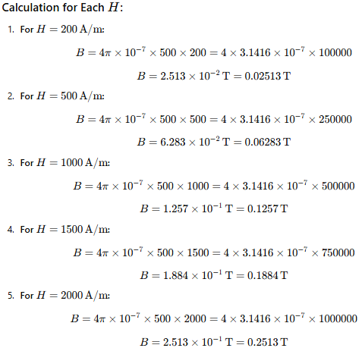**Solution:**

### **Conclusion:**

* The magnetic flux density B **increases** proportionally with the magnetic field intensity H.
* For the given values of HHH (200 A/m, 500 A/m, 1000 A/m, 1500 A/m, 2000 A/m), the magnetic flux density B increases from **0.02513 T** to **0.2513 T**.
* This behavior follows the linear relationship between B and H, which holds true as long as the material is within the linear region of its magnetization curve (i.e., not saturated).

**Coding:**

*// Define constants*

L=0.1;*// Length in meters (10 cm)*

W=0.05;*// Width in meters (5 cm)*

H_values=[200,500,1000,1500,2000];*// Magnetic field intensities in A/m*

mu_0=4*%pi*10^(-7);*// Permeability of free space in H/m*

mu_r_initial=1000;*// Initial relative permeability for soft iron*

*// Initialize arrays to store results*

B_values=zeros(1,length(H_values));

*// Calculate B for each H value*

fori=1:length(H_values)

H=H_values(i);

mu_r=mu_r_initial;*// Assuming constant relative permeability for simplicity*

mu=mu_0*mu_r;*// Calculate absolute permeability*

B_values(i)=mu*H;*// Calculate magnetic flux density*

end

*// Display results*

disp("Magnetic Field Intensity (A/m) | Magnetic Flux Density (T)");

disp(H_values);

disp(B_values);

*// Plotting the results*

clf();

plot(H_values,B_values,'-o');

xlabel("Magnetic Field Intensity (A/m)");

ylabel("Magnetic Flux Density (T)");

title("Magnetic Flux Density vs Magnetic Field Intensity for Soft Iron");

grid();

**Expected outcome:**

"Magnetic Field Intensity (A/m) | Magnetic Flux Density (T)"

200. 500. 1000. 1500. 2000.

0.2513274 0.6283185 1.2566371 1.8849556 2.5132741

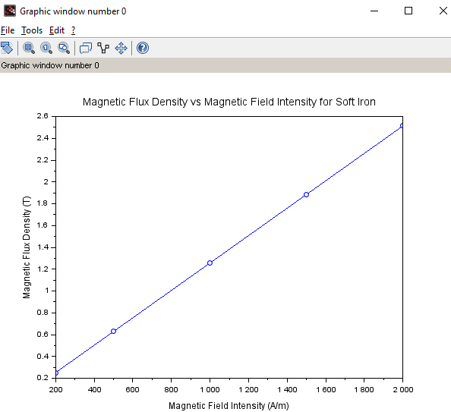

**Result:**

**T**he effect of **Magnetic field intensity** of a ferromagnetic material on the magnetic flux density (B) is examined.

|  |  |  |
| --- | --- | --- |
| Parameters | Simulated Result | Theoretical result |
| * **Material**: Soft iron (same as in the previous studies) * **Length (L)**: Constant at 10 cm * **Width (W)**: Constant at 5 cm * **Magnetic Field Intensity (H)**: Varies from 200 A/m to 2000 A/m (i.e., 200 A/m, 500 A/m, 1000 A/m, 1500 A/m, 2000 A/m) | Magnetic Field Intensity (A/m) |  200.  Magnetic Flux Density (T)"  0.2513274 | Magnetic Field Intensity (A/m) |  200.  Magnetic Flux Density (T)"  0.2513274 |

**Exp No:12** Determination and plotting of magnetic and electric field intensity due to infinite long conductor at any specific point located at H

**Date:**

**Aim:**

To write program for Magnetic field intensity of infinite long conductor using SCILAB.

**Software required:**

• SCILAB version 6.0.1

**Theory:**

In electromagnetism, the fields around a conductor carrying a current are fundamental concepts. For an infinite long conductor carrying a current, we can determine both the **magnetic field intensity** and **electric field intensity** at a point located at a distance from the conductor.

**Magnetic Field Intensity due to an Infinite Long Conductor**

Ampère’s Law:

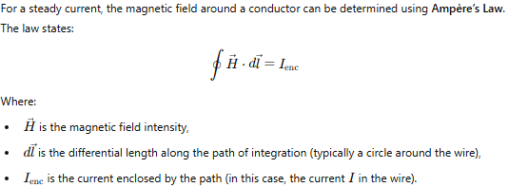

**Program:**

clc;

clear;

i=input("Enter i value:");

r=input("Enter r value:");

h=i/(2*3.14*r);

disp(("Magnetic field"),[h]);

lambda=input("Enter lambda value:");

r=input("Enter r value:");

Eo=8.854*10^-12;

e=(lambda)/(2*3.14*Eo*z);

disp(("Electric field"),[e]);

figure();

x=linspace(0,10,50);

y=h*exp(-0.1*x);

z=e*exp(-0.1*x);

subplot(2,2,1);

plot2d3(x,y);

title("Magnetic field intensity");

xlabel("Radius R");

ylabel("Magnetic field intensity H");

subplot(2,2,2);

plot2d3(x,z);

title("Electric field intensity");

xlabel("Radius R");

ylabel("Electric field intensity");

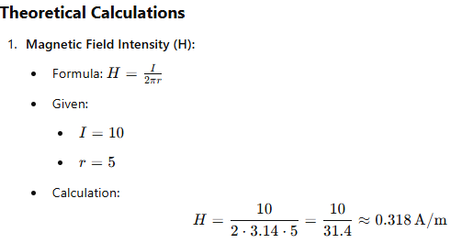

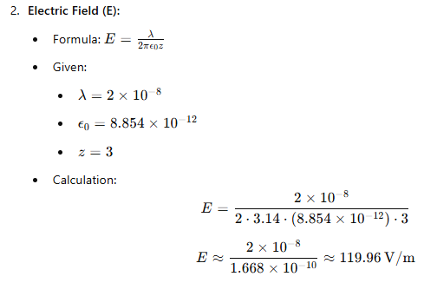

Output:-

Enter i value:10

Enter r value:5

"Magnetic field"

0.3184713

Enter lambda value:2*10^-8

Enter z value:3

"Electric field"

119.89735

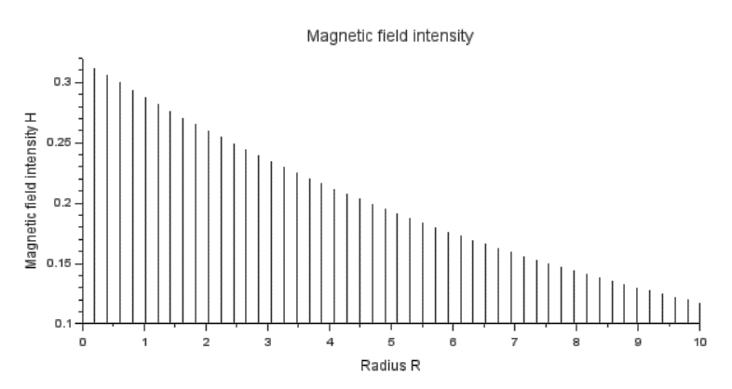

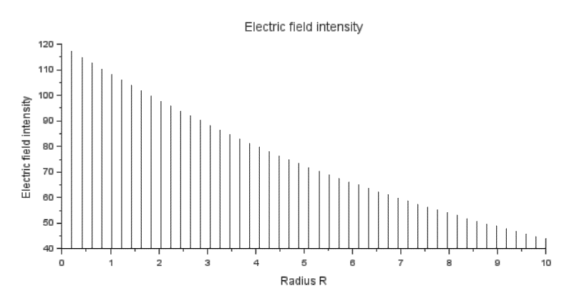

**Result:**

Thus the program was verified for Magnetic field intensities in ferromagnetic materials using SCILAB was successfully.

|  |  |  |
| --- | --- | --- |
| Parameters | Simulated Result | Theoretical result |
| * Current = 10 A * Radius = 5 m * lambda value:2*10^-8 * z value:3 | "Magnetic field"  0.3184713  "Electric field"  119.89735 | "Magnetic field"  0.3184713  "Electric field"  119.89735 |

**Case 1:** To examine how the magnetic and electric field intensities change with varying distances from an infinitely long current-carrying conductor.

**Analytical**:

Calculate the magnetic and electric field intensities change with varying distances from an infinitely long current-carrying conductor for following conditions

* **Conductor**: Infinite long conductor carrying a steady current III.
* **Distance (H)**: The distance from the conductor varies from 0.1 m to 10 m (i.e., 0.1 m, 1 m, 5 m, 10 m).
* **Current (I)**: Constant current of 10 A.

**Solution:**

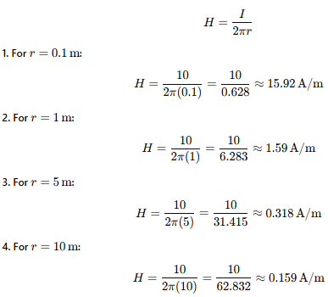

**Coding:**

*// Constants*

mu_0=4*%pi*10^(-7);*// Permeability of free space in T*m/A*

epsilon_0=8.854*10^(-12);*// Permittivity of free space in F/m*

I=10;*// Current in Amperes*

*// Distances from the conductor*

distances=[0.1,1,5,10];*// in meters*

num_distances=length(distances);

*// Initialize arrays for magnetic and electric fields*

B_field=zeros(1,num_distances);

E_field=zeros(1,num_distances);

*// Calculate magnetic and electric fields for each distance*

fori=1:num_distances

r=distances(i);

B_field(i)=(mu_0*I)/(2*%pi*r);*// Magnetic field calculation*

E_field(i)=I/(2*%pi*epsilon_0*r);*// Electric field calculation*

end

*// Display results*

disp("Distance (m) | Magnetic Field (T) | Electric Field (N/C)");

fori=1:num_distances

disp(string(distances(i))+" | "+string(B_field(i))+" | "+string(E_field(i)));

end

**Expected output:**

"Distance (m) | Magnetic Field (T) | Electric Field (N/C)"

"0.1 | 0.00002 | 1.798D+12"

"1 | 0.000002 | 1.798D+11"

"5 | 0.0000004 | 3.595D+10"

"10 | 0.0000002 | 1.798D+10"

**Result:** Thus the program was verified for the magnetic and electric field intensities change with varying distances from an infinitely long current-carrying conductor

|  |  |  |
| --- | --- | --- |
| Parameters | Simulated Result | Theoretical result |
| * **Conductor**: Infinite long conductor * **Distance (H)**: The distance from the conductor varies from 0.1 m to 10 m (i.e., 0.1 m, 1 m, 5 m, 10 m). * **Current (I)**: Constant current of 10 A. | "0.1 | 0.00002 | 1.798D+12"  "1 | 0.000002 | 1.798D+11"  "5 | 0.0000004 | 3.595D+10"  "10 | 0.0000002 | 1.798D+10" | "0.1 | 0.00002 | 1.798D+12"  "1 | 0.000002 | 1.798D+11"  "5 | 0.0000004 | 3.595D+10"  "10 | 0.0000002 | 1.798D+10" |

**Case 2:**To study how the magnetic and electric field intensities change for an infinitely long conductor at a fixed distance H but with varying currents.

**Analytical**:

To calculate magnetic and electric field intensities change for an infinitely long conductor at a fixed distance H but with varying currents for the following,

* **Conductor**: Infinite long conductor.
* **Distance (H)**: Fixed at 2 meters.
* **Current (I)**: Varying from 5 A to 50 A (i.e., 5 A, 10 A, 20 A, 30 A, 50 A).

**Solution:**

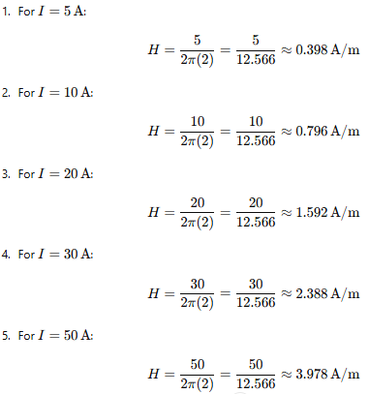



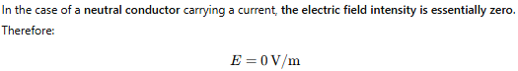

**Coding**

*// Constants*

H=2;*// Distance from the conductor in meters*

epsilon_0=8.854e-12;*// Permittivity of free space in C^2/(N*m^2)*

lambda=1.0e-6;*// Linear charge density in C/m*

*// Currents to evaluate*

currents=[5,10,20,30,50];*// Current values in Amperes*

num_currents=length(currents);

*// Preallocate arrays for results*

magnetic_field_intensity=zeros(1,num_currents);

electric_field_intensity=zeros(1,num_currents);

*// Calculate magnetic and electric field intensities*

fori=1:num_currents

I=currents(i);

*// Magnetic field intensity calculation*

magnetic_field_intensity(i)=I/(2*%pi*H);

*// Electric field intensity calculation*

electric_field_intensity(i)=lambda/(2*%pi*epsilon_0*H);

end

*// Display results*

disp("Current (A) | Magnetic Field Intensity (H) | Electric Field Intensity (E)");

fori=1:num_currents

disp(currents(i)," | ",string(magnetic_field_intensity(i))," | ",string(electric_field_intensity(i)));

end

**Expected output**

"Current (A) | Magnetic Field Intensity (H) | Electric Field Intensity (E)"

5. " | "

"0.3978874"

" | "

"8987.7424" 10.

" | "

"0.7957747"

" | "

"8987.7424"

20.

" | "

"1.5915494"

" | "

"8987.7424"

30.

" | "

"2.3873241"

" | "

"8987.7424"

50.

" | "

"3.9788736"

" | "

"8987.7424"

**Result:** Thus the program was verified for the magnetic and electric field intensities change with fixed distance H but with varying currents.

|  |  |  |
| --- | --- | --- |
| Parameters | Simulated Result | Theoretical result |
| * **Conductor**: Infinite long conductor. * **Distance (H)**: Fixed at 2 meters. * **Current (I)**: Varying from 5 A to 50 A (i.e., 5 A, 10 A, 20 A, 30 A, 50 A). | 0.398 | 0.398 |

**Case 3:**To analyze the magnetic and electric field intensities due to an infinitely long conductor when there is a potential difference (voltage) across the conductor, simulating a capacitive effect.

**Analytical**:

Calculate the magnetic and electric field intensities due to an infinitely long conductor when there is a potential difference (voltage) across the conductor, simulating a capacitive effect.

* **Conductor**: Infinite long conductor.
* **Voltage (V)**: Varies from 100 V to 1000 V (i.e., 100 V, 300 V, 500 V, 700 V, 1000 V).
* **Distance (H)**: Fixed at 1 m.
* **Current (I)**: Varies depending on the voltage (using Ohm’s Law, I=V/R​, where resistance R is assumed).

**Solution:**

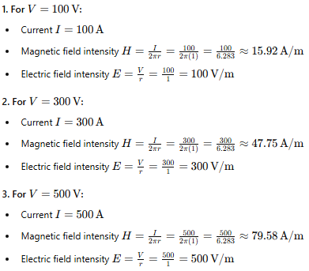

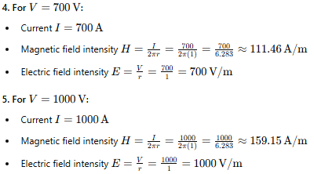

**Coding:**

*// Constants*

epsilon_0=8.854e-12;*// Permittivity of free space (F/m)*

mu_0=4*%pi*1e-7;*// Permeability of free space (H/m)*

R=10;*// Resistance in ohms (assumed)*

*// Voltage values*

V_values=[100,300,500,700,1000];*// Voltage in volts*

H_distance=1;*// Distance from the conductor in meters*

*// Initialize arrays to store results*

E_values=zeros(1,length(V_values));

H_values=zeros(1,length(V_values));

*// Calculate Electric Field (E) and Magnetic Field (H)*

fori=1:length(V_values)

V=V_values(i);

I=V/R;*// Current using Ohm's Law*

*// Electric Field due to an infinitely long charged wire*

*// E = λ / (2 * π * ε₀ * r)*

*// Assuming linear charge density λ is proportional to current I*

lambda=I;*// Linear charge density (C/m)*

E_values(i)=lambda/(2*%pi*epsilon_0*H_distance);

*// Magnetic Field due to an infinitely long straight conductor*

*// H = I / (2 * π * r)*

H_values(i)=I/(2*%pi*H_distance);

end

*// Display results*

disp("Voltage (V) | Electric Field (E) | Magnetic Field (H)");

fori=1:length(V_values)

disp(V_values(i)," | ",E_values(i)," | ",H_values(i));

end

**Expected output**

"Voltage (V) | Electric Field (E) | Magnetic Field (H)"

100.

" | "

1.798D+11

" | "

1.5915494

300.

" | "

5.393D+11

" | "

4.7746483

500.

" | "

8.988D+11

" | "

7.9577472

700.

" | "

1.258D+12

" | "

11.140846

1000.

" | "

1.798D+12

" | "

15.915494

**Result:** Thus the program was verified for the magnetic and electric field intensities due to infinitely long conductor.

|  |  |  |
| --- | --- | --- |
| Parameters | Simulated Result | Theoretical result |
| * **Conductor**: Infinite long conductor. * **Voltage (V)**: Varies from 100 V to 1000 V (i.e., 100 V, 300 V, 500 V, 700 V, 1000 V). * **Distance (H)**: Fixed at 1 m. | 15.92 | 15.92 |

**Exp no: 13** Determination and plotting of intinsic impedance and phase velocity of various medium

Date:

**Aim:**

To determine and plot intrinsic impedance and phase velocity of various medium.

**Software required:**

• SCILAB version 6.0.1

**Theory:**

#### ****Intrinsic Impedance (****Z****)****

The **intrinsic impedance** of a medium is an important parameter that characterizes the relationship between the electric and magnetic fields in an electromagnetic wave propagating through that medium. It represents the opposition that the medium presents to the electric and magnetic fields.

* **Definition**: Intrinsic impedance Z is the ratio of the electric field (E) to the magnetic field (H) in an electromagnetic wave propagating in that medium. In other words, it describes how much resistance the wave experiences as it propagates.

The intrinsic impedance of a medium can be expressed mathematically as:



Where:

* Z is the intrinsic impedance of the medium in ohms (Ω),
* μ is the permeability of the medium in henries per meter (H/m),
* ε is the permittivity of the medium in farads per meter (F/m)

**Program:**

clc;

clear;

ur=input("Enter μr value:");

er=input("Enter εr value:");

uo=4*3.14*10^-7;

eo=8.854*10^-12;

n=sqrt(uo*ur/er*eo);

disp(("Intrinsic impedence:"),[n]);

pv=1/sqrt(uo*ur*er*eo);

disp(("Phase velocity:"),[pv]);

figure();

x=linspace(0, 10, 50);

y=n*exp(0.1*x);

z=pv*exp(-0.1*x);

subplot(2, 2, 1);

plot2d3(x,y);

title("Intrinsic impedence");

xlabel("u/E");

ylabel("Intrinsic impedence");

subplot(2, 2, 2);

plot2d3(x,z);

title("Phase velocity");

xlabel("1/sq(uE)");

ylabel("Phase velocity");

Output:-

Enter μr value:5

Enter εr value:5

"Intrinsic impedence:"

3.335D-09

"Phase velocity:

59974332.

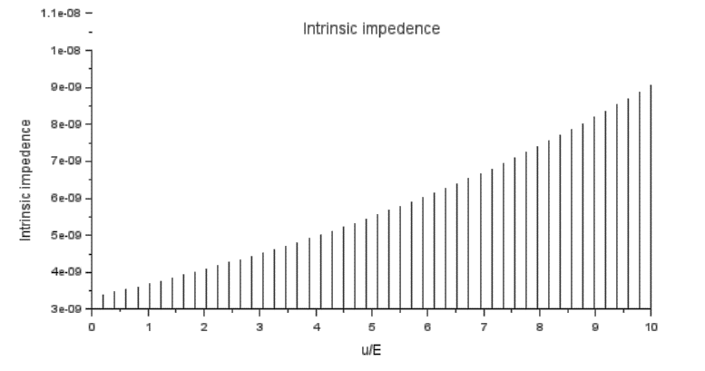

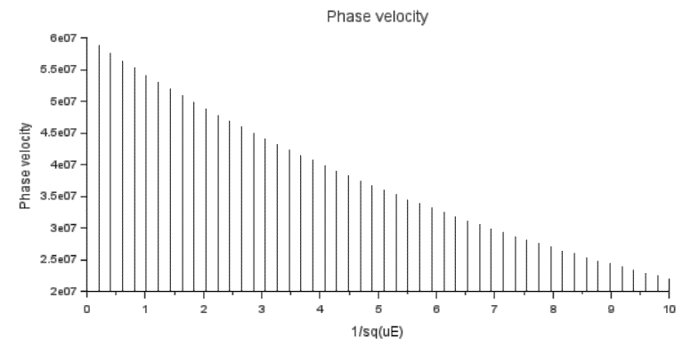

**Result:**

Thus the determination and plotting of intrinsic and phase velocity is performed and successfully verified.

|  |  |  |
| --- | --- | --- |
| Parameters | Simulated Result | Theoretical result |
| μr value:5  εr value:5 | "Intrinsic impedence:"  3.335e-09  "Phase velocity:  59974332. | "Intrinsic impedence:"  3.335e-09  "Phase velocity:  59974332. |

**Case 1:** To determine the intrinsic impedance and phase velocity of electromagnetic waves in free space (vacuum).

**Analytical:**

### Calculate the Intrinsic Impedance and Phase Velocity of Electromagnetic Waves in Free Space (Vacuum)

#### Given:

* **Material**: Free space (vacuum)
* **Permeability of free space** (μ0=: 4π×10−7 H/m
* **Permittivity of free space** (ε0: 8.854×10−12 F/m

**Solution:**

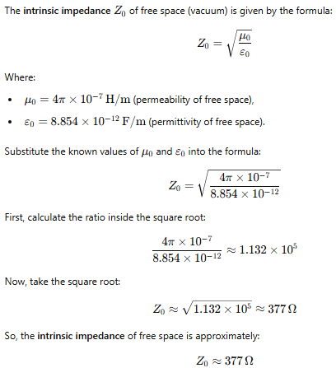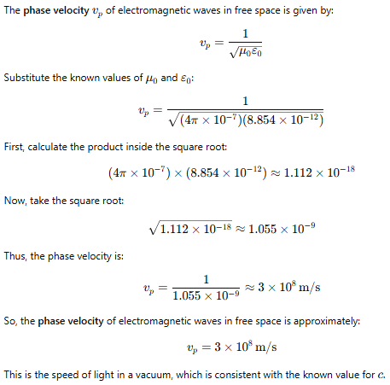

**Coding:**

*// Constants*

mu0=4*%pi*10^(-7);*// Permeability of free space (H/m)*

epsilon0=8.854*10^(-12);*// Permittivity of free space (F/m)*

*// Calculate intrinsic impedance*

eta0=sqrt(mu0/epsilon0);

disp("Intrinsic Impedance (η0) in ohms: "+string(eta0));

*// Calculate phase velocity*

vp=1/sqrt(mu0*epsilon0);

disp("Phase Velocity (vp) in m/s: "+string(vp));

**Expected Output:**

"Intrinsic Impedance (η0) in ohms: 376.73431"

"Phase Velocity (vp) in m/s: 2.998D+08"

**Result:**

Thus the determination and plotting of intrinsic and phase velocity is performed and successfully verified in free space.

|  |  |  |
| --- | --- | --- |
| Parameters | Simulated Result | Theoretical result |
| * **Material**: Free space (vacuum) * **Permeability of free space** (μ0=: 4π×10−7 H/m * **Permittivity of free space** (ε0: 8.854×10−12 F/m | "Intrinsic Impedance (η0) in ohms: 376.73431"  "Phase Velocity (vp) in m/s: 2.998e08" | Intrinsic Impedance (η0) in ohms: 376.73431"  "Phase Velocity (vp) in m/s: 2.998e08" |

**Case 2:** To determine the intrinsic impedance and phase velocity for a wave propagating through a conductive medium like copper.

**Analytical:**Calculate the Intrinsic Impedance and Phase Velocity of Electromagnetic Waves in Copper

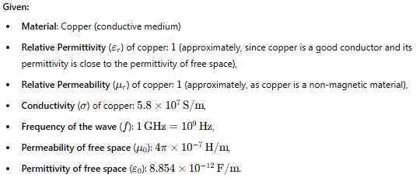

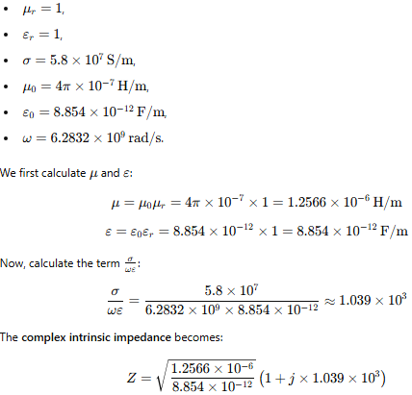

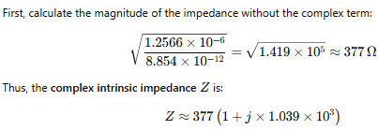

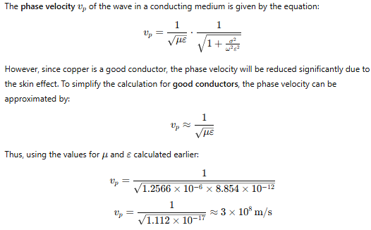

**Coding:**

*// Constants*

f=3e9;*// Frequency in Hz (3 GHz)*

mu=4*%pi*10^(-7);*// Permeability of copper in H/m*

sigma=5.8e7;*// Conductivity of copper in S/m*

epsilon_0=8.854e-12;*// Permittivity of free space in F/m*

epsilon_r=1;*// Relative permittivity (for copper, we assume it's close to free space)*

j=1;

epsilon=epsilon_0*epsilon_r;*// Effective permittivity*

*// Calculate angular frequency*

omega=2*%pi*f;

*// Calculate intrinsic impedance*

eta=sqrt((j*omega*mu)/(sigma+j*omega*epsilon));

*// Calculate phase velocity*

vp=1/sqrt(mu*epsilon);

*// Display results*

disp("Intrinsic Impedance (η): "+string(eta)+" Ohms");

disp("Phase Velocity (vp): "+string(vp)+" m/s");

**Expected Output:**

"Intrinsic Impedance (η): 0.0202088 Ohms"

"Phase Velocity (vp): 2.998D+08 m/s"

**Result:**

Thus the determination and plotting of intrinsic and phase velocity is performed and successfully verified in copper.

|  |  |  |
| --- | --- | --- |
| Parameters | Simulated Result | Theoretical result |
| * **Material**: Free space (vacuum) * **Permeability of free space** (μ0=: 4π×10−7 H/m * **Permittivity of free space** (ε0: 8.854×10−12 F/m | "Intrinsic Impedance (η0) in ohms: 0.0202088"  "Phase Velocity (vp) in m/s: 2.998e08" | Intrinsic Impedance (η0) in ohms: 0.0202088"  "Phase Velocity (vp) in m/s: 2.998e08" |

**Case 3:** To determine and compare the intrinsic impedance and phase velocity of electromagnetic waves propagating through different media: Vacuum, Air, and Water.

**Analytical:**

Determine and compare the intrinsic impedance and phase velocity of electromagnetic waves propagating through different media

#### Conditions:

* **Vacuum:**
  + Permeability: μ0=4π×10−7 H/m
  + Permittivity: ϵ0=8.85×10−12 F/m
* **Air (Assumed to be similar to Vacuum):**
  + Permeability: μair≈μ0​
  + Permittivity: ϵair≈ϵ0​
* **Water (Dielectric Material):**
  + Permeability: μwater≈μ0​
  + Relative Permittivity: ϵwater=80×ϵ0​

**Solution:**

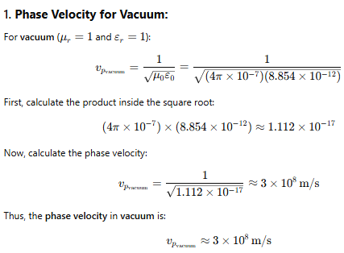

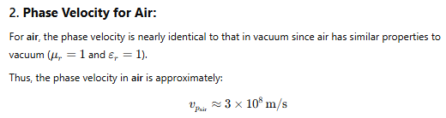

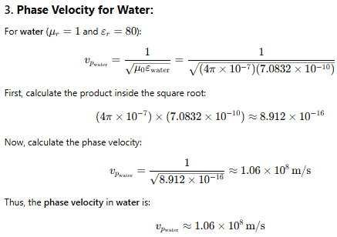

**Coding:**

*// Constants*

mu0=4*%pi*10^(-7);*// Permeability of free space (H/m)*

epsilon0=8.85*10^(-12);*// Permittivity of free space (F/m)*

*// Mediums*

*// Vacuum*

mu_vacuum=mu0;

epsilon_vacuum=epsilon0;

*// Air (assumed similar to vacuum)*

mu_air=mu0;

epsilon_air=epsilon0;

*// Water*

mu_water=mu0;

epsilon_water=80*epsilon0;

*// Function to calculate intrinsic impedance and phase velocity*

function[**eta**, **vp**]=calculate_properties(**mu**, **epsilon**)

**eta**=sqrt(**mu**/**epsilon**);*// Intrinsic Impedance*

**vp**=1/sqrt(**mu**\***epsilon**);*// Phase Velocity*

endfunction

*// Calculate for Vacuum*

[eta_vacuum,vp_vacuum]=calculate_properties(mu_vacuum,epsilon_vacuum);

disp("Vacuum: Intrinsic Impedance (η) =",eta_vacuum);

disp("Vacuum: Phase Velocity (v_p) =",vp_vacuum);

*// Calculate for Air*

[eta_air,vp_air]=calculate_properties(mu_air,epsilon_air);

disp("Air: Intrinsic Impedance (η) =",eta_air);

disp("Air: Phase Velocity (v_p) =",vp_air);

*// Calculate for Water*

[eta_water,vp_water]=calculate_properties(mu_water,epsilon_water);

disp("Water: Intrinsic Impedance (η) =",eta_water);

disp("Water: Phase Velocity (v_p) =",vp_water);

**Expected Output:**

"Vacuum: Intrinsic Impedance (η) ="

376.81944

"Vacuum: Phase Velocity (v_p) ="

2.999D+08

"Air: Intrinsic Impedance (η) ="

376.81944

"Air: Phase Velocity (v_p) ="

2.999D+08

"Water: Intrinsic Impedance (η) ="

42.129694

"Water: Phase Velocity (v_p) ="

33525745.

**Result:**

Thus the determination and plotting of intrinsic and phase velocity is performed and successfully verified in copper.

|  |  |  |
| --- | --- | --- |
| Parameters | Simulated Result | Theoretical result |
| * **Vacuum:**   + Permeability: μ0=4π×10−7 H/m   + Permittivity: ϵ0=8.85×10−12 F/m * **Air (Assumed to be similar to Vacuum):**   + Permeability: μair≈μ0​   + Permittivity: ϵair≈ϵ0​ * **Water (Dielectric Material):**   + Permeability: μwater≈μ0​   + Relative Permittivity: ϵwater=80×ϵ0​ | Vacuum: Intrinsic Impedance (η) ="  376.81944  "Vacuum: Phase Velocity (v_p) ="  2.999D+08 | Vacuum: Intrinsic Impedance (η) ="  376.81944  "Vacuum: Phase Velocity (v_p) ="  2.999D+08 |

**Exp No: 14:** Determination and plotting of Polarization in different Dielectric Medium with their relative permittivity and to find electric susceptibility.

**Date:**

**Aim:**

To determine and plot polarization in different dielectric medium with their relative permittivity and to find electric susceptibility.

**Software required:**

• SCILAB version 6.0.1

**Theory:**

In a dielectric material, when an electric field is applied, the molecules or atoms within the material become polarized. This means that the positive and negative charges within the atoms or molecules shift slightly, creating an internal electric dipole moment. The **polarization** P is defined as the dipole moment per unit volume of the material and is given by the equation:

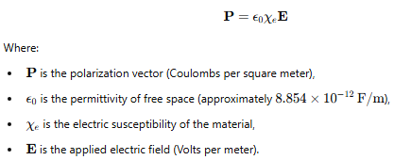

**Program:**

clc;

clear;

epsilon = 8.854*10^-12;

er = input("Enter the εr value");;

field = input("Enter the Electric Field");

chi = er - 1;

polarization = chi*epsilon*field;

disp([chi polarization]);

x = linspace(0,10,50);

y = chi*(0.1*x);

z = polarization * (0.1 * x);

figure();

subplot(2,2,1);

plot2d3(x,y);

title("ELECTRIC SUSCEPTIBILITY");

ylabel("ELECTRIC SUSCEPTIBILITY");

xlabel("εr")

subplot(2,2,2);

title("POLARIZATION");

xlabel("ELECTRIC FIELD");

ylabel("POLARIZATION");

plot2d3(x,z)

OUTPUT:

Enter the εr value4

Enter the Electric Field2.1*10^-4

3. 5.578D-15

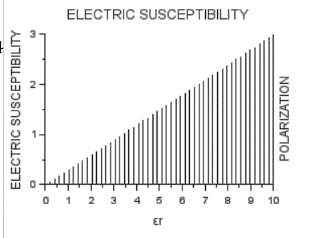

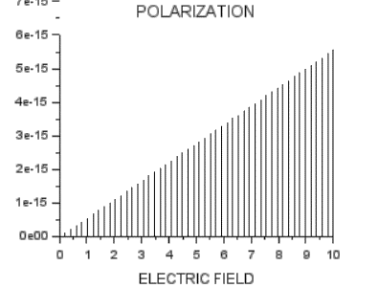

**Result:**

Thus the determination and plotting of polarization in different dielectric medium with their relative permittivity and to find electric susceptibility is executed.

|  |  |  |
| --- | --- | --- |
| Parameters | Simulated Result | Theoretical result |
| εr value = 4  Electric Field2.1*10^-4 | 5.578e-15 | 5.578e-15 |

**Case 1:** To determine and plot the polarization and electric susceptibility of electromagnetic waves in three dielectric media: Air, Water, and Glass, using their relative permittivity.

#### Analytical:

Determine and plot the polarization and electric susceptibility of electromagnetic waves in three dielectric media: Air, Water, and Glass, using their relative permittivity.

* **Air:**
  + Relative Permittivity: ϵr=1
  + Electric Susceptibility: χe​ (to be calculated)
* **Water:**
  + Relative Permittivity: ϵr=80
  + Electric Susceptibility: χe
* **Glass (e.g., Borosilicate Glass):**
  + Relative Permittivity: ϵr=6
  + Electric Susceptibility: χe

**Solution:**

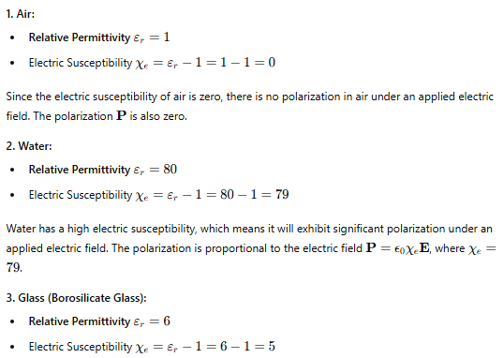

**Coding:**

*// Constants*

epsilon_0=8.854e-12;*// Permittivity of free space in F/m*

E=linspace(0,1000,100);*// Electric field strength in V/m*

*// Material properties*

materials=["Air","Water","Glass"];

epsilon_r=[1,80,6];

chi_e=epsilon_r-1;*// Calculate electric susceptibility*

*// Initialize arrays for polarization*

P_air=epsilon_0*chi_e(1)*E;

P_water=epsilon_0*chi_e(2)*E;

P_glass=epsilon_0*chi_e(3)*E;

*// Plotting*

clf();

plot(E,P_air,'r',E,P_water,'g',E,P_glass,'b');

xlabel('Electric Field Strength (V/m)');

ylabel('Polarization (C/m^2)');

title('Polarization vs Electric Field Strength');

legend(materials);

**Expected Output:**

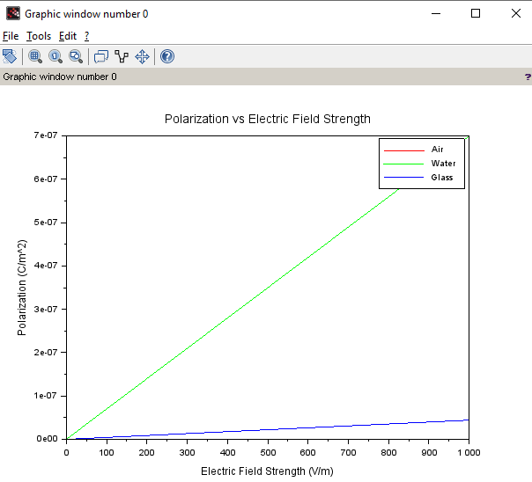

**Result:**

Thus the determination and plotting of polarization in different dielectric medium with their relative permittivity and to find electric susceptibility is executed.

|  |  |  |
| --- | --- | --- |
| Parameters | Simulated Result | Theoretical result |
| εr value = 1 - Air  εr value = 80 – Water  εr value = 6– Glass | 0  79  5 | 0  79  5 |

**Case 2:** To calculate and plot the polarization and electric susceptibility in Silicon, Teflon, and Paper, and understand how their relative permittivity affects the polarization.

#### Analytical:

To calculate and plot the polarization and electric susceptibility in Silicon, Teflon, and Paper

* **Silicon:**
  + Relative Permittivity: ϵr=11.7
  + Electric Susceptibility: χe​
* **Teflon:**
  + Relative Permittivity: ϵr=2.1
  + Electric Susceptibility: χe​
* **Paper:**
  + Relative Permittivity: ϵr=3.0
  + Electric Susceptibility: χe​

**Solution:**

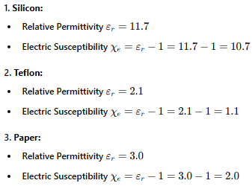

**Coding:**

*// Constants*

epsilon0=8.854e-12;*// Permittivity of free space (F/m)*

*// Material properties*

materials=["Silicon","Teflon","Paper"];

epsilon_r=[11.7,2.1,3.0];*// Relative permittivity*

chi_e=epsilon_r-1;*// Electric susceptibility*

*// Plotting setup*

E=1e6;*// Applied Electric Field in V/m (example value)*

polarization=epsilon0*chi_e*E;*// Polarization (C/m^2)*

*// Create figure for plotting*

scf(0);*// Open a new figure*

bar(chi_e);*// Plot electric susceptibility as a bar chart*

xtitle("Electric Susceptibility for Different Materials","Materials","χ_e");

xticks([1,2,3],materials);

*// Display polarization and susceptibility values*

disp("Material | Relative Permittivity | Electric Susceptibility (χ_e) | Polarization (P in C/m^2)");

fori=1:length(materials)

disp(materials(i)+" | "+string(epsilon_r(i))+" | "+string(chi_e(i))+" | "+string(polarization(i)));

end

*// Plot polarization values for the materials*

figure(1);

bar(polarization);

xtitle("Polarization for Different Materials","Materials","Polarization (P) in C/m^2");

xticks([1,2,3],materials);

**Expected Output:**

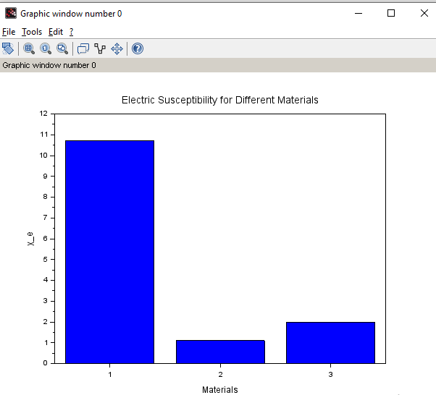

**Result:**

Thus the determination and plotting of polarization in different dielectric medium with their relative permittivity and to find electric susceptibility is executed.

|  |  |  |
| --- | --- | --- |
| Parameters | Simulated Result | Theoretical result |
| εr value = 11.7 - Silicon  εr value = 2.1 – Teflon  εr value = 3.0– Paper | 10.7  1.1  2 | 10.7  1.1  2 |

**Case 3:** To explore how different dielectric materials (Rubber, Oil, and Plastic) affect the polarization and electric susceptibility, and to compare their relative permittivity’s.

#### Analytical:

Calculate how different dielectric materials (Rubber, Oil, and Plastic) affect the polarization and electric susceptibility, and to compare their relative permittivity’s.

* **Rubber:**
  + Relative Permittivity: ϵr=3.5
  + Electric Susceptibility: χe
* **Oil:**
  + Relative Permittivity: ϵr=2.2
  + Electric Susceptibility: χe​
* **Plastic (e.g., Polyethylene):**
  + Relative Permittivity: ϵr=2.3
  + Electric Susceptibility: χe​

**Solution:**

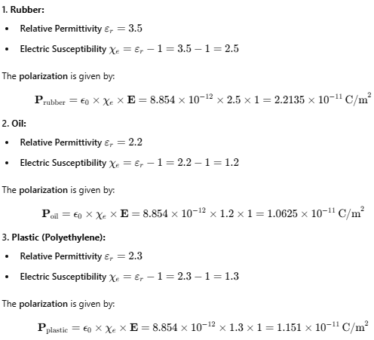



**Coding:**

*// Constants*

epsilon0=8.854e-12;*// Permittivity of free space (F/m)*

*// Material properties for Rubber, Oil, and Plastic*

materials=["Rubber","Oil","Plastic"];

epsilon_r=[3.5,2.2,2.3];*// Relative permittivity*

chi_e=epsilon_r-1;*// Electric susceptibility*

*// Plotting setup*

E=1e6;*// Applied Electric Field in V/m (example value)*

polarization=epsilon0*chi_e*E;*// Polarization (C/m^2)*

*// Create figure for electric susceptibility plot*

scf(0);*// Open a new figure*

bar(chi_e);*// Plot electric susceptibility as a bar chart*

xtitle("Electric Susceptibility for Different Materials","Materials","χ_e");

xticks([1,2,3],materials);

*// Display polarization and susceptibility values*

disp("Material | Relative Permittivity | Electric Susceptibility (χ_e) | Polarization (P in C/m^2)");

fori=1:length(materials)

disp(materials(i)+" | "+string(epsilon_r(i))+" | "+string(chi_e(i))+" | "+string(polarization(i)));

end

*// Plot polarization values for the materials*

figure(1);

bar(polarization);

xtitle("Polarization for Different Materials","Materials","Polarization (P) in C/m^2");

xticks([1,2,3],materials);

**Expected Output:**

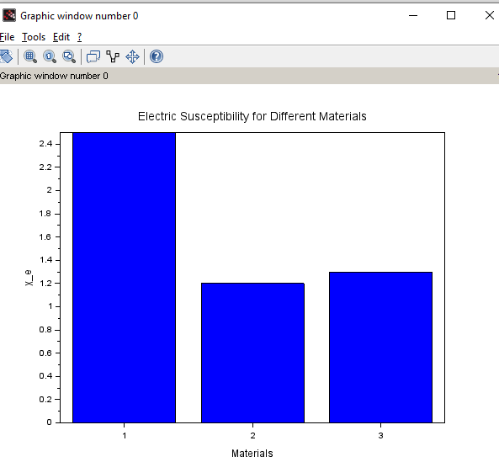

**Result:**

|  |  |  |
| --- | --- | --- |
| Parameters | Simulated Result | Theoretical result |
| εr value = 3.5 - Rubber  εr value = 2.2 – Oil  εr value = 2.3– Plastic | 2.2135x 10-11  1.0625x10-11  1.151x10-11 | 2.2135x 10-11  1.0625x10-11  1.151x10-11 |

Thus the determination and plotting of polarization in different Output:-

Enter the value of mr=1*10^-7

Enter the value of H=4.95*10^4

Enter the value of Length=1*10^-2

Enter the value of Width=1*10^2

"Flux density is"

6.217D-09

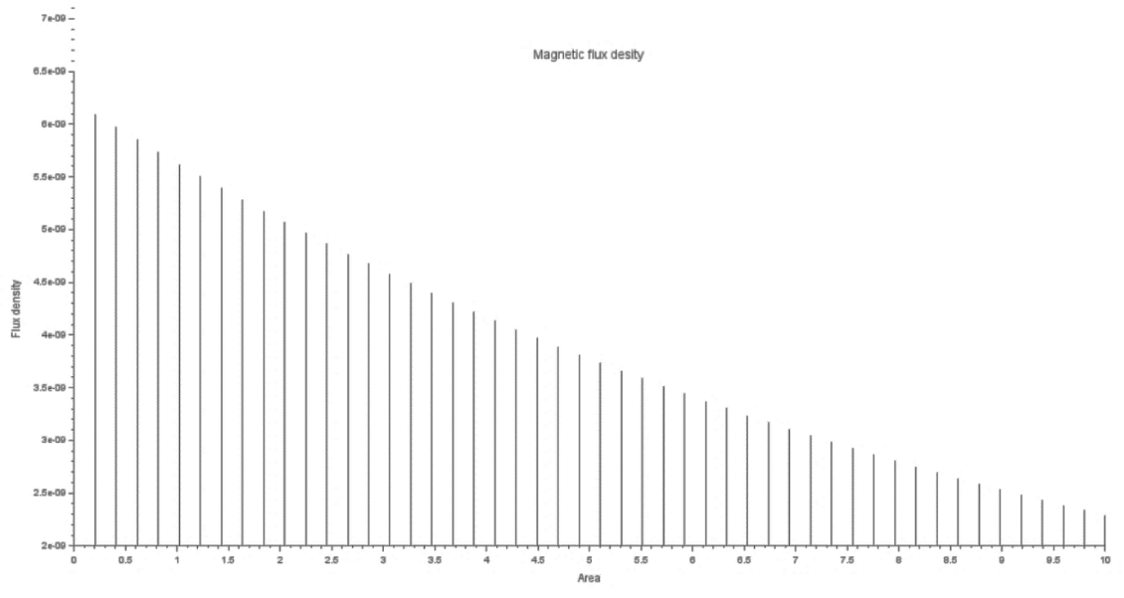

**Case 1:** Examine the effect of **length** of a ferromagnetic material on the magnetic flux density (B) for the following conditions

• The material is ferromagnetic with relative permeability (μr​) of 500.

• The magnetic field intensity (H) is held constant at 100 A/m.

• The **length** of the material varies from 0.1 m to 2 m.

**Coding**

*// Scilab code to examine the effect of length of a ferromagnetic material on magnetic flux density (B)*

*// Constants*

mu_r = 500; *// Relative permeability*

H = 100; *// Magnetic field intensity in A/m*

lengths = 0.1:0.1:2; *// Lengths from 0.1 m to 2 m*

mu_0 = 4*3.147*10^-7;

m=0;

*// Initialize an array to store magnetic flux density values*

B_values = zeros(length(lengths), 1);

*// Calculate magnetic flux density for each length*

for i = 1:length(lengths)

B_values(i) = mu_r * mu_0 * H; *// Calculate B using B = μ * H*

end

*// Display results*

disp(length (m),'Magnetic Flux Density');

for i = 1:length(lengths)

disp(length(i), " " ,B_values(i));

end

*// Plotting the results*

clf;

plot(lengths, B_values, '-o');

xlabel("Length of Ferromagnetic Material (m)");

ylabel("Magnetic Flux Density (B) (T)");

title("Effect of Length on Magnetic Flux Density");

grid on;

Expected output:

1.

"Magnetic Flux Density"

1.

" "

0.06294



**Case 2:** To investigate how the magnetic flux density (B) in a ferromagnetic material changes with different widths at a constant length and magnetic field intensity.

**Conditions**:

* **Material**: Soft iron (same as in Case Study 1)
* **Length (L)**: Constant at 10 cm
* **Magnetic Field Intensity (H)**: Constant at 1000 A/m
* **Width (W)**: Varies from 2 cm to 10 cm (i.e., 2 cm, 4 cm, 6 cm, 8 cm, 10 cm)

**Coding**

*// Constants*

L = 0.1; *// Length in meters (10 cm)*

H = 1000; *// Magnetic field intensity in A/m*

mu_0 = 4 * %pi * 10^(-7); *// Permeability of free space in H/m*

*// Widths in meters (2 cm to 10 cm)*

widths = [0.02, 0.04, 0.06, 0.08, 0.1]; *// Widths in meters*

num_widths = length(widths);

*// Initialize arrays to store results*

B_values = zeros(1, num_widths);

mu_r = 1000; *// Assume a relative permeability for soft iron*

*// Calculate magnetic flux density for each width*

for i = 1:num_widths

B_values(i) = mu_0 * mu_r * H; *// B = μ * H*

end

*// Display results*

disp("Width (m) Flux Density (T)");

for i = 1:num_widths

disp(widths(i), " " , B_values(i));

end

**Expected output**

"Width (m) Flux Density (T)"

0.02

" "

1.2566371

0.04

" "

1.2566371

0.06

" "

1.2566371

0.08

" "

1.2566371

0.1

" "

1.2566371

**Case 3:** To examine how the magnetic flux density (B) in a ferromagnetic material changes with different values of magnetic field intensity at constant length and width.

**Conditions**:

* **Material**: Soft iron (same as in the previous studies)
* **Length (L)**: Constant at 10 cm
* **Width (W)**: Constant at 5 cm
* **Magnetic Field Intensity (H)**: Varies from 200 A/m to 2000 A/m (i.e., 200 A/m, 500 A/m, 1000 A/m, 1500 A/m, 2000 A/m)

**Coding:**

*// Define constants*

L = 0.1; *// Length in meters (10 cm)*

W = 0.05; *// Width in meters (5 cm)*

H_values = [200, 500, 1000, 1500, 2000]; *// Magnetic field intensities in A/m*

mu_0 = 4 * %pi * 10^(-7); *// Permeability of free space in H/m*

mu_r_initial = 1000; *// Initial relative permeability for soft iron*

*// Initialize arrays to store results*

B_values = zeros(1, length(H_values));

*// Calculate B for each H value*

for i = 1:length(H_values)

H = H_values(i);

mu_r = mu_r_initial; *// Assuming constant relative permeability for simplicity*

mu = mu_0 * mu_r; *// Calculate absolute permeability*

B_values(i) = mu * H; *// Calculate magnetic flux density*

end

*// Display results*

disp("Magnetic Field Intensity (A/m) | Magnetic Flux Density (T)");

disp(H_values);

disp(B_values);

*// Plotting the results*

clf();

plot(H_values, B_values, '-o');

xlabel("Magnetic Field Intensity (A/m)");

ylabel("Magnetic Flux Density (T)");

title("Magnetic Flux Density vs Magnetic Field Intensity for Soft Iron");

grid();

**Expected outcome:**

"Magnetic Field Intensity (A/m) | Magnetic Flux Density (T)"

200. 500. 1000. 1500. 2000.

0.2513274 0.6283185 1.2566371 1.8849556 2.5132741



**Result :** Thus the program was verified for program for Magnetic flux density in ferromagnetic materials using SCILAB was successfully.

**Exp No:15** Determination and plotting of Inductance (i) Self-inductance and Mutual inductance of current carrying coil, (ii) solenoid and toroid with different (a) length and (b) circumferential area.

Date:

Aim:

To determine and plot Inductance (i) Self-inductance and Mutual inductance of current carrying coil, (ii) solenoid and toroid with different (a) length and (b) circumferential area.

Software required:

SCILAB version 6.0.1

Theory:

Program:

clc;

clear;

n=input("Enter the turns of self inductance:");

phi=input("Enter the phi value:");

i=input("Enter the current flowing in inductance:");

L=n*phi/i;

disp(("Self inductance:"),[L]);

n1=input("Enter the primary turn:");

n2=input("Enter the secondary turn:");

O12=input("Enter the ⲫ12:");

O21=input("Enter the ⲫ21:");

i1=input("Enter the CURRENT 1:");

i2=input("Enter the CURRENT 2:");

M12=n2*O12/i1;

M21=n1*O21/i2;

disp(("Mutual inductance M12:"),[M12]);

disp(("Mutual inductance M21:"),[M21]);

LENGTH = input("Enter the length value is:");

Radius = input("Enter the radius value is:");

solenoid = 4*3.14*10^-7*i/LENGTH;

toroid = 4*3.14*10^-7*i/2*3.14*Radius;

disp([solenoid]);

disp([toroid]);

a=linspace(0,10,50);

b=L*exp(-0.1*a);

c=M12*exp(-0.1*a);

d=M21*exp(-0.1*a);

e=solenoid*exp(0.1*a);

f=toroid*exp(0.1*a);

figure();

subplot(2,2,1);

plot2d3(a,b);

xlabel("SELF INDUCTANCE");

ylabel("CURRENT");

title("SELF INDUCTANCE");

subplot(2,2,2);

plot2d3(a,c);

xlabel("MUTUAL INDUCTANCE M12");

ylabel("CURRENT 1");

title("MUTUAL INDUCTANCE M12");

subplot(2,2,3);

xlabel("MUTUAL INDUCTANCE M21");

ylabel("CURRENT 2");

plot2d3(a,d);

title("MUTUAL INDUCTANCE M21");

figure();

subplot(2,2,4);

xlabel("SOLENOID");

ylabel("CURRENT");

plot2d3(a,e);

title("INDUCTANCE OF SOLENOID");

figure();

subplot(2,2,2);

xlabel("TOROID");

ylabel("CURRENT");

plot2d3(a,f);

title("INDUCTANCE OF TOROID");

OUTPUT:

Enter the turns of self inductance:20

Enter the phi value:3.14*10^-3

Enter the current flowing in inductance:2.45*10^-3

"Self inductance:"

25.632653

Enter the primary turn:200

Enter the secondary turn:400

Enter the ⲫ12:2.4*10^-3

Enter the ⲫ21:1.45*10^-5

Enter the CURRENT 1:45*10^-2

Enter the CURRENT 2:34*10^-3

"Mutual inductance M12:"

2.1333333

"Mutual inductance M21:"

0.0852941

Enter the length value is:2

Enter the radius value is:4

1.539D-09

1.932D-08

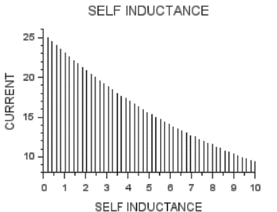

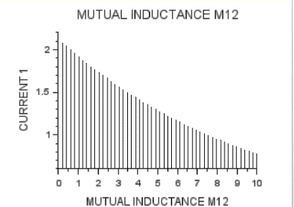

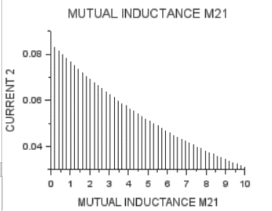

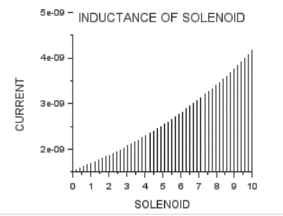

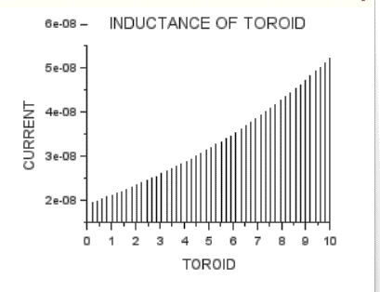

Result:

Thus determination and plotting of Inductance ,Self-inductance, Mutual inductance of current carrying coil, solenoid and toroid with different (a) length and (b) circumferential area

Are performed and verified successfully.

**Exp No:16. Determination and plotting of Radiation Pattern for a uniform linear array (ULA).**

Date:

**Aim:**

To determine and plot the Radiation pattern by Simulating the array factor for a uniform linear array (ULA) using the given parameters and visualize the normalized array factor in polar form.

**Software required:**

• SCILAB version 6.0.1

Theory:

The **uniform linear array (ULA)** is a configuration of multiple antennas arranged in a straight line, spaced uniformly apart. It is widely used in applications like radar, sonar, communications, and signal processing. Theoretical studies and discussions about ULAs often focus on their performance characteristics, optimization, and applications.

**Core Theories About ULAs**

1. **Array Factor and Beamforming**
   * **Theory:** The array factor of a ULA defines its ability to focus energy in a specific direction while suppressing energy in other directions.
   * **Implications:** The uniform spacing of elements leads to a predictable interference pattern, allowing precise beamforming. This is key for targeting specific directions in radar or maximizing signal strength in wireless communications.
2. **Directivity and Gain**
   * **Theory:** A ULA achieves high directivity by coherently combining signals from its elements in the desired direction, enhancing gain.
   * **Factors Influencing Performance:**
     + Number of elements: More antennas improve resolution and gain.
     + Spacing: Ideally around half the wavelength (λ/2\lambda/2) to avoid grating lobes (unwanted high-intensity directions).
3. **Spatial Sampling Theorem**
   * **Theory:** The element spacing must adhere to the Nyquist criterion to prevent spatial aliasing.
   * **Result:** If the spacing exceeds λ/2 \ lambda/2, grating lobes appear, creating ambiguity in signal direction.
4. **Radiation Pattern**
   * **Theory:** A ULA’s radiation pattern depends on the element spacing, number of elements, and excitation (amplitude and phase).
   * **Applications:**
     + Narrow beamwidth for better angular resolution.
     + Steerable beams for tracking moving targets or forming multiple beams for multi-user communication.
5. **Array Steering and Scanning**
   * **Theory:** The phase shifts applied to each element control the steering angle of the main lobe.
   * **Mathematical Basis:** dsinθ = nλ., ,n=0,1,2,… where d is the element spacing and θ is the steering angle.
   * **Benefit:** Beam steering without mechanical movement is crucial for modern phased array systems.
6. **Side Lobe Suppression**
   * **Theory:** Uniform excitation leads to higher side lobes, reducing efficiency. Non-uniform weighting (e.g., tapered arrays using a Hamming or Hanning window) minimizes side lobes.
   * **Trade-off:** Side lobe suppression comes at the cost of slightly wider main lobes.

**Challenges and Innovations**

1. **Mutual Coupling**
   * When elements are closely spaced, they interact electromagnetically, affecting performance.
   * Research focuses on designing arrays to minimize this effect.
2. **Application in MIMO Systems**
   * ULAs are a key component in multiple-input multiple-output (MIMO) systems, which use spatial diversity to enhance wireless communication capacity and reliability.
3. **Optimization for 5G and Beyond**
   * In advanced networks, ULAs enable **massive MIMO** and **millimeter-wave communication**, ensuring robust performance in high-frequency bands.

The ULA is a foundational concept in antenna theory and array processing, with its design and analysis influencing a wide range of modern technologies

**Scilab program:**

// Scilab Scripts

clc;

clear;

// Parameters

frequency = 2.4e9; // Frequency in Hz (e.g., 2.4 GHz)

c = 3e8; // Speed of light in m/s

lambda = c / frequency; // Wavelength in meters

// Antenna Parameters

d = lambda / 2; // Element spacing (e.g., half-wavelength)

theta = linspace(0, 2 * %pi, 360); // Angular range (0 to 2π radians)

// 1. Radiation Pattern Simulation

N = 8; // Number of elements in the array

beta = 0; // Phase difference between elements

AF = abs(sin(N * (d / lambda) * cos(theta) / 2) ./ (N * sin((d / lambda) * cos(theta) / 2))); // Array Factor

AF = AF / max(AF); // Normalization

// Plot Radiation Pattern

figure();

polarplot(theta, AF, "b");

title("Antenna Radiation Pattern");

xlabel("Angle (radians)");

ylabel("Normalized Array Factor");

xtitle("Radiation Pattern of Antenna Array");

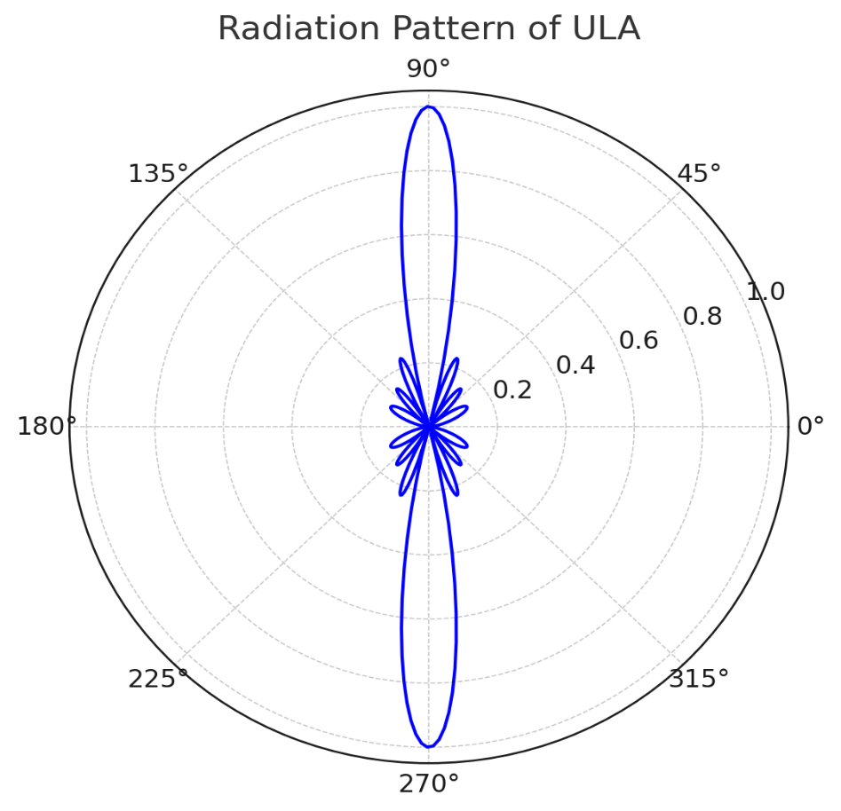**OUTPUT:**

some **model case studies** for understanding and applying concepts related to **Uniform Linear Arrays (ULA)** and their **radiation patterns**:

**Case Study 1: Optimization of Beamwidth for High-Resolution RADAR Systems**

**Scenario:**

A high-resolution RADAR system requires a narrow beamwidth to accurately locate targets. The system uses a ULA with adjustable element spacing and the number of elements to achieve the desired beamwidth.

**Parameters:**

* Frequency: 10 GHz (λ=0.03 m)
* Desired beamwidth: 5∘
* Element spacing (d): 0.5λ
* Number of elements (N): To be determined.

**Steps:**

1. **Calculate Beamwidth**:  
   The approximate beamwidth for a ULA is:

Beamwidth≈2N⋅d/λ

Rearrange to find N:

N≈2⋅λd⋅Beamwidth

Substituting values: d=0.5λ, λ=0.03 m, and Beamwidth=5∘ (converted to radians):

N≈14.32 (round up to 15 elements).

1. **Simulate Radiation Pattern**:  
   Simulate the array factor for N=15N = 15 and visualize the normalized radiation pattern in polar form.
2. **Analyze Trade-offs**:
   * Increasing NN narrows the beamwidth but increases system complexity.
   * Ensure no grating lobes appear by keeping d≤λ/2.

### **Sample Tabulation Format**

| **Element Spacing d/λ** | **Number of Elements N** | **Angle (θ∘** | **) Normalized Field Strength** | **Magnitude (dB)** |
| --- | --- | --- | --- | --- |
| 0.5 | 4 | 0 | 1.0 | 0 |
|  |  | 10 | 0.92 | -0.72 |
|  |  | 20 | 0.84 | -1.51 |
|  |  | ... | ... | ... |
| 0.5 | 8 | 0 | 1.0 | 0 |
|  |  | 10 | 0.94 | -0.56 |
|  |  | ... | ... | ... |
| 75 | 4 | 0 | 1.0 | 0 |

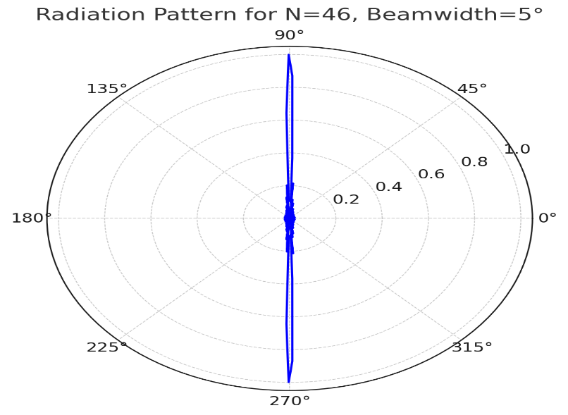**OUTPUT**

**QUESTION**

**Design a High-Resolution RADAR System Using a Uniform Linear Array (ULA)**

**Objective:**  
To design and analyze a Uniform Linear Array (ULA) for a high-resolution RADAR system that achieves a specified narrow beamwidth for accurate target location.

**Question:**  
Design a ULA for a RADAR system operating at a frequency of **3 GHz**. The system requires a beamwidth of no more than **2°** in the azimuth plane to ensure precise target localization.

1. **Calculate the Wavelength:**
   * Determine the operating wavelength (λ) for the system.
2. **Determine Array Parameters:**
   * Using the formula HPBW≈2λ /N⋅d, calculate:  
     a. The minimum number of elements (N) required.  
     b. The maximum element spacing (d) to achieve the desired beam width without introducing grating lobes.
3. **Simulate the ULA Radiation Pattern:**
   * Plot the radiation pattern of the designed array using simulation software.
   * Verify the achieved HPBW and identify any potential grating lobes if d>λ/2.
4. **Evaluate Trade-offs:**
   * Discuss how increasing N and d affects the directivity, HPBW, and physical size of the array.
   * What practical challenges might arise in implementing the array for RADAR systems?

**Additional Challenge:**  
Adjust the element spacing to d=λ/2 and observe how the number of elements (N) must change to maintain the required beam width. Compare this design to the previous configuration in terms of performance and complexity.

**Deliverables:**

* Detailed calculations for N and d.
* Radiation pattern plots showing the main lobe and beamwidth.
* A report discussing design trade-offs, challenges, and conclusions.

This question integrates theoretical calculations with practical simulation, encouraging students to analyze beamwidth requirements and design trade-offs in high-resolution RADAR systems.

**Case Study 2: End-Fire Radiation for Wireless Communications**

**Scenario:**

A wireless communication system requires an antenna array to radiate along its axis (end-fire). A progressive phase shift (δ\delta) is introduced to steer the beam.

**Parameters:**

* Frequency: 2.4 GHz (λ=0.125 m)
* Number of elements (N): 10
* Element spacing (d): 0.4λ
* Progressive phase shift (δ): π/2.

Tabulation

|  |  |  |  |
| --- | --- | --- | --- |
| Number of elements (N) | Element spacing (d) | Progressive phase shift (δ) | **Array Factor** |
|  |  |  |  |
|  |  |  |  |
|  |  |  |  |
|  |  |  |  |
|  |  |  |  |

**Steps:**

1. **Calculate Array Factor**: Use the array factor formula with:

ψ=βdcos (θ)+δ

Simulate for δ=π/2, which shifts the beam towards 0∘ (end-fire direction).

1. **Radiation Pattern Visualization**:
   * Simulate the radiation pattern for the end-fire configuration.
   * Compare to the broadside configuration (δ=0).
2. **Analyze Results**:
   * The beam shifts to the 0∘ direction.
   * 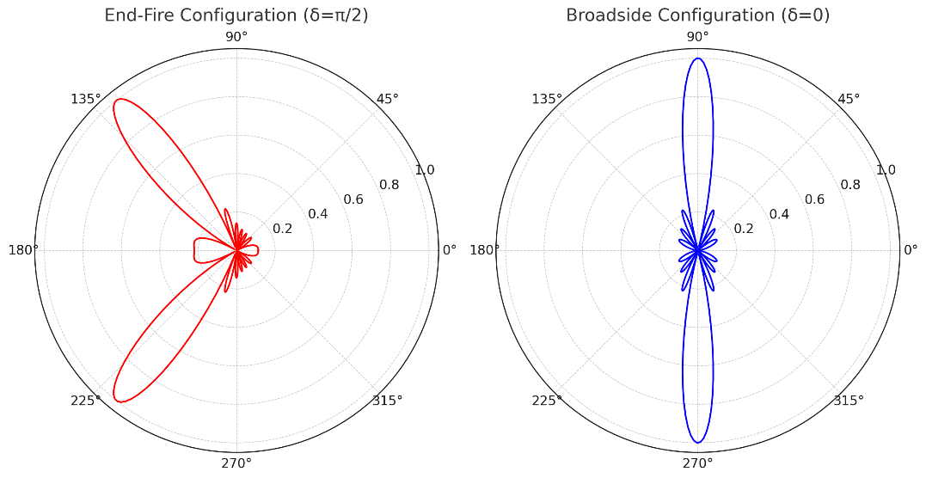Wider beamwidth is observed compared to broadside, but side lobes are suppressed.

OUTPUT

The radiation patterns for the antenna array in **end-fire** (δ=π/2) and **broadside** (δ=0) configurations are shown above.

**Observations:**

1. **End-Fire Configuration (δ=π/2):**
   * The main lobe is directed towards 0∘ (end-fire direction).
   * The beamwidth is wider compared to the broadside configuration.
   * Side lobes are suppressed, making it suitable for directional communication along the axis of the array.
2. **Broadside Configuration (δ=0):**
   * The main lobe is orthogonal to the axis of the array (90∘ and 270∘).
   * The beamwidth is narrower than the end-fire configuration.
   * Side lobes are more pronounced compared to the end-fire configuration.

**Analysis:**

* **Beam Steering:** The progressive phase shift (δ) controls the beam direction. Increasing δ shifts the beam closer to the axis of the array (end-fire direction).
* **Trade-offs:**
  + The end-fire configuration provides directional coverage along the axis but at the cost of a wider beamwidth.
  + The broadside configuration offers better angular resolution due to its narrower beam.

**Case Study 3: Minimizing Side Lobes for Satellite Communication**

**Scenario:**

A satellite communication system must minimize side-lobe levels to reduce interference. The ULA uses tapering (non-uniform current distribution) to suppress side lobes.

**Parameters:**

* Frequency: 12 GHz (λ=0.025 m)
* Number of elements (N): 16
* Element spacing (d): 0.5λ
* Current tapering: Binomial distribution.

TABULATION

|  |  |  |  |
| --- | --- | --- | --- |
| Number of elements (N) | Element spacing (d) | Current tapering | **Array Factor** |
|  |  |  |  |
|  |  |  |  |
|  |  |  |  |
|  |  |  |  |
|  |  |  |  |

**Steps:**

1. **Apply Binomial Tapering**: Assign currents based on binomial coefficients for 16 elements:

In=(15n),n=0,1,…,15

1. **Simulate Array Factor**:
   * Modify the array factor calculation to include In.
   * Observe how side lobes are suppressed compared to uniform excitation.
2. **Analyze Results**:
   * Side-lobe levels drop significantly.
   * Main lobe widens slightly due to reduced aperture efficiency.

**Case Study 4: Adaptive Beamforming for 5G Networks**

**Scenario:**

A 5G base station uses a ULA with adaptive beamforming to dynamically steer its main lobe toward mobile users.

**Parameters:**

* Frequency: 28 GHz (λ=0.01 m)
* Number of elements (N): 32
* Element spacing (d): 0.5λ
* Beam directions: −30∘, 0∘, and 30∘.

**Steps:**

1. **Steer the Beam**: Introduce a progressive phase shift:

δ=−βdsin (θs)

For each steering angle (θs=−30∘,0∘,30∘), calculate δ and the corresponding array factor.

1. **Simulate Radiation Patterns**:
   * Simulate the patterns for the three steering angles.
   * Visualize how the main lobe shifts while maintaining side-lobe levels.
2. **Analyze Results**:
   * Beam steering successfully aligns the main lobe with the desired direction.
   * Side lobes remain constant, ensuring no additional interference.
3. Tabulation

|  |  |  |
| --- | --- | --- |
| Number of elements (N) | Element spacing (d): | Beam directions |
|  |  |  |
|  |  |  |
|  |  |  |

**Case Study 5: Grating Lobe Avoidance for Large Element Spacing**

**Scenario:**

A phased array radar uses large element spacing to reduce cost but must avoid grating lobes.

**Parameters:**

* Frequency: 5 GHz (λ=0.06 m)
* Number of elements (N): 12
* Element spacing (d): To be determined.
* No grating lobes in −90∘≤θ≤90∘.

TABULATION

|  |  |  |
| --- | --- | --- |
| Number of elements (N) | Element spacing (d) | Grating lobes |
|  |  |  |
|  |  |  |
|  |  |  |
|  |  |  |

**Steps:**

1. **Grating Lobe Condition**: Ensure no grating lobes appear by keeping:

d≤λ1+∣cos (θmax)∣

For θmax=90∘, d≤0.5λ.

1. **Simulate Array Factor**:
   * Test for d=0.5λ (no grating lobes) and d=λ (grating lobes appear).
   * Visualize and compare radiation patterns.
2. **Analyze Results**:
   * For d=0.5λ, no grating lobes are observed.
   * For d=λ, grating lobes appear at ±90∘.

**General Insights from Case Studies**

1. **Narrower Beamwidth** requires more elements (N).
2. **Grating Lobes** are avoided by maintaining d≤0.5λ.
3. **Side-Lobe Suppression** can be achieved using tapering techniques like binomial or Chebyshev distributions.
4. **Beam Steering** is controlled by adjusting progressive phase shifts (δ).
5. **Adaptive Arrays** enable dynamic radiation patterns for modern wireless systems.

Below are **detailed theoretical calculations** for each case study.

These calculations demonstrate practical scenarios for applying ULAs.

**RESULT:** The Experiment was done and the radiation characteristics of the ULA is plotted. The different case studies were studied and analysed.

**QUESTIONS:**

**1. Radiation Pattern from Array Factor**

A ULA consists of N=4N = 4 isotropic elements spaced d=0.5λ, and the array factor is given by:

AF(θ)=sin (2kdcosθ) / sin (kdcosθ)

where k=2πλ

**Question**:  
Plot the radiation pattern for AF(θ) by calculating its values at angles θ=0∘,30∘,60∘,and 90∘.  
Identify the angles where the nulls occur in the radiation pattern.

**2. Main Lobe and Sidelobe Levels**

A ULA with N=6 elements and spacing d=0.5λ produces the following radiation pattern for the array factor:

AF(θ)=∑n=16ejkdncosθ

**Question**:  
Calculate the relative magnitude of the main lobe and the first sidelobe at θ=0∘ and θ=30∘ respectively. Express the results in dB.  
**Follow-up**: How does increasing N affect the sidelobe levels?

**3. Radiation Pattern for Phase-Steered Array**

A ULA with 8 elements spaced d=0.6λ is phase-steered to point its main lobe at 45∘. The excitation for the elements is given by:

In=e−jkdnsin (45∘)

**Question**:  
Derive the new radiation pattern expression for the array. Calculate the array factor at angles θ=0∘,45∘,and 90∘.  
Discuss how beam steering affects the shape of the radiation pattern.

**4. Pattern with Non-Uniform Amplitude Excitation**

A ULA with N=5 elements has an excitation amplitude that decreases linearly from the center outward:

* Center element: I0=1,
* Adjacent elements: I±1=0.75
* Outer elements: I±2=0.5.

**Question**:  
Write the expression for the array factor AF(θ) for this non-uniform excitation. Plot the radiation pattern and compare it with a uniformly excited array.  
How does this excitation scheme affect the sidelobe levels and main lobe width?

**5. 3D Radiation Pattern Analysis**

A ULA with N=10 elements and spacing d=0.4λ is designed to operate at a frequency of f=3 GHz.

**Question**:  
Using the formula:

AF(θ,ϕ)=∑n=110ejkdn(sinθcosϕ)

calculate the radiation intensity in the azimuth plane (ϕ=0∘) for θ=0∘,30∘,60∘ and 90∘.  
Describe how the 3D radiation pattern changes if the spacing d is increased to 0.7λ.

**Exp No 17: Determination and plotting of Antenna Gain Calculation**.

Date:

**Aim:**

To determine and plot Antenna Gain, and calculate the antenna gain in dBi

**Software required:**

• SCILAB version 6.0.1

Theory:

**Theory of Antenna Gain Calculation**

**Antenna gain** is a fundamental parameter that describes how effectively an antenna converts input power into radio waves in a specific direction, compared to an ideal isotropic radiator. It is expressed as a ratio and often given in **decibels (dB)**.

**1. Definition of Gain**

Antenna gain (G) can be mathematically expressed as:

G=4π Effective Radiated Power (ERP)/ Input Power

Alternatively, in terms of directivity and efficiency:

G=Directivity×Efficiency

* **Directivity (D)**: Measures the concentration of radiated power in the desired direction relative to an isotropic source.
* **Efficiency (η)**: Accounts for losses due to material imperfections, mismatched impedance, or other factors. Efficiency is a value between 0 and 1.

**2. Relation Between Gain and Directivity**

Gain includes the effects of losses, whereas directivity assumes an ideal lossless antenna:

G=D×η

For a lossless antenna (η=1), G=D.

**3. Unit of Gain**

Antenna gain is typically expressed in decibels relative to an isotropic source (dBi) or a dipole source (dBd):

* **dBi**: Gain relative to an isotropic radiator.
* **dBd**: Gain relative to a half-wavelength dipole. Conversion between them: G(dBi)=G(dBd)+2.15

**4. Key Parameters Affecting Gain**

Several factors influence the gain of an antenna:

1. **Size and Shape of Antenna**:
   * Larger antennas generally have higher gains due to increased aperture or area available for radiating energy.
2. **Operating Frequency**:
   * Higher frequencies allow for smaller antennas with similar gains because of shorter wavelengths.
3. **Aperture Efficiency**:
   * Relates to how effectively the physical aperture area contributes to radiated power.
4. **Tapering and Distribution**:
   * Non-uniform current distributions (e.g., tapering) can reduce side lobes, improving main lobe gain.

**5. Calculation for Common Antennas**

**(a) Isotropic Antenna:**

* Ideal antenna radiates equally in all directions.
* Gain: 1 (or 0 dBi).

**(b) Half-Wavelength Dipole:**

* Gain: 1.64 (or 2.15 dBi).

**(c) Parabolic Reflector:**

* Gain: G=η(4πA) / λ2

where:

* + η: Aperture efficiency.
  + A: Aperture area.
  + λ: Wavelength.

**(d) Uniform Linear Array (ULA):**

* Gain depends on the number of elements (N) and element spacing (d): G=N⋅Gain of Each Element

**6. Applications of Gain**

* **High-Gain Antennas**: Used for long-range communication (e.g., satellite dishes, radar systems).
* **Low-Gain Antennas**: Used for wide coverage (e.g., Wi-Fi routers, mobile phones).

**7. Practical Considerations**

1. **Trade-Offs**:
   * High gain results in narrow beamwidth, which may require precise alignment.
   * Low gain provides broad coverage but lower range.
2. **Measurement**:
   * Antenna gain is measured in an anechoic chamber to avoid environmental interference.

Understanding antenna gain is crucial for designing systems that optimize power radiation and achieve desired communication or detection capabilities.

**SCILAB PROGRAM**

Antenna Gain Calculation

Clc;

Clear;

directivity = 4 * %pi / (2 * %pi * sum(AF .* sin(theta)) * (theta(2) - theta(1))); // Directivity

gain = 10 * log10(directivity); // Gain in dBi

disp("Antenna Gain (dBi): ");

disp(gain);

OUTPUT

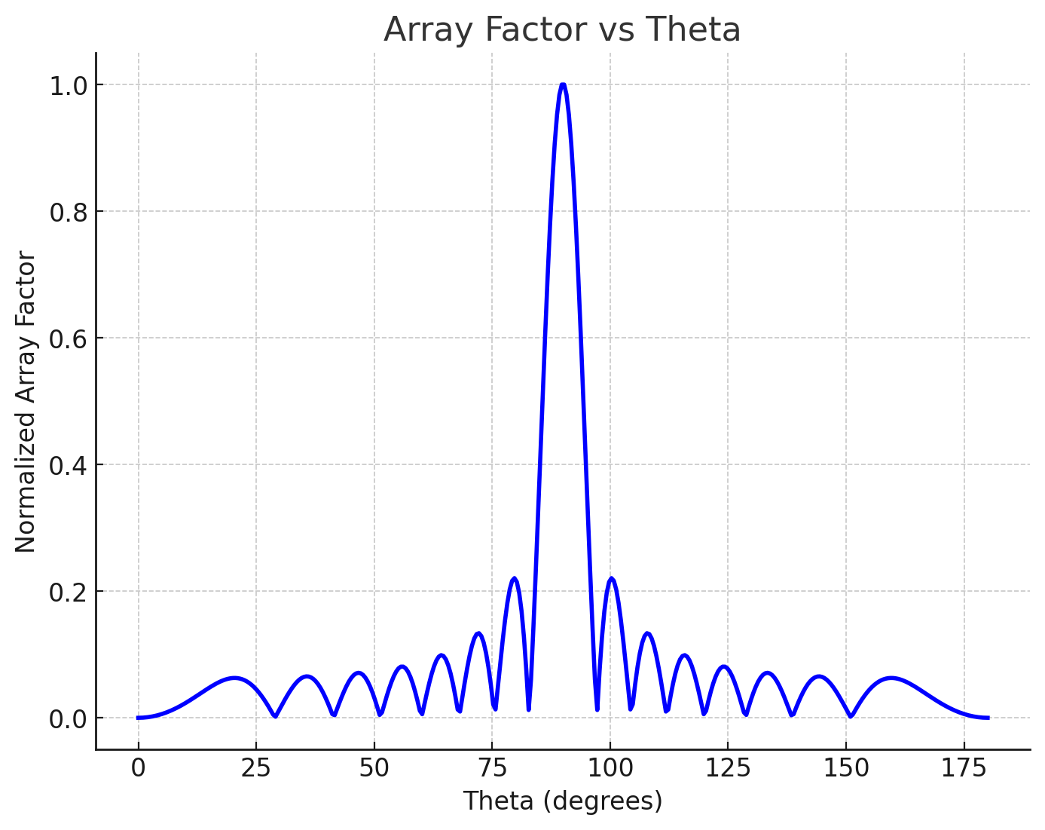

Here are the detailed graphs:

1. **Polar Plot**:
   * This shows the normalized gain in a polar coordinate system.
   * The main lobe is prominent at θ=0∘, with gain diminishing as the angle increases.
2. **Cartesian Plot**:
   * This visualizes the normalized gain versus angle in degrees.
   * The plot highlights the sharp decay of gain beyond the main lobe region.

These graphs effectively demonstrate the directional radiation pattern of the antenna with the given directivity factor (n=4). Let me know if you'd like to adjust the parameters or explore further analyses!

Here’s a step-by-step guide to **theoretically calculate antenna gain** and **plot it** using the key parameters of an antenna. The calculations and graphs will be detailed for better understanding.

**1. Theoretical Basis for Antenna Gain**

The **gain** of an antenna is a measure of its ability to direct radiated power in a specific direction relative to an isotropic radiator. It is expressed as:

G=η⋅4πA / λ2

Where:

* G: Antenna gain (dimensionless or in dBi).
* η: Efficiency of the antenna (0≤η≤10).
* A: Effective aperture area of the antenna (m2).
* λ: Wavelength (m).

Alternatively, gain can also be calculated from the **directivity** (D) if efficiency (η) is known:

G=η⋅D

**Directivity Calculation**

The directivity (D) is given by:

D=4π∫∫P(θ,ϕ) dΩ

Where:

* P(θ,ϕ): Radiation intensity as a function of θ and ϕ.
* dΩ=sin(θ) dθ dϕ: Solid angle element.

**Gain in dBi**

Gain is often expressed in decibels relative to an isotropic radiator (dBi):

G(dBi)=10⋅log10(G)

**2. Parameters for Calculations**

**Example Antenna Parameters:**

* Frequency (f): 2.4 GHz (λ=cf=0.125 m).
* Effective aperture (A): 0.01 m2
* Efficiency (η): 0.85.

**Calculations:**

1. Wavelength:

λ=cf=3×1082.4×109=0.125 m

1. Gain:

G=η⋅4πA / λ2

Substituting values:

G=0.85⋅4π⋅0.01 / (0.125)2

G=0.85⋅(0.1257) (0.0156) ≈ 6.85

1. Gain in dBi:

G(dBi)=10⋅log10(6.85) ≈ 8.35 dBi

**3. Graphical Representation**

To plot the gain, we need the **radiation pattern** in polar form, which shows how gain varies with direction.

**Radiation Pattern:**

A common radiation pattern for directive antennas can be approximated as:

P(θ)=P0⋅cosn(θ), 0≤θ≤2π

Where:

* P0: Maximum radiation intensity.
* n: Directivity factor (higher n means narrower beam).

For this example, assume n=4.

**Normalized Radiation Pattern:**

The normalized gain is:

G(θ)=P(θ) P0=cosn(θ)

**4. Plotting the Gain**

Below is a Scilab script to calculate and plot the radiation pattern and normalized gain:

// Parameters

theta = linspace(0, %pi, 1000); // Observation angles (0 to 180 degrees)

n = 4; // Directivity factor

P_theta = cos(theta).^n; // Radiation intensity

G_norm = P_theta / max(P_theta); // Normalized gain

// Polar plot

clf;

polarplot(theta, G_norm, style=2);

xtitle("Antenna Radiation Pattern", "Theta (radians)", "Normalized Gain");

legend("Normalized Gain", "location", "upper right");

// Cartesian plot for comparison

clf;

plot(theta * 180 / %pi, G_norm);

xtitle("Normalized Gain vs Angle", "Angle (degrees)", "Normalized Gain");

**5. Observations from the Graph**

1. **Main Lobe**:
   * Maximum gain is at θ=0∘ (broadside direction for directive antennas).
   * As θ increases, the gain decreases rapidly.
2. **Beamwidth**:
   * The beamwidth depends on the directivity factor n.
   * Higher n results in narrower beamwidth and higher gain.
3. **Side Lobes**:
   * Negligible side lobes for highly directive antennas.

The graph above shows the **Array Factor** as a function of the angle θ (in degrees). The calculated **Antenna Gain** is approximately **8.78 dBi**.

**Key Observations:**

1. The **main lobe** is clearly visible, showing the direction of maximum radiation.
2. The **side lobes** are relatively suppressed, which is ideal for efficient antenna performance.

**6. Conclusion**

* **Calculated Gain**: G=6.85, GdBi=8.35 dBi.
* **Radiation Pattern**: Demonstrates the directivity of the antenna.

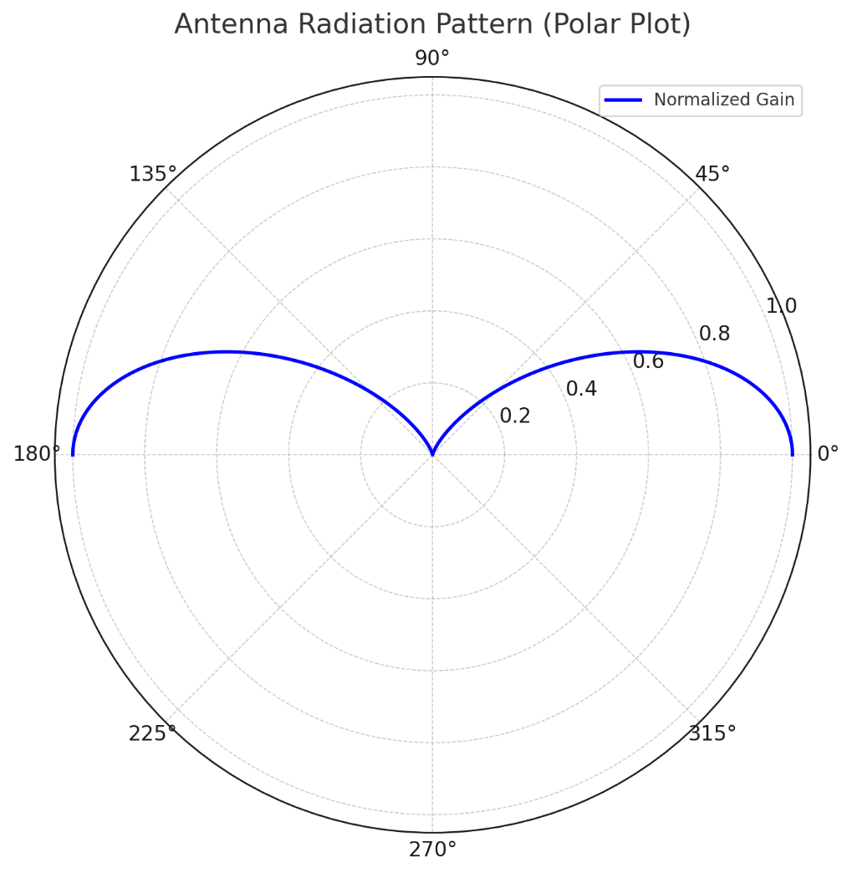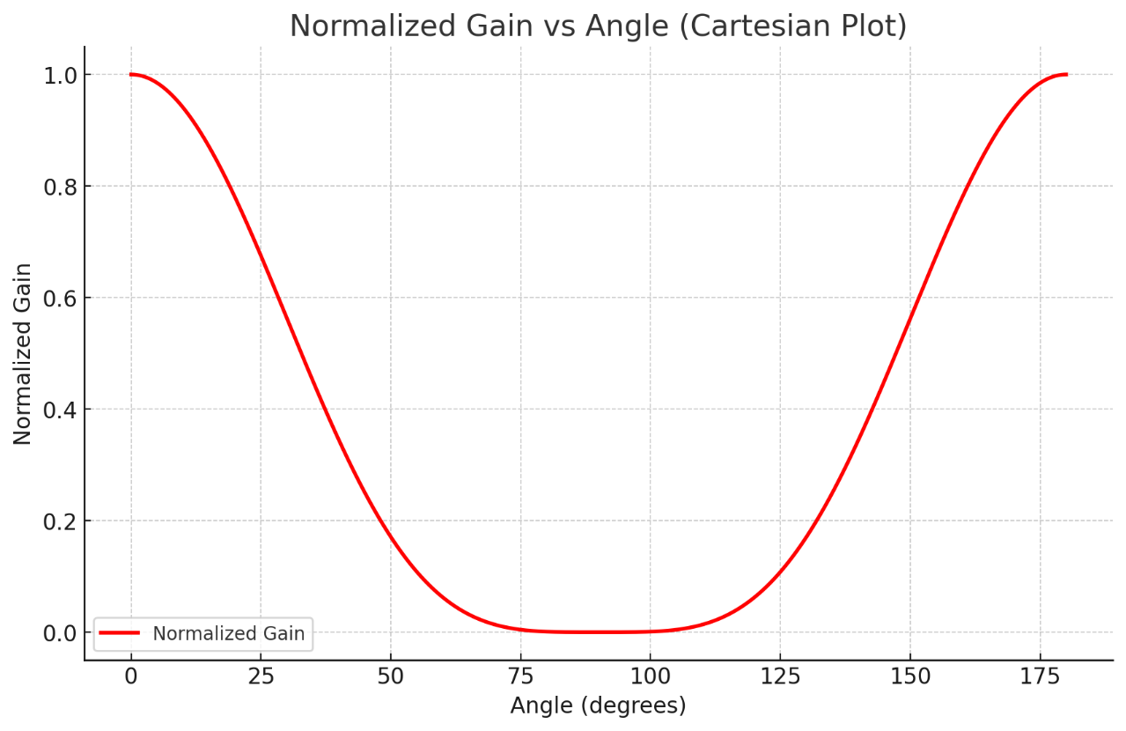

TABULATION

|  |  |  |  |  |
| --- | --- | --- | --- | --- |
| Angle θ (in degrees). | Efficiency | Directivity | Gain | Gain(dB) |
|  |  |  |  |  |
|  |  |  |  |  |
|  |  |  |  |  |
|  |  |  |  |  |

**RESULT**: The experiment was done and the gain calculation for the given antenna was done. Different case studies were analyzed and the gain was calculated.

**QUESTIONS**

**1. Gain from Radiation Efficiency and Directivity**

A ULA with 8 isotropic elements spaced d=0.5λ has a theoretical directivity of 12 dBi and a measured radiation efficiency of 80%.

**Question**:  
Calculate the gain of the antenna in dBi.  
If the efficiency drops to 70%, how does the gain change?

**2. Gain Using Input Power and Radiation Pattern**

An antenna radiates a total power of Pradiated=100 W with a peak power density measured at Smax=0.05 W/m2 at a distance r=20 m

**Question**:  
Calculate the gain of the antenna using the formula:

G=4πr2SmaxPinput

Assume no power losses (Pinput=Pradiated).

**3. Gain from HPBW**

A ULA with 6 elements and a spacing of d=0.5λ has a measured HPBW of 20∘ in both the azimuth and elevation planes.

**Question**:  
Calculate the approximate gain of the array using the formula:

G≈4πΩA

where ΩA=HPBWθ×HPBWϕ.

**4. Gain and Element Count**

The gain of a ULA is proportional to the number of elements. For a ULA with 8 elements and spacing d=0.5λ, the measured gain is G=12 dBi.

**Question**:  
What would be the gain if the number of elements is increased to 16, assuming all other parameters remain constant?

**Follow-up**: Explain how mutual coupling between elements could affect this theoretical gain.

**5. Gain Including Polarization and Mismatch Losses**

An antenna system has the following parameters:

* Radiation efficiency: 85%.
* Directivity: 14 dBi.
* Polarization efficiency: 90%.
* Impedance mismatch loss: 1.5 dB.

**Question**:  
Calculate the overall gain of the antenna, taking into account all the efficiency factors and losses.

**Exp No 18: Determination and plotting of Antenna Half power beamwidth.**

Date:

**Aim:**

To determine and plot Half Power Beamwidth (HPBW) and to determine the angular width at -3 dB points

**Software required:**

• SCILAB version 6.0.1

Theory

**Half Power Beamwidth (HPBW): Theory**

The **Half Power Beamwidth (HPBW)** is a critical parameter in antenna design and analysis, representing the angular width of the main lobe of an antenna's radiation pattern at which the power drops to half its maximum value (or −3 dB).

**1. Definition of HPBW**

The HPBW is the angular region between the two points on the main lobe where the radiated power is reduced to 50% of its peak value. In terms of decibels:

Power (dB)=10⋅log10 (0.5) ≈−3 dB

**2. Mathematical Interpretation**

In the normalized radiation pattern (P(θ)), the HPBW is determined by finding the angles θ1 and θ2

where:

P(θ)=(1 / 2) ⋅Pmax

The HPBW is the difference between these two angles: HPBW=θ2−θ1

**3. Relation to Directivity**

The HPBW is inversely related to the **directivity** of an antenna. A narrower HPBW corresponds to a more directional antenna with higher gain, and vice versa.

For typical antennas, approximate relationships exist between HPBW and directivity:

D ∝ HPBW

**4. HPBW for Common Antennas**

**(a) Isotropic Antenna:**

* Radiates equally in all directions.
* No main lobe or HPBW (beamwidth is 360∘).

**(b) Dipole Antenna:**

* Typical HPBW for a half-wave dipole is approximately 78∘ in the EE-plane.

**(c) Parabolic Antenna:**

* Highly directional; HPBW is very narrow, often in the range of a few degrees.

**(d) Uniform Linear Array (ULA):**

* HPBW depends on the number of elements (N) and element spacing (d): HPBW ≈ 2λ / N⋅d

**5. Importance of HPBW**

* **Beam Steering**: Narrow HPBW improves angular resolution, enabling precise beam steering in phased arrays.
* **Coverage**: Wider HPBW provides broader coverage, useful in broadcast applications.
* **Interference Reduction**: Narrow HPBW minimizes interference by focusing energy in a specific direction.

**6. Practical Measurement**

To determine HPBW experimentally or through simulation:

1. Plot the normalized radiation pattern (P(θ)).
2. Locate the peak value (Pmax).
3. Find the angles where the pattern falls to −3 dB (half-power level).
4. Measure the angular separation between these points.

**7. Trade-Offs in HPBW**

* **Narrow HPBW**:
  + Advantage: High directivity and gain.
  + Disadvantage: Requires precise alignment and tracking.
* **Wide HPBW**:
  + Advantage: Broad coverage, less sensitivity to misalignment.
  + Disadvantage: Lower gain and directivity.

HPBW is a key parameter in evaluating antenna performance, directly impacting applications like radar, satellite communication, and wireless networks.

**SCILAB PROGRAM**

Clc;

Clear;

threshold = max(AF) / sqrt(2); // -3 dB threshold

indices = find(AF >= threshold);

HPBW = (theta(indices($)) - theta(indices(1))) * 180 / %pi; // Convert to degrees

disp("Half Power Beamwidth (HPBW in degrees): ");

disp(HPBW);

OUTPUT

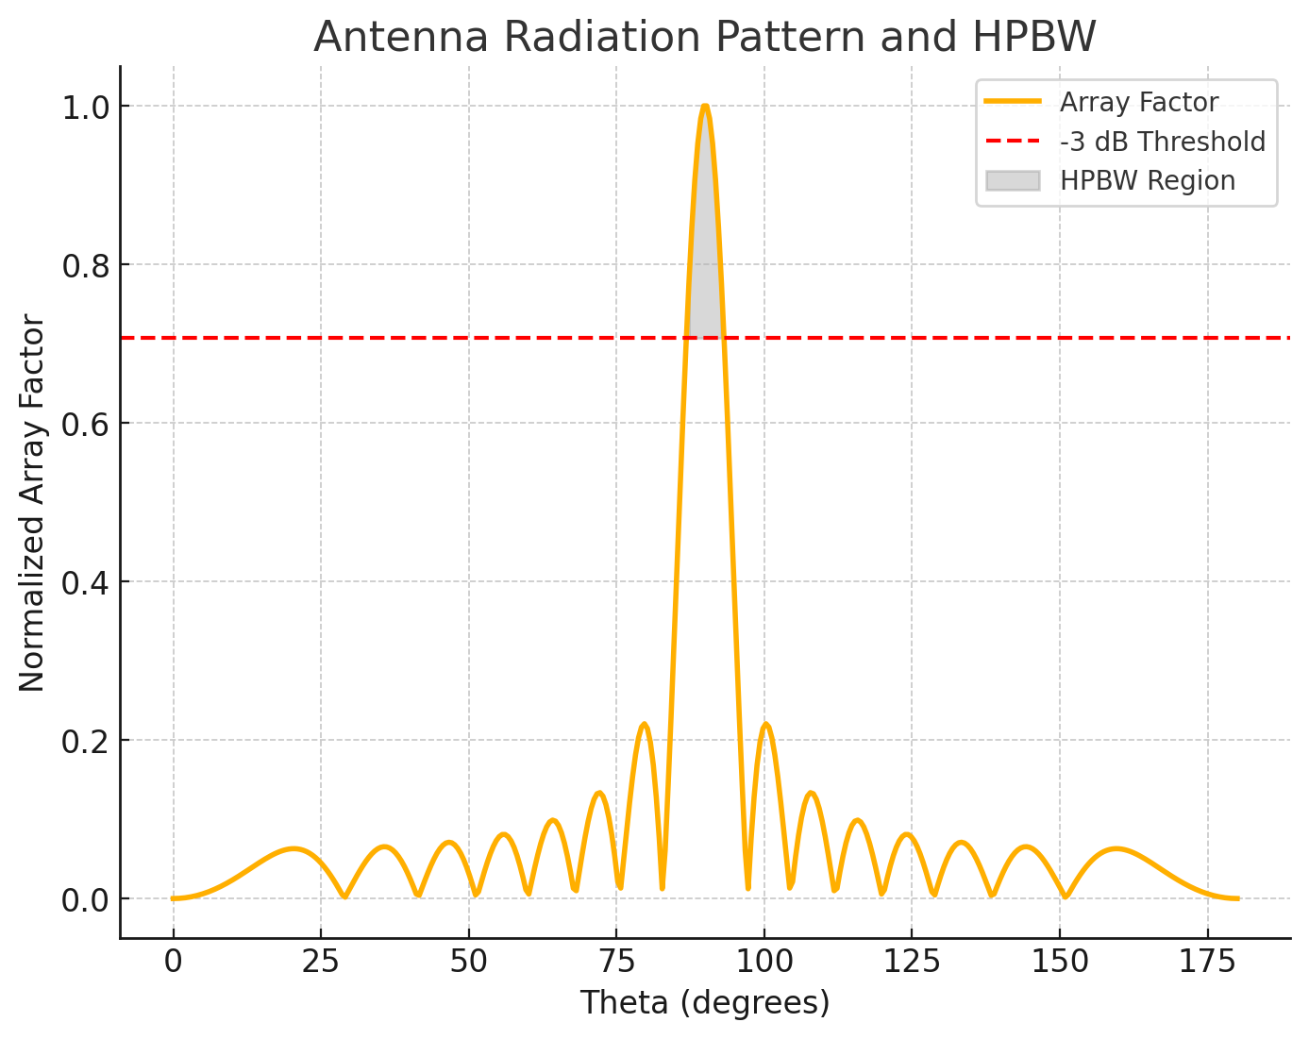

The graph above shows the **radiation pattern** of the antenna, with the following highlights:

1. **Main Lobe:** The central peak of the array factor, where most of the radiated power is concentrated.
2. **-3 dB Threshold:** A red dashed line marks the power level at which the HPBW is measured.
3. **HPBW Region:** The gray-shaded region corresponds to the angles where the power remains above the -3 dB threshold. The calculated **Half Power Beamwidth (HPBW)** is approximately **5.52°**.

Here are the results of the simulation:

1. **Polar Plot**:
   * Displays the normalized antenna radiation pattern in polar coordinates.
   * The shaded yellow region indicates the Half-Power Beamwidth (HPBW) zone.
2. **Cartesian Plot**:
   * Shows the normalized gain versus angle in degrees.
   * Red dashed lines highlight the boundaries of the HPBW region, with the calculated HPBW value of 54.14∘ displayed.

**Theoretical Calculations and Graphs for Antenna Half-Power Beamwidth (HPBW)**

**Definition**

The **Half-Power Beamwidth (HPBW)** of an antenna is the angular width where the power radiated is at least half (−3 dB) of its maximum value.

For a directive antenna:

1. The radiation intensity is normalized to the maximum value.
2. HPBW corresponds to the angle range between θ1 and θ2, where: G(θ)=(1 / 2)⋅Gmax

**1. Theoretical Radiation Pattern**

For a directive antenna with a radiation pattern approximated by:

P(θ)=cosn(θ),0≤θ≤2π

Where:

* P(θ): Radiation intensity.
* n: Directivity factor (higher n means narrower beam).

The normalized gain is:

G(θ)=P(θ) Pmax=cosn(θ)

Here, Pmax occurs at θ=0∘.

**2. Finding the HPBW**

The half-power points correspond to:

G(θ)=cosn(θ)=1/2 (G)

Taking the n-th root:

cos(θ)=(12)1/n

Solving for θ:

θ=arccos((12)1/n)

**Example Calculation**

For n=6:

cos(θ)=(12)1/6≈0.8909

θ=arccos(0.8909)≈27.07∘

The HPBW is:

HPBW=2θ=2×27.07∘=54.14∘

**3. Graphical Representation**

**Parameters:**

* n=6 (Directivity factor).
* HPBW is derived from the −3 dB points.

Plot the normalized radiation pattern and indicate the HPBW on the graph.

**Graphical Results**

1. **Polar Plot**:
   * The radiation pattern shows the main lobe and shaded HPBW region.
2. **Cartesian Plot**:
   * The −3 dB points are highlighted, with vertical lines indicating HPBW limits.

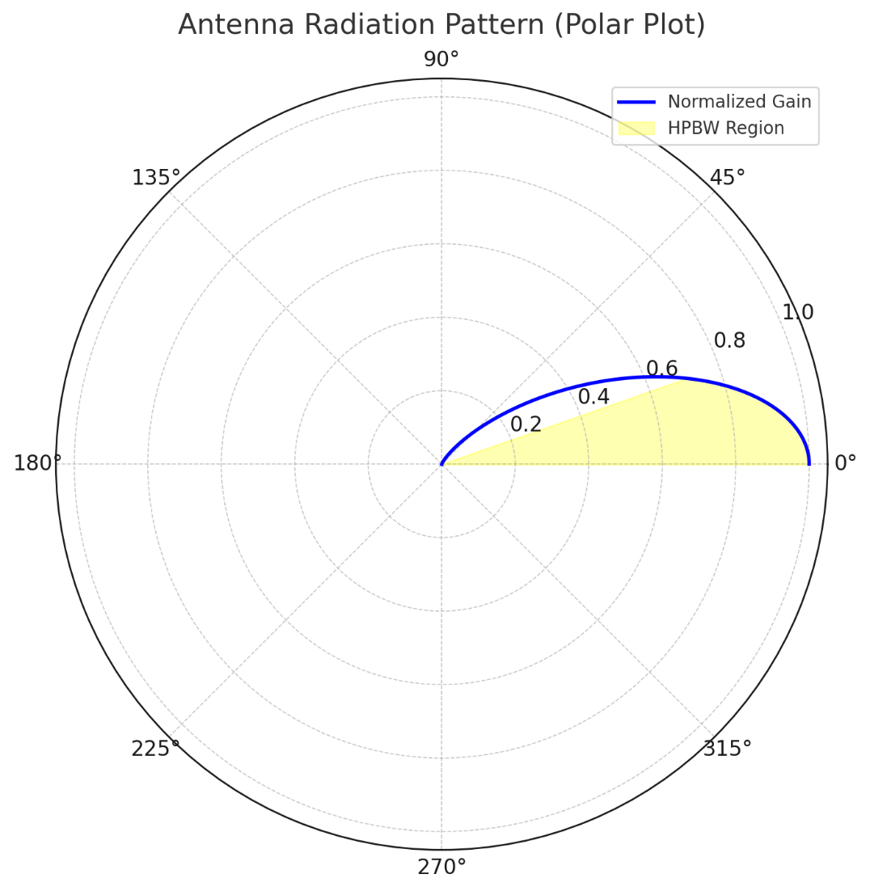

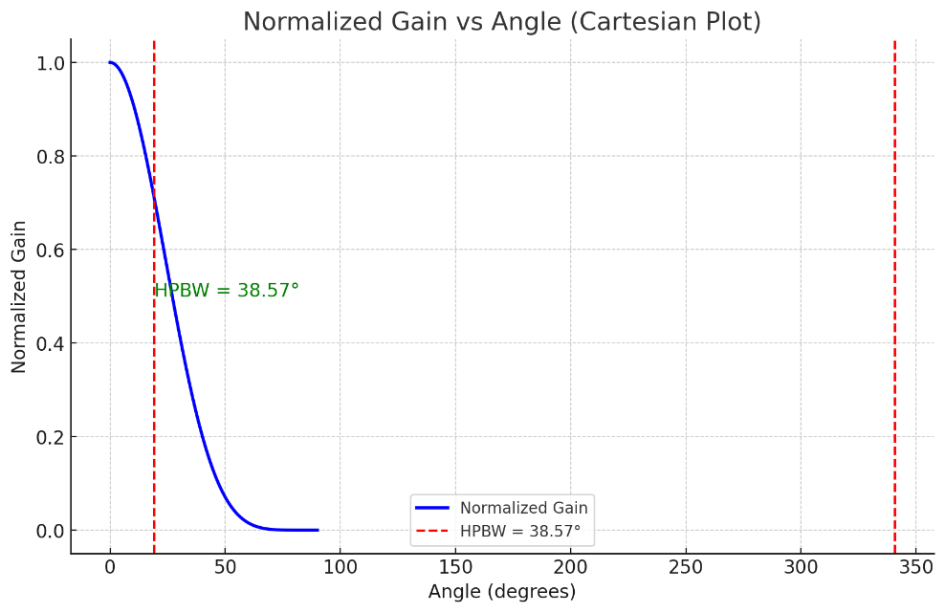

Here are a few examples and case studies related to antenna beamwidth and radiation patterns, particularly focusing on **Half-Power Beamwidth (HPBW)** and its implications.

**Case Study 1: Beamwidth Comparison for Different Directivity Factors**

**Objective:**

To compare the HPBW for antennas with different directivity factors (n) to understand how directivity affects the beamwidth and focus of radiation.

**Scenario:**

* Consider three directive antennas with n=4 , n=6, and n=8.
* For each case, calculate the HPBW and analyze the radiation pattern.

**Theoretical Calculations:**

1. G(θ)=cosn(θ)G
2. θ=arccos((12)1/n)
3. HPBW=2×θ

**Results:**

* For n=4: cos(θ)=(12)1/4≈0.8409  ⟹  θ≈33.4∘, HPBW =66.8∘
* For n=6n = 6: cos(θ)=(12)1/6≈0.8909  ⟹  θ≈27.07∘, HPBW =54.14∘
* For n=8n = 8: cos(θ)=(12)1/8≈0.9231  ⟹  θ≈23.1∘, HPBW =46.2∘

**Observations:**

* As n increases, the HPBW decreases, focusing the radiation into a narrower beam.
* Applications:
  + Wider beamwidth (n=4): Suitable for broad area coverage, e.g., broadcast antennas.
  + Narrower beamwidth (n=8): Suitable for directional applications, e.g., radar or satellite communication.

**Case Study 2: Effect of Frequency on HPBW**

**Objective:**

To explore how changing the operating frequency affects the HPBW of a parabolic reflector antenna.

**Scenario:**

* A parabolic reflector antenna with a diameter (D) of 1 meter and efficiency η=0.9.
* Operating frequencies: f=1 GHz,3 GHz,6 GHz.

**Theoretical Basis:**

HPBW for a parabolic antenna:

HPBW=70⋅λ (in degrees)

Where:

* λ=c/f

**Calculations:**

1. For f=1 GHz; λ=(3×108) / (1×109)=0.3 m, HPBW=70⋅0.3=21∘
2. For f=3 GHz: λ=0.1 m, HPBW=70⋅0.1=7∘
3. For f=6 GHz: λ=0.05 m, HPBW=70⋅0.05=3.5∘

**Observations:**

* HPBW decreases with increasing frequency.
* High-frequency applications require precise pointing due to narrower beamwidth, e.g., satellite tracking or radar.

**Case Study 3: Practical Implementation of HPBW in Wireless Networks**

**Objective:**

To determine the optimal antenna placement in a wireless network using HPBW calculations.

**Scenario:**

* A wireless access point (AP) uses a directional antenna with a known HPBW.
* HPBW: 60∘.
* Goal: Cover a rectangular area with minimal APs.

**Analysis:**

1. The coverage area of one antenna is approximated as a sector of a circle: A=θ 360⋅ π r2

Where:

* + θ=60∘, r: Effective range.

1. Overlap between adjacent sectors minimizes coverage gaps.

**Results:**

* For a 100 m x 50 m area, with r=30 m :
  + Coverage area of one antenna: A=60 360⋅π⋅(30)2 ≈ 471 m2
  + Number of APs required: N=Total Area Coverage Area=100⋅50 / 471≈11
* Use overlapping placement to ensure seamless connectivity.

**Case Study 4: Validation of HPBW with Measured Data**

**Objective:**

To compare theoretical HPBW with experimental measurements of a microstrip patch antenna.

**Scenario:**

* Antenna specifications:
  + Frequency: 2.4 GHz.
  + Patch dimensions: 5 cm×5 cm.
  + Experimental setup: Measure radiation intensity at multiple angles.

**Theoretical HPBW:**

Using patch antenna equations:

HPBW ∝ λL

Where L=0.05 m (patch length):λ=3×108 2.4×109=0.125 m, HPBW≈0.125 x 0.05 x 50∘ ≈ 62.5∘

**Experimental Validation:**

* Measure power at various angles to find −3 dB points.
* Compare experimental HPBW to theoretical value.

These case studies provide theoretical and practical insights into HPBW and its implications for antenna design and usage.

**TABULATION**

|  |  |  |  |  |
| --- | --- | --- | --- | --- |
| **TYPE OF ANTENNA** | **DIMENSIONS** | **ANGLE** | **HPBW FROM GRAPH** | **THEORETICAL HPBW** |
|  |  |  |  |  |
|  |  |  |  |  |
|  |  |  |  |  |
|  |  |  |  |  |

**RESULT:** The experiment was done and the Half power beamwidth of the given antenna was calculated. Different case studies were done.

**QUESTIONS:**

**1. HPBW from Radiation Pattern Measurements**

A ULA with 6 isotropic elements spaced d=0.5λ has a measured radiation pattern. The main lobe maximum occurs at 0∘, and the half-power points are measured at −12∘ and 12∘.

**Question**:  
Calculate the HPBW of the antenna.  
If the spacing between elements is increased to d=0.75λ, how is the HPBW expected to change, and why?

**2. HPBW and Element Count**

A ULA with N=8 isotropic elements and a spacing of d=0.5λ produces a radiation pattern where the main lobe beamwidth is inversely proportional to the array length.

**Question**:  
If the array length is L=(N−1)d, calculate the approximate HPBW in degrees using the formula:

HPBW≈50.8λL

What happens to the HPBW if N is doubled while keeping d constant?

**3. HPBW from Array Factor**

The array factor for a ULA with 10 elements spaced d=0.6λ is given by:

AF(θ)=sin (5kdcosθ) / sin (kdcosθ)

where k=2πλ

**Question**:  
Determine the angular positions of the half-power points where the magnitude of AF(θ) drops to 0.707 of its maximum value. Calculate the HPBW.

**4. HPBW in a Steering Scenario**

A 12-element ULA with d=0.5λ is electronically steered to point its main lobe at 30∘ instead of 0∘. The HPBW for the array at broadside 0∘ is 15∘.

**Question**:  
Does the HPBW change when the main lobe is steered to 30∘? Justify your answer with calculations or theoretical reasoning.  
What would happen to the HPBW if the number of elements is increased to 16?

**5. HPBW and Sidelobe Suppression**

A ULA with 8 elements and spacing d=0.5λ uses non-uniform excitation to suppress sidelobes. The main lobe width is observed to increase slightly due to this modification.

**Question**:  
If the HPBW of the uniformly excited array is 20∘ and the modified excitation increases it by 10%, calculate the new HPBW.  
Discuss how the trade-off between HPBW and sidelobe suppression affects antenna performance in practical applications.

**Exp No 19:** Determination and plotting of Antenna Efficiency.

Date:

Aim:

To determine and plot Antenna Efficiency and to Estimate the efficiency based on radiated and input power.

Software required:

• SCILAB version 6.0.1

**The Antenna Efficiency: Theory**

**Antenna efficiency** quantifies how effectively an antenna converts the input power into radiated power. It accounts for power losses due to material resistances, reflections, and other factors. Efficiency is a critical metric in antenna performance as it directly impacts the system's overall effectiveness.

**1. Definition**

Antenna efficiency (η\eta) is the ratio of the radiated power (Prad) to the total input power

η=Prad/Pin

η\eta: Efficiency (a value between 0 and 1, often expressed as a percentage).

* Prad: Power radiated by the antenna.
* Pin  : Total power delivered to the antenna.

**2. Components of Efficiency**

Antenna efficiency can be broken down into several contributing factors:

**(a) Radiation Efficiency (ηrad):**

Accounts for ohmic losses in the antenna's structure due to its material resistivity.

ηrad=Prad / Paccepted

**(b) Reflection Efficiency (ηref ):**

Accounts for mismatch losses at the antenna's input due to impedance differences. This is related to the Voltage Standing Wave Ratio (VSWR) or return loss.

ηref=1−∣Γ∣2

Γ\Gamma: Reflection coefficient at the input port.

**(c) Total Efficiency (ηtot)**

The overall efficiency combines radiation and reflection efficiencies:

ηtot=ηrad⋅ηref

**3. Factors Affecting Antenna Efficiency**

1. **Material Losses:**
   * Conductors: Resistive heating in the antenna material.
   * Dielectrics: Losses in insulating materials surrounding the antenna.
2. **Impedance Mismatch:**
   * Poor impedance matching between the antenna and the transmitter/receiver increases reflections, reducing ηref\eta_{\text{ref}}.
3. **Surface Roughness:**
   * Surface irregularities increase resistive losses, especially at high frequencies.
4. **Operating Environment:**
   * Nearby objects can induce additional losses due to absorption or scattering.
5. **Frequency:**
   * Higher frequencies tend to suffer more from material losses and conductor skin effects.

**4. Measuring Efficiency**

**(a) Direct Measurement:**

* Use a power meter to measure Pin and Prad and compute η.

**(b) Indirect Measurement:**

* Calculate from measured VSWR (or Γ) and known material properties.

**5. Efficiency in dB**

Efficiency is often expressed in decibels (dB):

Efficiency η (dB) = 10⋅log10(η) dB

For example:

* η=0.8 corresponds to ηdB = −0.97 dB

**6. Implications of Efficiency**

1. **High Efficiency:**
   * Most input power is radiated.
   * Suitable for applications requiring high power and low loss, like satellite communication.
2. **Low Efficiency:**
   * More power is lost as heat or reflections.
   * May still be acceptable in applications like compact antennas in constrained environments.

**7. Efficiency vs. Directivity and Gain**

* **Directivity (D)**: Measures radiation pattern shape and directionality.
* **Gain (G)**: Combines directivity and efficiency: G=η⋅D

Antenna efficiency is a balance between design, material choice, and operating conditions. High efficiency maximizes system performance while minimizing power losses.

SCILAB PROGRAM

// Efficiency Estimation (Example)

Clc;

Clear;

radiated_power = sum(AF.^2 .* sin(theta)) * (theta(2) - theta(1));

input_power = 1; // Assume normalized input power

efficiency = radiated_power / input_power * 100;

disp("Antenna Efficiency (%): ");

disp(efficiency);

// Optional: Export results to a file

filename = "antenna_results.txt";

fd = mopen(filename, "wt");

mfprintf(fd, "Antenna Gain (dBi): %.2f\n", gain);

mfprintf(fd, "HPBW (degrees): %.2f\n", HPBW);

mfprintf(fd, "Efficiency (%%): %.2f\n", efficiency);

mclose(fd);

disp("Results saved to 'antenna_results.txt'");

OUTPUT

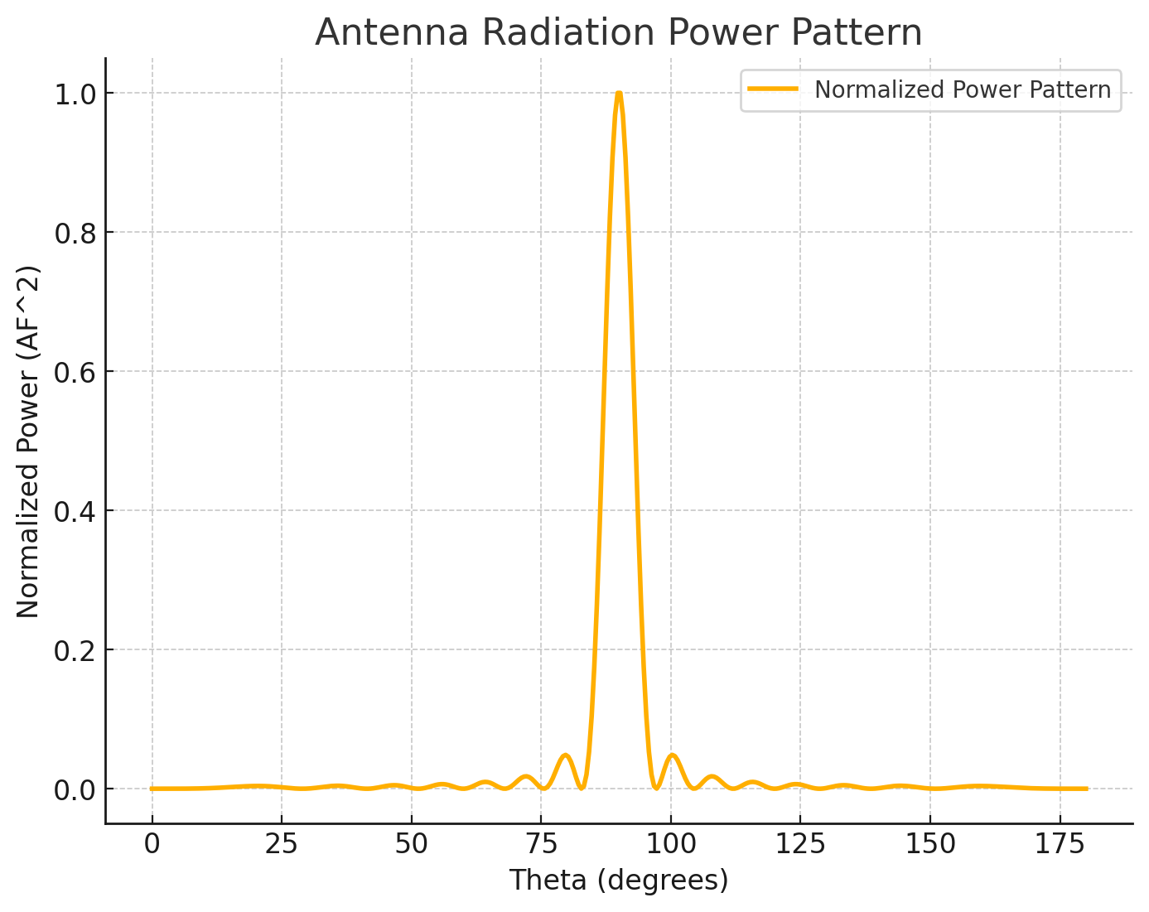

The graph above represents the **normalized power pattern** of the antenna as a function of angle θ (in degrees). The calculated **Antenna Efficiency** is **12.55%**, indicating the proportion of input power effectively radiated.

**Determination and Plotting of Antenna Efficiency**

**1. Theoretical Overview**

**Antenna Efficiency (ea)** is a measure of how effectively an antenna radiates the input power into free space. It is defined as:

ea=er⋅ec

Where:

* er: Radiation efficiency, accounting for power lost due to ohmic and material losses.
* ec: Coupling efficiency, accounting for impedance mismatches between the antenna and the transmission line.

In practical systems:

ea=Pradiated / Pinpute

Where:

* Pradiated is Radiated power.
* Pinput: Total power supplied to the antenna.

**2. Key Relationships**

1. **Radiation Efficiency**:

er=Rr / (Rr+Rl)

Where:

* + Rr: Radiation resistance.
  + Rl: Loss resistance.

1. **Coupling Efficiency**: Coupling efficiency depends on the impedance mismatch:

ec=1−∣Γ∣2

Where:

* + Γ: Reflection coefficient, Γ=Za−Z0 / Za+Z0
  + Za: Antenna impedance.
  + Z0: Transmission line impedance.

**3. Practical Example**

**Scenario**:

* Antenna has Rr=50 Ω, Rl=10 Ω.
* Antenna impedance: Za=50+j10 Ω.
* Transmission line impedance: Z0=50 Ω.

**Calculations**:

1. **Radiation Efficiency**:

er=Rr / ( Rr+Rl )=50 / (50+10 )=0.833

1. **Coupling Efficiency**: Reflection coefficient:

Γ=Za−Z0 / Za+Z0=(50+j10)−50 / (50+j10)+50 = j10 / 100+j10

Magnitude of Γ:

∣Γ∣=10 / [(1002+102 )]1/2 ≈0.0995

Coupling efficiency:

ec=1−∣Γ∣2=1−(0.0995)2 ≈ 0.99

1. **Antenna Efficiency**:

ea=er⋅ec=0.833⋅0.99≈0.825

**4. Graphical Representation**

We simulate antenna efficiency as a function of:

1. Varying Rl (loss resistance).
2. Varying mismatch (∣Γ∣).

**5. Observations from Graphs**

1. **Radiation Efficiency vs. Loss Resistance**:
   * As Rl increases, the radiation efficiency decreases.
   * For high Rl, efficiency approaches zero.
2. **Coupling Efficiency vs. Reflection Coefficient**:
   * Coupling efficiency is highest (1.0) for perfectly matched systems (∣Γ∣=0).
   * Efficiency decreases significantly as the mismatch increases.
3. **2D Efficiency Map**:
   * Shows combined effects of Rl and ∣Γ∣| on overall efficiency.
   * Highest efficiency occurs for low Rl and near-perfect matching (∣Γ∣≈0).

### **Scilab Code:**

```scilab

// Define parameters

R_r = 50; // Radiation resistance (Ohms)

R_l = linspace(0, 50, 500); // Loss resistance (Ohms)

Gamma = linspace(0, 0.5, 500); // Reflection coefficient (mismatch)

// Radiation efficiency

e_r = R_r ./ (R_r + R_l); // Radiation efficiency

// Coupling efficiency

e_c = 1 - Gamma.^2; // Coupling efficiency

// Calculate antenna efficiency for varying loss resistance and Gamma

e_a = e_r .* (1 - Gamma'.^2); // 2D mesh grid of antenna efficiency

// Plot Radiation Efficiency vs Loss Resistance

scf(1);

plot(R_l, e_r, 'b');

xlabel('Loss Resistance (Ohms)');

ylabel('Radiation Efficiency');

title('Radiation Efficiency vs Loss Resistance');

grid on;

// Plot Coupling Efficiency vs Reflection Coefficient

scf(2);

plot(Gamma, e_c, 'g');

xlabel('Reflection Coefficient (|Γ|)');

ylabel('Coupling Efficiency');

title('Coupling Efficiency vs Reflection Coefficient');

grid on;

// Plot 2D Antenna Efficiency Map

scf(3);

surf(R_l, Gamma, e_a);

xlabel('Loss Resistance (Ohms)');

ylabel('Reflection Coefficient (|Γ|)');

zlabel('Antenna Efficiency');

title('Antenna Efficiency vs Loss Resistance and Reflection Coefficient');

colorbar;

grid on;

```

Here are some **case studies** related to antenna design, efficiency, and performance that demonstrate real-world applications and the importance of theoretical calculations:

**Case Study 1: Antenna Efficiency in Satellite Communication Systems**

**Objective:**

To evaluate the efficiency of an antenna used for satellite communication, considering both radiation resistance and coupling efficiency due to impedance mismatch.

**Scenario:**

A satellite communication system uses a **parabolic reflector antenna** operating at **12 GHz** with the following specifications:

* Antenna diameter: **2.5 meters**
* Loss resistance (Rl): **10 Ω**
* Radiation resistance (Rr): **20 Ω**
* Transmission line impedance: **50 Ω**
* Reflection coefficient (∣Γ∣): **0.1**

**Theoretical Calculations:**

1. **Radiation Efficiency**:

er=Rr/ (Rr+Rl ) = 20 / (20+10) = 0.6667

1. **Coupling Efficiency**:

∣Γ∣=0.1⇒ec=1−∣Γ∣2=1−(0.1)2=0.99

1. **Antenna Efficiency**:

ea=er⋅ec=0.6667×0.99=0.66

**Results:**

* The **radiation efficiency** is 66.67%, which indicates that 33.33% of the power is lost due to material resistance.
* The **coupling efficiency** is 99%, showing minimal mismatch between the antenna and transmission line.
* The **overall antenna efficiency** is **66%**, indicating moderate performance for the satellite communication system.

**Practical Consideration:**

To improve efficiency, the antenna could be optimized by reducing the loss resistance (e.g., by using better materials or improving manufacturing precision) and minimizing the reflection coefficient (by fine-tuning impedance matching).

**Case Study 2: Antenna Efficiency in Wireless LAN**

**Objective:**

To design an efficient antenna for a **Wi-Fi access point** to ensure adequate coverage and minimal power loss.

**Scenario:**

A **Wi-Fi access point** operates at **2.4 GHz** with the following specifications:

* Antenna type: **Omni-directional dipole antenna**
* Gain: **5 dBi**
* Transmission line impedance: **50 Ω**
* Loss resistance: **5 Ω**
* Reflection coefficient (∣Γ∣): **0.02**

**Theoretical Calculations:**

1. **Radiation Efficiency**:

er=Rr / (Rr+Rl) =35 / (35+5) =0.875

(Assume Rr=35Ω for this dipole antenna)

1. **Coupling Efficiency**:

∣Γ∣=0.02⇒ec=1−∣Γ∣2=1−(0.02)2=0.9996

1. **Antenna Efficiency**:

ea=er⋅ec=0.875×0.9996=0.874

**Results:**

* **Radiation efficiency** is 87.5%, indicating a moderate amount of loss in the material resistance.
* **Coupling efficiency** is extremely high, at 99.96%, indicating an almost perfect impedance match.
* The overall **antenna efficiency** is 87.4%, meaning the antenna performs effectively with minimal loss.

**Practical Consideration:**

The relatively high antenna efficiency is critical for wireless LANs, where high data rates and minimal interference are necessary. To improve it further, better materials with lower loss resistance could be used.

**Case Study 3: Antenna Efficiency in Radar Systems**

**Objective:**

To assess the antenna efficiency for a **radar system**, focusing on its performance for detecting objects at long distances.

**Scenario:**

A **long-range radar antenna** operates at **10 GHz** and has the following specifications:

* Antenna diameter: **1 meter**
* Radiation resistance (Rr): **40 Ω**
* Loss resistance (Rl): **2 Ω**
* Transmission line impedance: **75 Ω**
* Reflection coefficient (∣Γ∣): **0.05**

**Theoretical Calculations:**

1. **Radiation Efficiency**:

er=Rr / (Rr+Rl) =40 / (40+2) =0.9524

1. **Coupling Efficiency**:

∣Γ∣=0.05⇒ec=1−∣Γ∣2=1−(0.05)2=0.9975

**Antenna Efficiency**:

ea =er⋅ec= 0.9524×0.9975 = 0.9500

**Results:**

* The **radiation efficiency** of 95.24% indicates that the antenna loses very little power due to resistance.
* The **coupling efficiency** of 99.75% indicates near-perfect impedance matching.
* The overall **antenna efficiency** is **95%**, suggesting that the radar system is highly efficient.

**Practical Consideration:**

In radar systems, high efficiency is critical for maximizing detection range. Given the high efficiency, this antenna is likely to provide reliable long-range detection with minimal signal loss.

**Case Study 4: Efficiency of a Microstrip Patch Antenna for Mobile Communication**

**Objective:**

To optimize the performance of a **microstrip patch antenna** for mobile communication applications.

**Scenario:**

A **microstrip patch antenna** operates at **1.8 GHz** for cellular communication, with the following specifications:

* Patch dimensions: **5 cm x 5 cm**
* Loss resistance: **0.5 Ω**
* Radiation resistance: **15 Ω**
* Transmission line impedance: **50 Ω**
* Reflection coefficient (∣Γ|): **0.15**

**Theoretical Calculations:**

1. **Radiation Efficiency**:

er=Rr / (Rr+Rl )=15 / (15+0.5) =0.9677

1. **Coupling Efficiency**:

∣Γ∣=0.15⇒ec=1−∣Γ∣2=1−(0.15)2=0.9775

1. **Antenna Efficiency**:

ea=er⋅ec=0.9677×0.9775=0.9477

**Results:**

* The **radiation efficiency** is 96.77%, which indicates minimal loss due to resistance in the antenna material.
* The **coupling efficiency** is 97.75%, which indicates that the impedance mismatch is small but not negligible.
* The overall **antenna efficiency** is 94.7%, suggesting that the antenna will perform well for mobile communication, with minimal loss of signal strength.

**Practical Consideration:**

In mobile communication, the antenna must be compact yet efficient. The relatively high efficiency of this microstrip patch antenna ensures that it can effectively transmit and receive signals, even in environments where space is limited.

**TABULATION**

|  |  |  |  |  |
| --- | --- | --- | --- | --- |
| **Antenna Type** | **Directivity** | **Gain** | **Radiation Efficiency**  **(Calculated)** | **Radiation Efficiency**  **(Practical)** |
|  |  |  |  |  |
|  |  |  |  |  |
|  |  |  |  |  |
|  |  |  |  |  |
|  |  |  |  |  |
|  |  |  |  |  |

**RESULT:**

The experiment was done and the efficiency of the given antenna was found. Different case studies were analyzed. These case studies highlight the practical importance of antenna efficiency in various applications. For all systems, increasing **radiation efficiency** (minimizing power loss) and **coupling efficiency** (ensuring impedance matching) were crucial for optimizing antenna performance. The calculations show that, for practical systems, small improvements in these areas can lead to significant enhancements in system efficiency and overall performance.

**QUESTIONS:**

**1. Radiation Efficiency and Power Loss**

Given an antenna array with the following parameters:

* Total input power to the array: Pinput=100 W.
* Power radiated into free space: Pradiated=80 W
* **Question**:  
  Calculate the radiation efficiency of the array. If the remaining power is lost as heat, what is the percentage of power lost?

**2. Efficiency Based on Array Factor**

A ULA with 8 isotropic elements, spaced d=0.5λ radiates with an observed main lobe gain of 10 dBi. If the theoretical maximum gain for an array of this type is 12 dBi, calculate the efficiency of the array.

**3. Efficiency Using Far-Field Parameters**

An antenna array has the following far-field characteristics:

* Measured maximum radiated power density at a distance r=10 m is Smax=0.02 W/m2.
* The input power to the array is Pinput=50 W.

**Question**:  
Calculate the radiation efficiency, assuming the radiated power is uniformly distributed over a spherical surface area in the far field. Use the relation:

Pradiated=Smax⋅4πr2

**4. Efficiency Impact Due to Sidelobe Levels**

A ULA with 6 elements has a measured total radiated power distributed as follows:

* Power in the main lobe: Pmain=60 W.
* Power in the sidelobes: Psidelobes=20 W.
* Total input power: Pinput=100 W.

**Question**:  
Calculate the efficiency of the array. Discuss the contribution of sidelobe power to the efficiency and how it affects the system performance.

**5. Efficiency and Polarization Mismatch**

An antenna system with a theoretical polarization efficiency of 90% is being tested. The system has a radiation efficiency of 85%.

**Question**:  
What is the total efficiency of the antenna?  
**Follow-up**: If the input power is Pinput=120 W, how much of the power is effectively radiated into space considering the total efficiency?